Take home messges here

The Elizabeth Fry Society of Calgary





Court Service Provision Report

January 2017-December 2018

Contents

1 Contents 1

2 Executive Summary 4

2.1 Background 4

2.1.1 Objective 4

2.2 Methodology 4

2.3 Results 4

2.3.1 Gender Distribution 4

2.3.2 Age Distribution 4

2.3.3 Minority Status 4

2.3.4 Family Size 4

2.3.5 Annual Household Income 4

2.3.6 Support 5

2.3.7 Offences 5

2.3.8 Appearances 5

2.3.9 Legal Representation 5

2.3.10 Service Provision 5

2.4 Conclusions 5

3 Background 6

3.1 Demographics of Corrections in Canada 6

3.2 Poverty 6

3.3 Gender 6

3.4 Age 7

3.5 Minority Status 7

3.6 The Elizabeth Fry Society of Calgary 8

4 Methodology 9

4.1 Research Question 9

4.2 Research Design 9

4.3 Data Collection 9

4.4 Data Analysis 10

4.5 Ethics and Data Handling 10

4.6 Strengths 10

4.7 Limitations 10

5 Results 11

5.1 Calgary’s Adult Court 11

5.2 North Adult Court 21

5.3 South Adult Court 30

5.4 Calgary Youth Court 37

5.5 North Youth Courts 41

5.6 South Youth Court 46

5.7 Traffic Court 50

5.8 South Traffic Courts 61

5.9 Domestic Court 68

6 Discussion 74

6.1 Gender Distribution 74

6.1.1 Gender Distribution 74

6.1.2 Gender and Age Distribution 74

6.1.3 Gender and Minority Status 74

6.2 Age Distribution 75

6.2.1 Adult courts 75

6.2.2 Youth courts 75

6.2.3 Traffic courts 75

6.2.4 Domestic Court 76

6.3 Minority Status 76

6.3.1 Adult courts 76

6.3.2 Youth courts 78

6.3.3 Traffic courts 79

6.3.4 Domestic Court 80

6.4 Family Size 81

6.4.1 Adult courts 81

6.4.2 Traffic courts 81

6.5 Annual Household Income 81

6.5.1 Adult courts 81

6.5.2 Traffic courts 82

6.6 Offences 82

6.6.1 Adult courts 82

6.6.2 Traffic courts 83

6.7 Support 83

6.8 Appearances 84

6.9 Legal Representation 84

6.10 Service Provision 84

7 Conclusions 85

8 Reference List 87

9 Appendix 89

9.1 Market Basket Measure (MBM) Thresholds for Economic Families and Persons not in Economic Families, 2015 89

9.2 Odds Ratio Formula and Sample Calculation 89

9.3 Chi-Squared (X2) Formula and Sample Calculation 89

9.4 Average Immediate Family Size, From the 2016 National Census 89

9.5 Data Collection Sheet Exemplars – Adult, Youth, Traffic, and Domestic Court 91

# Executive Summary

Key Findings

Indigenous youth had the most support in court, and newcomers the least.

Criminal charges usually preceded administration charges.

Failure to appear was the most common administration charge.

Speeding was the most common Traffic charge.

Newcomers were overrepresented in Traffic courts, with higher odds of having several offence types. This is less true of Indigenous attendees.

Most attendees presented for a first appearance, lacked a legal representative, and received services for <4 minutes.

## Background

Key Findings

Men were broadly overrepresented.

Indigenous women were similarly overrepresented.

Adult court attendees were generally younger. Youth court attendees were generally older adolescents.

Indigenous attendees were broadly overrepresented in many courts, and newcomers underrepresented outside of Traffic courts .

Smaller attendee family sizes were often noted.

Attendees with minority status were financially worse off on average.

The composition of court attendees nationally reflects longstanding, well-documented trends. At this time, it is unknown whether these same trends are observed in the population supported by the Elizabeth Fry Society of Calgary.

### Objective

This report endeavours to explore trends observed in the Calgary, North, and South court attendees supported by the Elizabeth Fry Society of Calgary.

## Methodology

Qualitative and quantitative data collected from attendees receiving in-person support from Elizabeth Fry court floor representatives between January 2017 and December 2018 was assessed for relationships between demographic factors. Statistical analysis was carried out using SPSS software.

## Results

### Gender Distribution

Men were overrepresented across all courts examined, particularly in Domestic Court. Gender distribution was most even in the Traffic courts. Newcomer and Indigenous attendees had the most and least divergent gender distributions, respectively. Indigenous women were overrepresented in most courts. These observations are consistent with existing literature.

### Age Distribution

Younger adults were overrepresented in most courts, particularly young men. This relationship was less prominent in the Traffic courts. In the youth courts, older adolescents represented the most contributory age strata. This is consistent with existing literature.

### Minority Status

Indigenous attendees were overrepresented in all but Calgary’s Traffic Court. This is especially true of the North Adult and Youth courts, which served the First Nation community of Morley, and had larger young adult populations. This trend is congruent with existing literature on the effects of social determinants, discrimination, the legacy of colonization, and intergenerational trauma on the population. Newcomer attendees were broadly underrepresented in the few courts for which appropriate data for comparison was available, but were overwhelmingly overrepresented in the Traffic courts.

### Family Size

Across all courts, attendees were most often part of smaller families of 1-2 individuals. However, North Adult Court demonstrated more even distribution across family sizes; Indigenous attendee families were larger, and more significantly represented in this court.

### Annual Household Income

Across all courts, a greater proportion of household incomes of <$15,000, and a lesser proportion of those >$55,000, were observed in attendees with minority status. Across adult courts, Indigenous attendee families consistently had higher odds of falling below Market Basket Measure values than attendees without minority status, especially in North Adult Court. Newcomers appeared to demonstrate a similar trend, however data was considerably limited. These observations are consistent with existing literature.

### Support

Indigenous attendees and newcomer attendees had the highest and lowest rates of support in the youth courts, respectively. The nature of the types of supports present represents a promising area for future study.

### Offences

Charges preceding administration offences in all Adult courts were overwhelmingly criminal, while the most common administration charge was failure to appear. The most common bylaw offences for all groups included Calgary traffic offences and other bylaw offences. The most common offence in all Traffic courts, in all minority status groups, was speeding. Indigenous attendees had higher odds of having several traffic offence types, and newcomers higher odds of nearly every traffic offence type, than individuals without minority status. Newcomers conversely had lower odds of having offences related to careless driving, or failure to provide a licence or registration.

### Appearances

Across all courts for which data was available, attendees were most commonly present for a first appearance.

### Legal Representation

Overwhelmingly, attendees did not have legal representation, save for in Calgary’s Youth Court; as per the Youth Criminal Defence Act, all youth are required to have legal representation in court. Youth courts demonstrated the highest proportion of attendees with legal representation overall, as would be expected, while Traffic courts demonstrated the lowest.

### Service Provision

On average, attendees received support services for a duration of <4 minutes. This was especially true of Calgary’s Domestic Court, while the North and South Youth Courts, and South Adult Court, demonstrated higher proportions of individuals requiring longer term supports of ≥15 minutes. This is believed to reflect the differing processes and organization of the courts, their volume, the experience and expertise of court floor representatives, as well as the demographics served by each court.

## Conclusions

Overall, the trends observed in attendees receiving services through the Elizabeth Fry Society of Calgary largely mirrored those cited in existing literature, and regional statistics. Familiarity with the population served may help direct service approaches. Several areas for future exploration were noted that may uncover more nuanced relationships, particularly those involving minority status, and fill in existing information deficits.

# Background

## Demographics of Corrections in Canada

The current composition of court attendees at a national level reflects longstanding, well-documented trends. Overrepresentation of certain demographic groups has been attributed to a variety of factors, including but not limited to poverty, discrimination, and the enduring effects of colonization (Kanters, 2018). However, patterns observed at a national level do not always reflect those apparent locally. This report aims to explore the trends apparent in attendees at Calgary’s, North (Cochrane, Didsbury, and Canmore), and South (Airdrie and Okotoks) courts – specifically, in defendants receiving support services through the Elizabeth Fry Society of Calgary. Trends in demographic distribution were assessed for congruency with existing data and literature.

## Poverty

There exists a large body of literature substantiating that individuals living in poverty are at a greater risk of engaging in criminal activities (McFarlane and Milaney, 2008). In fact, within Alberta’s correctional system, a documented 74% of women lacked the financial resources to meet their basic needs at the time of their conviction (McFarlane and Milaney, 2008). Across Canada, roughly 80% of incarcerated Canadian women have been imprisoned for charges relating to poverty, in particular failure to pay fines (McFarlane and Milaney, 2008). Homelessness is a recognized predictor for participation in illegal activity, as a means of survival (Roebuck, 2008). The deleterious effects of poverty-related incarceration are understood to perpetuate the cycle of poverty (McFarlane and Milaney, 2008). A charge on a police information check, frequently requested by employers (Centre for Public Legal Education of Alberta, 2015), has the potential to affect an individual’s earning potential and employability in a significant way (Brown, 2019). Few jurisdictions offer protections against employment discrimination for individuals with criminal records (Statistics Canada, 2017). Similarly, individuals with criminal records face unique challenges securing housing (Kanters, 2018). A criminal record can prove a barrier to obtaining approval for social housing, while landlords reserve the right to require background checks as part of the process of applying for tenancy (Statistics Canada, 2017). Both the Alberta Human Rights Act (Government of Alberta, 2000), and Residential Tenancies Act, fail to offer protections against housing discrimination on the grounds of a criminal record (McKay-Panos, 2017). It is perhaps unsurprising to learn then, that incarceration is a strong predictor of homelessness (Roebuck, 2008).

Individuals with criminal records face unique challenges securing housing and employment.

Statistics canada, 2017; Kanters, 2018

Homelessness is a well recognized predictor for participation in illegal activity, as a means of survival.

Roebuck, 2008

## Gender

It has been observed that on a national level the number of completed cases in Adult courts involving a male defendant are greater than the number of cases involving a female defendant, for all offence types (Statistics Canada, 2017). In fact, as per the findings of the Integrated Criminal Court Survey, in 2014/2015 only one in five adult court cases in Canada involved a female attendee (Statistics Canada, 2017). Young men have historically experienced the most significant overrepresentation in all Adult courts (Statistics Canada, 2018), while older male adolescents have long been overrepresented across Youth courts (Statistics Canada, 2017). In 2017/2018, male youth aged 16-17 accounted for 42% of youth admissions to correctional services (Statistics Canada, 2018). Incarceration rates for male court attendees are also notably disproportionate; it is believed that this may be attributable to male attendees reporting a greater number of charges on average than their female counterparts (Statistics Canada, 2017). Despite making up a relatively small proportion of all attendees, nationally the number of female defendants across adult criminal courts continues to grow (Statistics Canada, 2017); this trend is especially true of women with Indigenous status (Statistics Canada, 2017). Indigenous women are broadly more likely to interact with the criminal justice system than women without minority status (Statistics Canada, 2017). In 2014/2015, Indigenous women made up 39% of admissions to federal custody, despite comprising less than 5% of the total population of women in Canada (Statistics Canada, 2017). It is widely accepted that this trend has its roots in the effects of social determinants, discrimination, the legacy of colonization, and intergenerational trauma (Statistics Canada, 2017).

The economic status of Indigenous Albertans is poorer than that of the general population.

Statistics Canada, 2013

Indigenous women are broadly more likely to interact with the criminal justice system than women without minority status.

statistics canada, 2017

## Age

Nationally, both men and women of younger age groups have been overrepresented in Adult courts (Statistics Canada, 2017). Aligned with this observation, women in provincial and federal custody are overwhelmingly younger than 35 years of age (Statistics Canada, 2017). Similarly, young men remain the most statistically overrepresented group within the criminal justice system (Statistics Canada, 2018). Older adolescents – particularly male youth - make up the largest contributory age strata for both male and female defendants in Youth courts, across Canada (Statistics Canada, 2017). For many offences, female Youth court attendees with Indigenous status outnumber the women with Indigenous status appearing in Adult courts (Statistics Canada, 2017).

## Minority Status

The overrepresentation of individuals with Indigenous status - First Nations, Métis, or Inuit (Statistics Canada, 2016) - in both courts and in correctional institutions is longstanding, and well-documented (Statistics Canada, 2017; Statistics Canada, 2018; Perreault, 2009). For example, in 2016/2017, Indigenous youth made up 46% of admissions to correctional services, while representing only 8% of the total population of Canadian youth (Statistics Canada, 2018). In recent years, this discrepancy in representation in custody by minority status has only been trending upwards (Statistics Canada, 2018), despite national efforts to employ an increasing number of alternative and culturally specific sentences (Corrado et al., 2014). This disproportionate representation has been well studied, and is understood to be rooted in effects of social determinants, discrimination, the legacy of colonization, and intergenerational trauma (Statistics Canada, 2017).

It has been observed that the economic status of Indigenous Albertans is poorer than that of the general population (Statistics Canada, 2013). This is significant, given that poverty is a risk factor for interaction with the criminal justice system (Kanters, 2018). In 2016, 55% of Indigenous persons were in the bottom half of the Canadian income distribution, suggesting that the population has relatively lower incomes than Canada as a whole (Statistics Canada, 2013). In Calgary in 2016, the median household income for Indigenous individuals was $69,378 – a marked $12,000 lower than that of Calgarians overall – and 22% were considered low income (Statistics Canada, 2013). This is in part owing to differential rates of employment, educational attainment (Pager, 2003), and the fields of employment in this group; in 2016, approximately half of Indigenous Calgarians were employed in sales and service positions, fields which demonstrate some of the lowest wages (Statistics Canada, 2013).

The Elizabeth Fry Society of Calgary aims to remove barriers, and to empower service recipients to develop the skills they need to create more hopeful futures.

The elizabeth fry society of calgary

## The Elizabeth Fry Society of Calgary

The Elizabeth Fry Society of Calgary is a non-profit organization committed to supporting the needs of individuals involved in the criminal justice system. Offering practical programs, basic necessities, and valuable resources, the organization has been serving Calgary and area for more than 50 years, providing a hand up to thousands of women, youth, and individuals from marginalized populations with complex needs. The Elizabeth Fry Society aims to remove barriers, and to empower individuals accessing services to develop the skills they need to create more hopeful futures. A key service provided by the organization is support to court attendees on the court floors, at several courts across Southern Alberta; the contents of this report reflect findings derived from data collected through this service.

# Methodology

## Research Question

“What relationships can be observed between demographic factors in the court attendees supported by Elizabeth Fry?”

## Research Design

All data analysed in this report was generated from discussion with individuals receiving direct support from Elizabeth Fry staff and/or volunteers, on the court floors.

The information obtained through this data collection process is intended to identify potentially significant relationships between demographic factors, and to help inform future decisions surrounding service provision. For the metrics assessed, please see Appendix 9.5.

## Data Collection

Quantitative data was collected by both staff members and highly skilled volunteers involved in direct service provision to individuals at the courthouse, from January 2017-December 2018. Informed consent was secured prior to data collection, with participants informed that the Elizabeth Fry representative was not associated with the legal system, information was being collected for the purposes of better understanding the population served by the organization, confidentiality would be maintained, and participation was voluntary.

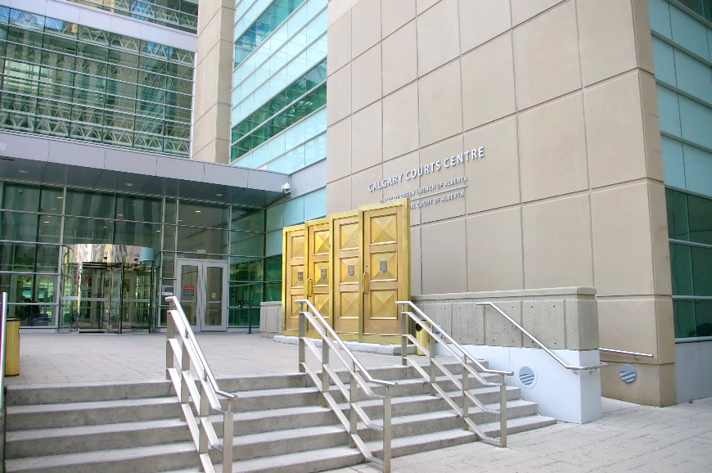All data acquisition occurred on-site on the courthouse floors. The statistical data collection method employed was informed and updated as needed, using information gathered throughout the process. Attention was taken to ensure the confidentiality and privacy of individuals’ responses was respected as much as possible, and to facilitate a safe environment for sharing. Names were omitted from the data sheets with the understanding that all data would be treated as aggregate. Completed data sheets were kept private and transported to the main office following data collection. Questions with the potential to cause discomfort – such as those relating to income or charges – were addressed discretely, with participants occasionally indicating their answers themselves directly on the data sheet, as appropriate. Court dockets were referenced to aid respondents as needed.

To better ensure the accurate reporting of information, questions were short and specific, designed to accommodate variable levels of literacy and familiarity with the English language. Elizabeth Fry representatives were provided multiple strategies to acquire this data.

## Data Analysis

To facilitate ease of analysis, for the purposes of this report North court data refers to that which was collected from the Cochrane, Didsbury, and Canmore courts. Similarly, South court data refers to that which was collected from the Airdrie and Okotoks courts. Data was reviewed for errors and inconsistencies, transcribed into Microsoft Excel 365 software utilizing a binary coding system, and was subsequently analysed using SPSS 2019 software. Analysis involved the computation of several basic statistical measures, chi2 tests, and odds ratio calculations to evaluate the relationship between demographic factors, and associations between demographic factors and specific outcomes (for example, having a given type of offence). Trends drawn from smaller data sets of less than 50 individuals have been indicated. In keeping with standard practice, chi2 analysis was reserved for data sets that included at least 4 individuals per given category. For the purposes of establishing the statistical significance of relationships between these variables, a p-value of 0.05 was used. For a complete list of formulas used, please see Appendix 9.2 and 9.3. Conclusions drawn from the completion of this statistical analysis were intended to help answer the research question. All data transcription, handling, and interpretation was conducted by an internal evaluator.

## Ethics and Data Handling

As part of their training, staff and volunteers involved in data collection and management completed oaths of confidentiality and received training relating to privacy protection, cultural competency, and non-judgemental support. On-site training ensured that volunteers were well prepared to collect statistical information in a consistent manner. Before commencing the data collection process, participants’ informed consent was obtained, noting the name of the organization, voluntary nature of participation, and how their information would be used and managed. Information collected was anonymous, and treated as aggregate. Attention was paid to ensuring respondent privacy as much as possible on the court floors, with individuals provided the option to respond to more sensitive questions by discretely indicating their answers on the data sheet. Data was collected and stored in accordance with organization policy, and in compliance with the FOIPP Act of Alberta.

## Strengths

The data set analysed represents the result of 2 years of collection efforts, with a considerable sample size. The duration of the data collection period allowed opportunity to accurately capture trends observed over time. Data was collected by volunteers on the court floors every day throughout operating hours, leaving limited room for selection bias. Volunteers received many hours of training, with instruction on conducting the data collection in a standardized manner. Use of standardized, vetted questions limited potential interviewer bias.

## Limitations

The conclusions presented in this report reflect findings from the population served by the organization in Calgary, and may not be generalizable to populations in other localities. Despite efforts made to ensure privacy for the data collection process, it is possible that discomfort on the part of select individuals, or Elizabeth Fry representatives, may have previously affected responses and response rates to certain questions. In an effort to mitigate the latter concern, each representative’s statistics were monitored for completeness, with support provided to individuals struggling with certain questions with susceptibility to individual bias or discomfort. Owing to a paucity of provincial court data, prevalence values from years preceding 2017 were sometimes used as a basis for comparison as needed; dates for these values have been noted throughout this report.

# Results

## Calgary’s Adult Court

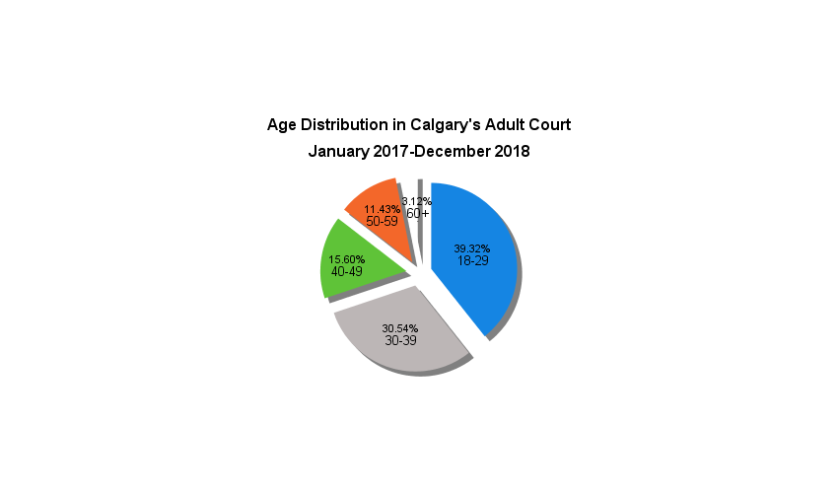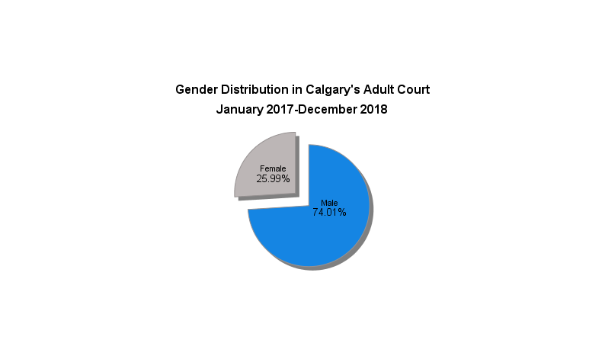

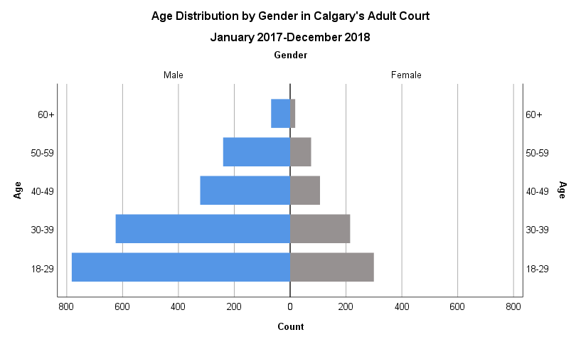

**Figure 1.** A pie chart of gender distribution as observed in Calgary’s Adult Court between January 2017 and December 2018, from a sample size of 2,809. Slice sizes represent the proportion of attendees identifying as a specific gender.

**Figure 2.** A pie chart of age distribution as observed in Calgary’s Adult Court between January 2017 and December 2018, from a sample size of 2,757. Slice size represents the relative proportion of respondents within an age category.

**Figure 3**. A population pyramid representing the frequency (x-axis) of attendee gender (split), stratified by age (y-axis), at Calgary’s Adult Court between January 2017 and December 2018, from a sample size of 2,752.

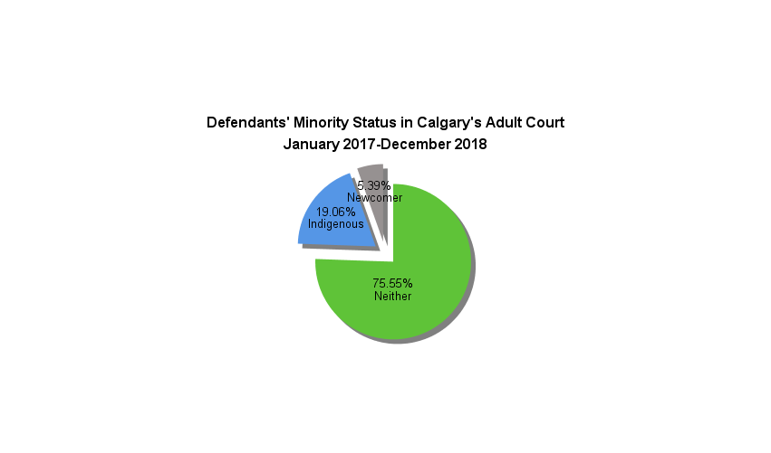It was observed that in defendants receiving services from the Elizabeth Fry Society of Calgary in Calgary’s Adult Court, distribution was heavily concentrated in younger age groups, and in men. Nearly 3 in every four (74.01%) defendants identified as male (Figure 1), while 39.32% reported being under the age of 30 (Figure 2). With men aged 30-39 making up the second largest demographic observed, more than two thirds of defendants served (69.86%) were under the age of 40, with progressively reduced proportions in subsequent age groups (Figure 2). This is reflected in the population pyramid (Figure 3), which is demonstrably bottom-heavy, suggesting a trend towards younger age groups, and left-leaning, suggesting substantial representation of male defendants. Men under 30 represent the most common demographic supported by the organization (Figure 3), making up 28.42% of all defendants, with a prevalence 2.61X that of their age-matched female peers (Figure 3).

**Figure 4.** A pie chart of minority status as observed in Calgary’s Adult Court between January 2017 and December 2018, from a sample size of 2,822. Slice size represents the relative proportion of respondents identifying as part of a minority group.

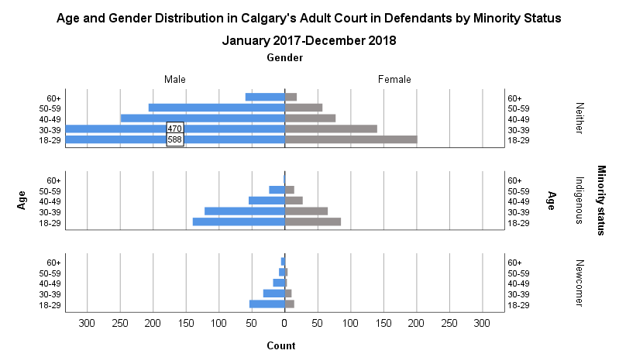

**Figure 5.** A population pyramid representing frequency (x-axis) of attendee gender (split), stratified by age (y-axis), and grouped by minority status at Calgary’s Adult Court between January 2017 and December 2018, from a sample size of 2,750 (neither: 2067, indigenous: 532, newcomers: 151). Values exceeding the scale of the count have been indicated on their respective bar, to allow for ease of observing minority group data.

It was observed that over three quarters of defendants (75.5%) defendants receiving services from the Elizabeth Fry Society of Calgary in Calgary’s Adult Court had no minority status (Figure 4). When stratified by minority status, distribution was heavily concentrated in younger age categories, and in men, across all groupings. This is reflected in the population pyramids (Figure 5), which are demonstrably bottom-heavy, suggesting a trend towards younger age groups, and left-leaning, suggesting substantial representation of male defendants. Men under 30 represent the most common demographic supported by the organization (Figure 5), making up 28.45%, 26.32%, and 35.76% of defendants with no minority, Indigenous, and newcomer status, with a prevalence 2.93X, 1.65X, and 3.86X that of their age-matched female peers, respectively (Figure 5). Reflecting these differences in prevalence ratios, male:female representation is visibly least, and most, divergent in the Indigenous and newcomer groupings respectively (Figure 5).

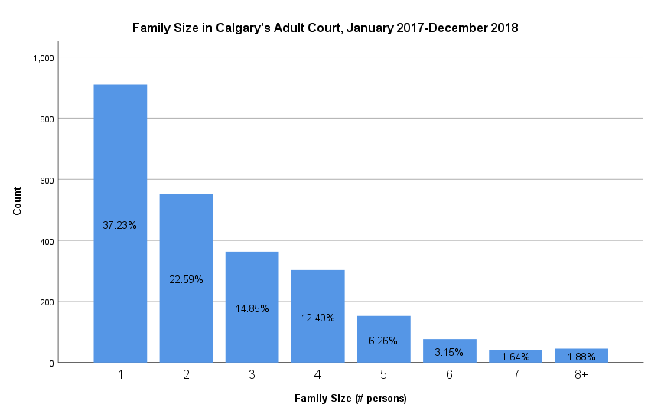

***Figure 6.*** *A bar graph of attendee immediate family size as observed in Calgary’s Adult Court between January 2017 and December 2018, from a sample size of 2444. Bar height corresponds to the number of respondents reporting a given family size (y-axis), with relative proportions of family size categories indicated within the bar.*

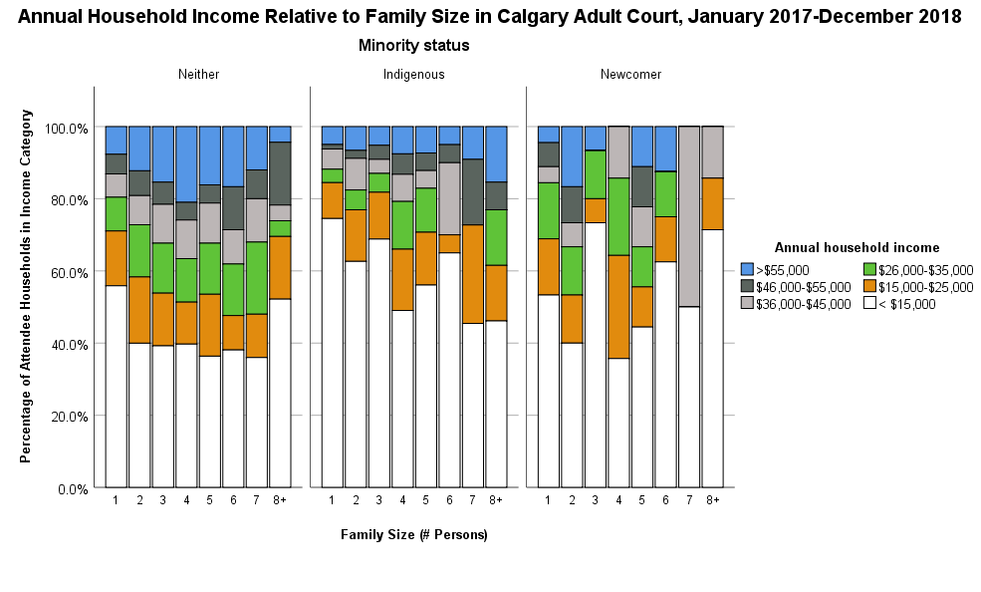

**Figure 7.** Proportion of attendee households (y-axis) in a given income category (colour legend) by family size (x-axis), grouped by minority status, at Calgary’s Adult Court between January 2017 and December 2018. Complete height of bar represents 100% of attendee households in a family size category. This data was generated from a sample size of 2342.

The majority of attendees (37.23%) indicated that they were not part of an immediate family unit (Figure 6). An inverse relationship is observed between family size and attendee count, apart from attendees identifying as being part of a family of 8 (Figure 6). Nuanced observations in specific annual income categories between minority status groupings and family sizes are less apparent (Figure 7). This is particularly true of the newcomer group, which was comprised of only 130 attendees; it is possible that a larger sample size may better uncover potential trends of interest.

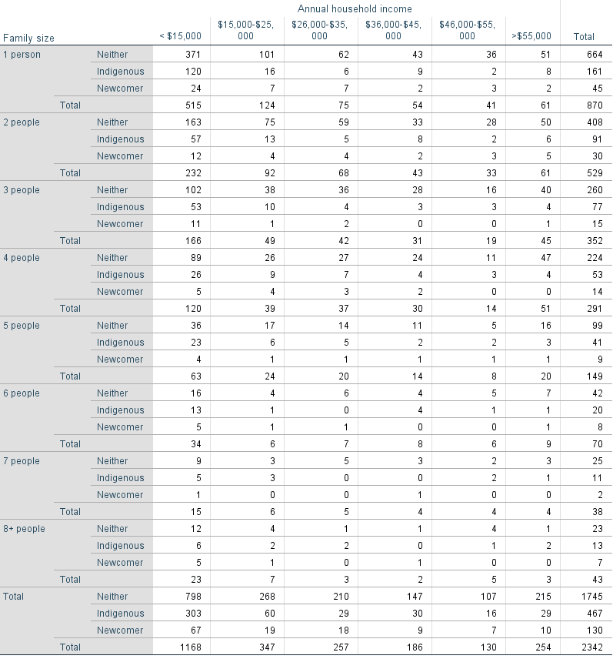

**Table 1.** Number of attendee households in various income categories, stratified by family size and minority status, at Calgary’s Adult Court between January 2017 and December 2018.

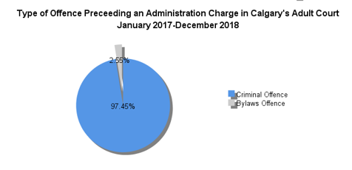However, there exists an observable general trend towards groups with minority status – particularly those identifying as Indigenous – demonstrating a greater proportion of individuals with an annual household income of less than $15,000, and a lesser proportion with more than $55,0000, in contrast to individuals without minority status (Figure 7, Table 1). This observation is corroborated by the odds ratio values for Indigenous families’ annual household incomes, relative to families without minority status. The odds of Indigenous families of one to five members falling below the Market Basket Measure (MBM, Appendix 9.1; Statistics Canada, 2015) value for a living income in Calgary are 2.48X, 2.33X, 3.05X, 2.45X, and 1.94X that of non-Indigenous families of a comparable size, respectively (Table 2).

|  |  |
| --- | --- |
| Indigenous Attendees at Calgary’s Adult Court | |
| Family Size | **Odds Ratio for Living Below the Market Basket Measure for Calgary** |
| 1 | 2.48 |
| 2 | 2.33 |
| 3 | 3.05 |
| 4 | 2.45 |
| 5 | 1.94 |

**Table 2.** Odds of Indigenous attendees in Calgary’s Adult Court, from January 2017-December 2018, living below the Market Basket Measure (MBM) value for Calgary, relative to attendees without minority status.

These values are artificially depressed, owing to limitations associated with data collection. Counts are derived from preestablished income categories (discrete variables), necessitating that categories inclusive of MBM values be excluded. This consequently excludes families whose income falls marginally below the MBM values. Odds ratios have been related to a specific value, such that a group has ‘X odds of being below the appropriate MBM value by at least $Y’. For further information on the calculation and interpretation of these values, please see Appendix 9.2.

**Figure 8.** A pie chart of the type of offence preceding defendants’ administration charges, as observed in Calgary’s Adult Court between January 2017 and December 2018, from a sample size of 314. Slice size represents the relative proportion of respondents convicted of a given offence type.

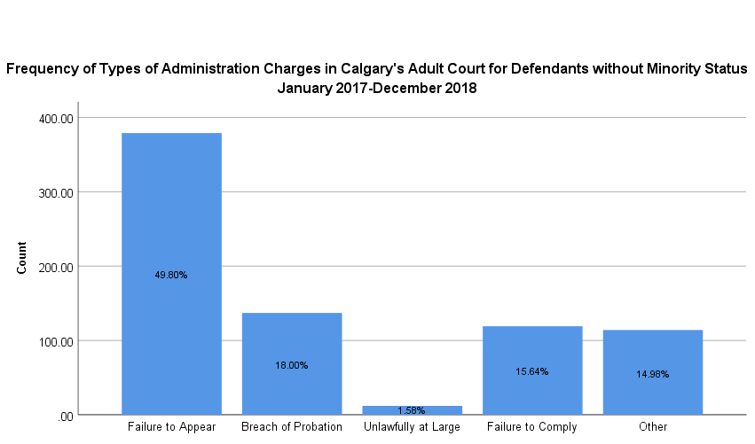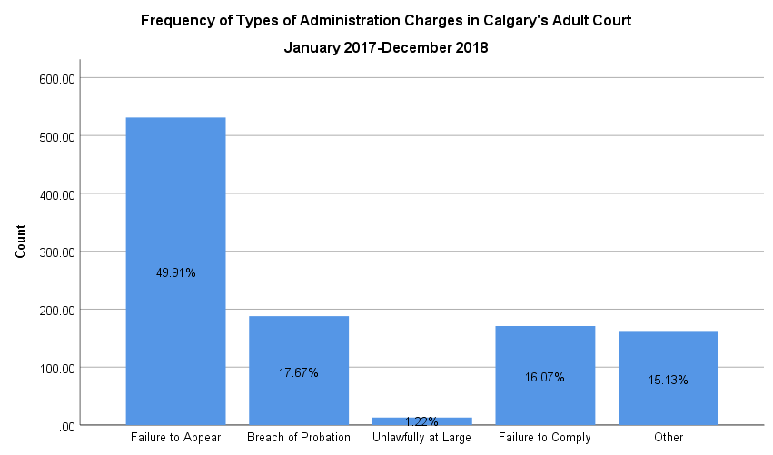

**Figure 10**. A bar graph of the frequency of various types of administration charges for defendants without minority status, as observed in Calgary’s Adult Court between January 2017 and December 2018, from a sample size of 761. Bar height corresponds to the number of respondents with a given charge (y-axis), with relative proportions of charge type categories indicated within the bar.

**Figure 9**. A bar graph of the frequency of various types of administration charges, as observed in Calgary’s Adult Court between January 2017 and December 2018, from a sample size of 1064. Bar height corresponds to the number of respondents with a given charge (y-axis), with relative proportions of charge type categories indicated within the bar.

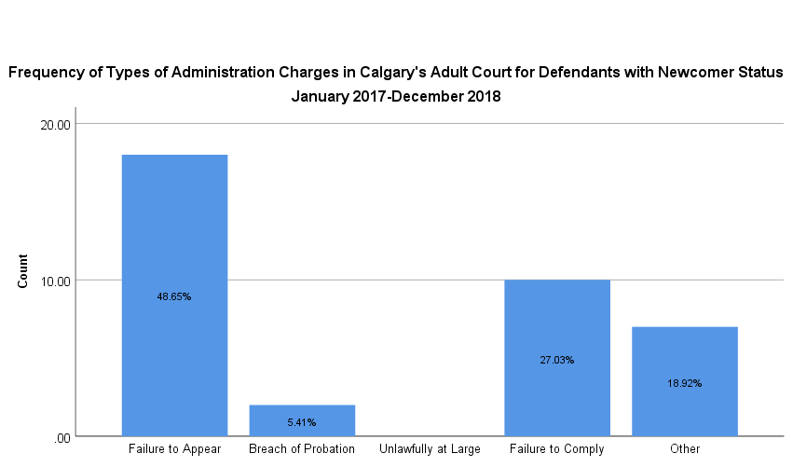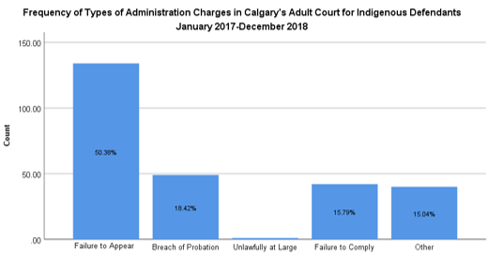

**Figure 12**. A bar graph of the frequency of various types of administration charges for defendants who identify as newcomers, as observed in Calgary’s Adult Court between January 2017 and December 2018, from a sample size of 37. Bar height corresponds to the number of respondents with a given charge (y-axis), with relative proportions of charge type categories indicated within the bar.

**Figure 11**. A bar graph of the frequency of various types of administration charges for defendants who identify as Indigenous, as observed in Calgary’s Adult Court between January 2017 and December 2018, from a sample size of 265. Bar height corresponds to the number of respondents with a given charge (y-axis), with relative proportions of charge type categories indicated within the bar.

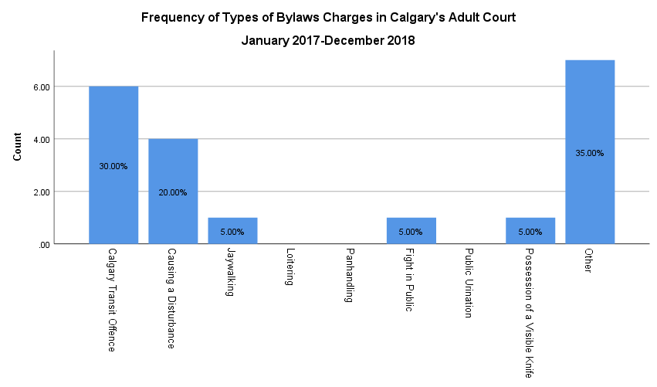The original charges preceding an administration charge in Calgary’s Adult Court were overwhelmingly (97.45%) criminal (Figure 8). ‘Failure to appear’ represented the most frequent administrative charge overall, and across individuals of all minority status (Figures 9, 10, 11, 12). Using the grouping without minority status as a comparator, there existed limited deviation by minority status for ‘failure to appear’, ‘unlawfully at large’, and ‘other’ charges, with a maximum deviation of -1.15%, -1.58%, and +3.94% respectively (Figures 10, 11, 12). Statistically significant differences were apparent in the newcomer group, with deviation for the ‘breach of probation’ offence (X2 = 3.89, p-value = 0.04, p<0.05), such that newcomer attendees had 0.26X the odds of attendees without minority status having this charge in Calgary’s Adult Court. ‘Failure to comply’ charges deviated by -12.59% and +11.39% respectively (Figure 12); further data collection may better elucidate whether this substantial deviation reflects actual differences in frequency between the groups, or if it is attributable to the use of a small sample. Few individuals in Calgary’s Adult Court demonstrated bylaws charges (20); most (7) reported having ‘other’ bylaw charges, while 6 others reported having a ‘Calgary transit offence’. A breakdown of the frequency of bylaw charges across different minority status groups has been omitted, owing to limited data availability.

**Figure 13**. A bar graph of the frequency of various types of bylaws charges, as observed in Calgary’s Adult Court between January 2017 and December 2018, from a sample size of 20. Bar height corresponds to the number of respondents with a given charge (y-axis), with relative proportions of charge type categories indicated within the bar.

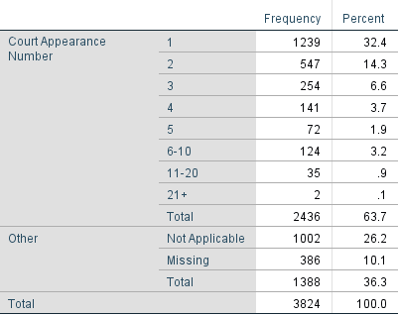It was observed that approximately half (50.86%) of attendees at Calgary’s Adult Court, for which data was available, were at their first court appearance, with an apparent inverse relationship between increasing court appearance number and attendee count (Table 3). The overwhelming majority of attendees (85.58%), for which data was available, reported having no legal representation at court (Table 4). Most (77.53%) attendees received services through the organization of a duration of 0-4 minutes, with an inverse relationship between increasing service length and attendee count (Table 5). Only 1.32% of defendants required support exceeding 15 minutes (Table 5).

**Table 3.** Frequency and proportion of Calgary’s Adult Court attendees by appearance number, between January 2017 and December 2018.

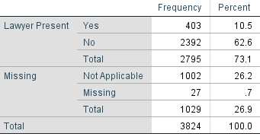

**Table 4.** Frequency and proportion of Calgary’s Adult Court attendees with legal representation, between January 2017 and December 2018.

**Table 5.** Frequency and proportion of Calgary’s Adult Court attendees by duration of service provision, between January 2017 and December 2018.

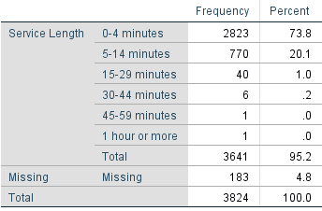

## North Adult Court

**Figure 14.**  A pie chart of gender distribution as observed in the North Adult Courts between January 2017 and Dec/ember 2018, from a sample size of 3345. Slice sizes represent the proportion of attendees identifying as a specific gender.

**Figure 15.** A pie chart of age distribution as observed in the North Adult Courts between January 2017 and December 2018, from a sample size of 3326. Slice size represents the relative proportion of respondents within an age category.

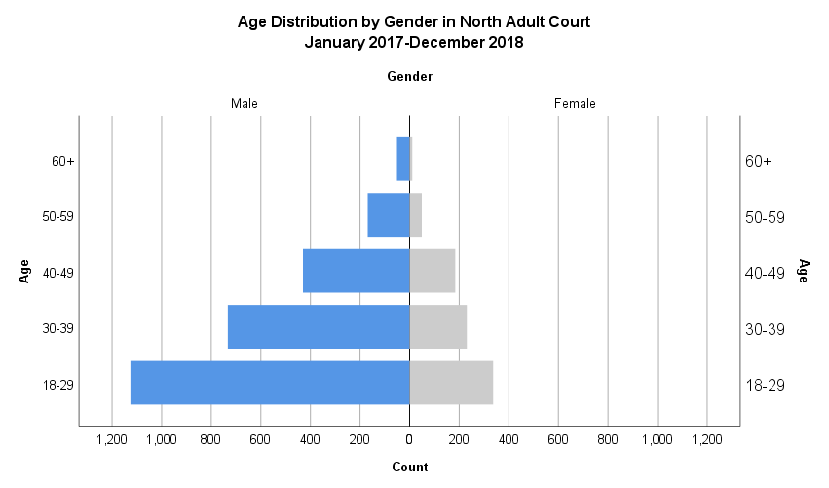  
It was observed that in defendants receiving services from the Elizabeth Fry Society of Calgary in the North Adult Courts, distribution was heavily concentrated in younger age groups, and in men. This is reflected in the population pyramid (Figure 16), which is demonstrably bottom-heavy, suggesting a trend towards younger age groups, and left-leaning, suggesting substantial representation of male defendants. More than 3 in 4 (75.61%) defendants identified as male (Figure 14), while 43.99% reported being under the age of 30 (Figure 15). Men under 30 represent the most common demographic supported by the organization, making up 33.91% of all defendants, with a prevalence 3.34X that of their age-matched female peers (Figure 16). With men aged 30-39 making up the second largest demographic observed, more than half of defendants served (55.98%) were under the age of 40, with progressively reduced proportions in subsequent age groups (Figure 16).

**Figure 16**. A population pyramid representing the frequency (x-axis) of attendee gender (split), stratified by age (y-axis), at the North Adult Courts between January 2017 and December 2018, from a sample size of 3321.

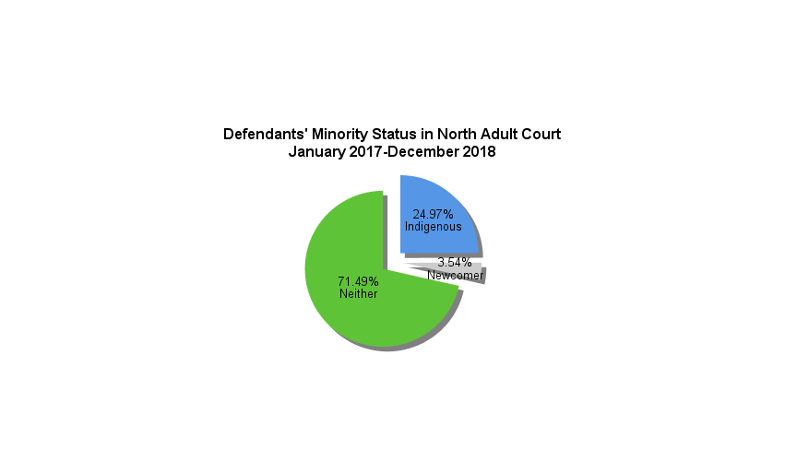

**Figure 17.** A pie chart of minority status distribution as observed in the North Adult Courts between January 2017 and December 2018, from a sample size of 3360. Slice size represents the relative proportion of respondents identifying as part of a minority group.

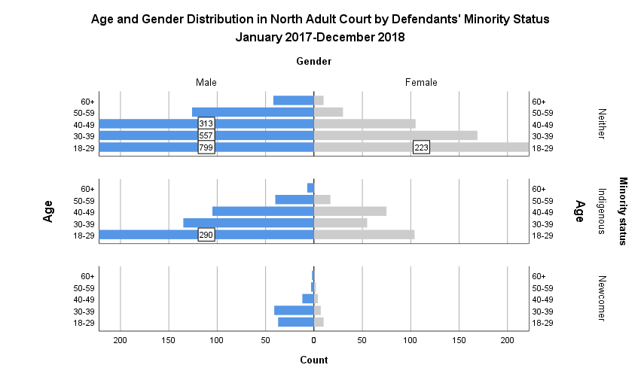

**Figure 18.** A population pyramid representing the frequency (x-axis) of attendee gender (split), stratified by age (y-axis), and grouped by minority status at the North Adult Courts between January 2017 and December 2018, from a sample size of 3320 (neither: 2374, Indigenous: 828, newcomers: 118). Values exceeding the scale of the count have been indicated within their respective bar, to allow for ease of observing minority group data.

It was observed that nearly three in four (71.49%) defendants receiving services from the Elizabeth Fry Society of Calgary in the North Adult Courts had no minority status (Figure 17). When stratified by minority status, distribution was heavily concentrated in younger age categories, and in men, across all groupings. This is reflected in the population pyramids (Figure 18), which are demonstrably bottom-heavy, suggesting a trend towards younger age groups, and left-leaning, suggesting substantial representation of male defendants. In individuals without minority status, and those identifying as Indigenous, individuals under 30 represent the most common demographic supported, making up 33.66% and 35.02% of defendants with no minority and Indigenous status, with a prevalence 3.58X and 2.79X that of their age-matched female peers, respectively (Figure 18). In defendants of newcomer status, individuals within the under 30 and 30-39 age groups represented the most common demographics supported, making up 31.36% and 34.75% of individuals supported, with a prevalence 3.71X and 5.86X that of their age-matched female peers, respectively (Figure 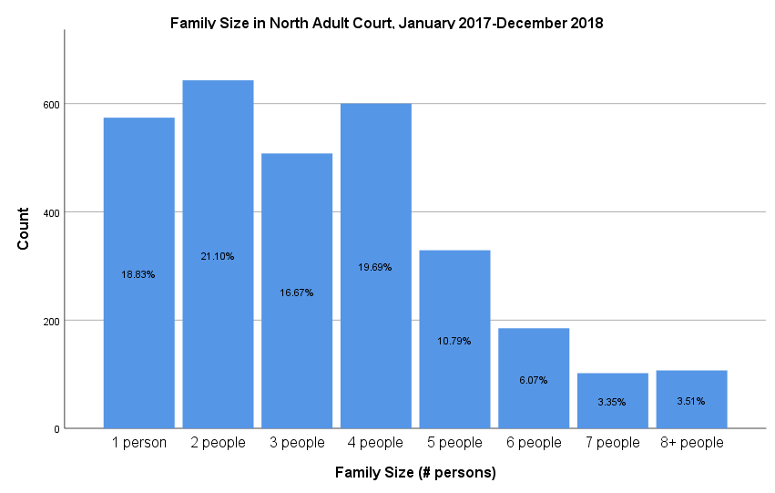18).

***Figure 19.*** *A bar graph of attendee family size as observed in the North Adult Courts between January 2017 and December 2018, from a sample size of 3069. Bar height corresponds with the number of respondents reporting a given family size (y-axis), with relative proportions of family size categories indicated within the bar.*

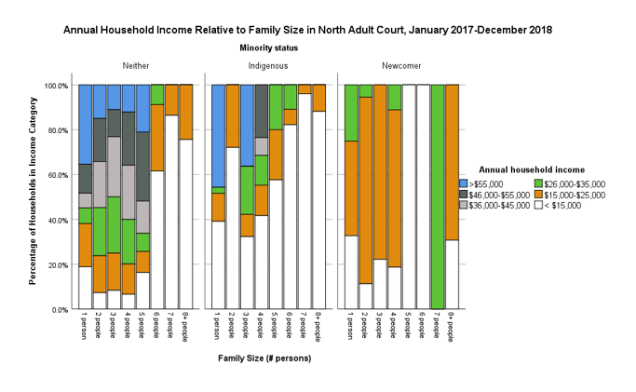

**Figure 20.** Proportion of attendee households (y-axis) in a given income category (colour legend) by family size (x-axis), grouped by minority status, at the North Adult Courts between January 2017 and December 2018. Bar height represents 100% of attendee households in a family size category. This data was generated from a sample size of 3017.

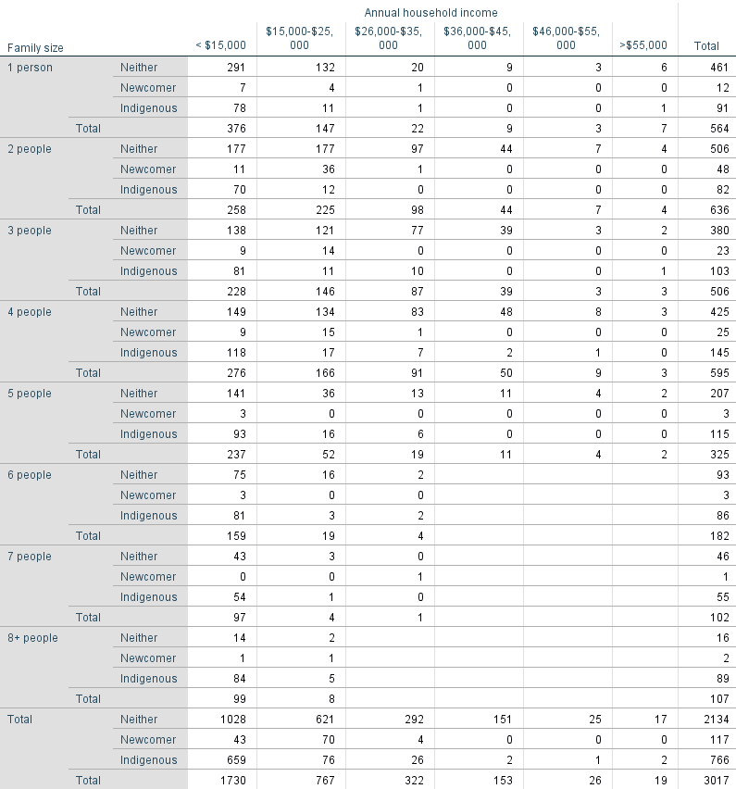

**Table 6.** Number of attendee households in various income categories, stratified by family size and minority status, at the North Adult Courts between January 2017 and December 2018.

The majority (76.29%) of attendees indicated that they were part of an immediate family unit of four or fewer individuals, with attendees most commonly (21.10%) being part of a family of two (Figure 19). Generally, an inverse relationship is observed between family size and attendee count (Figure 19). Across all minority status groupings, there was a trend towards the proportion of households making less than $15,000

annually increasing with family size (Figure 20). The lowest income categories are overwhelmingly represented within both the Indigenous and newcomer grouping, across all family sizes (Figure 20).

|  |  |
| --- | --- |
| Indigenous Attendees at the North Adult Courts | |
| Family Size | **Odds Ratio for Living Below the Market Basket Measure for Rural AB** |
| 1 | 5.09 |
| 3 | 15.63 |
| 4 | 3.10 |

There exists an observable general trend towards groups with minority status demonstrating a greater proportion of individuals with an annual household income of less than $15,000, and a lesser proportion with more than $55,0000, in contrast to individuals without minority status (Figure 20, Table 6). This observation is corroborated by the odds ratio values for Indigenous families’ annual household income, relative to families without minority status. The odds of Indigenous families of one, three, and four members falling below the Market Basket Measure (MBM, Appendix 9.1; Statistics Canada, 2015) value for a living income in rural Alberta are 5.09X, 15.63X, and 3.10X that of non-Indigenous families of a comparable size, respectively (Table 7). No values were calculated for families of two or five, owing to a deficit of individuals living above the MBM. These values are artificially depressed, owing to limitations associated with data collection. Counts are derived from preestablished income categories (discrete variables), necessitating that categories inclusive of MBM values be excluded. This excludes families whose income falls marginally below the MBM values. Odds ratios have been related to a specific value, such that a group has ‘X odds of being below the appropriate MBM value by at least $Y’. For further information on the calculation and interpretation of these values, please see Appendix 9.2.

**Figure 21.** A pie chart of the type of offence preceding defendants’ administration charges, as observed in the North Adult Courts between January 2017 and December 2018, from a sample size of 122. Slice size represents the relative proportion of respondents convicted of a given offence type.

**Table 7.** Odds of Indigenous attendees in the North Adult Courts, from January 2017-December 2018, living below the Market Basket Measure (MBM) value for Calgary, relative to attendees without minority status.

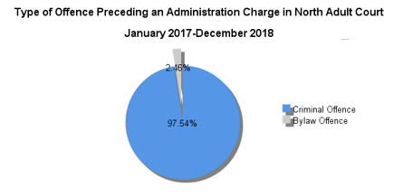

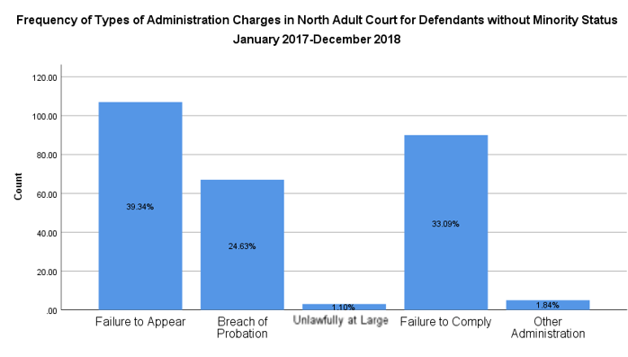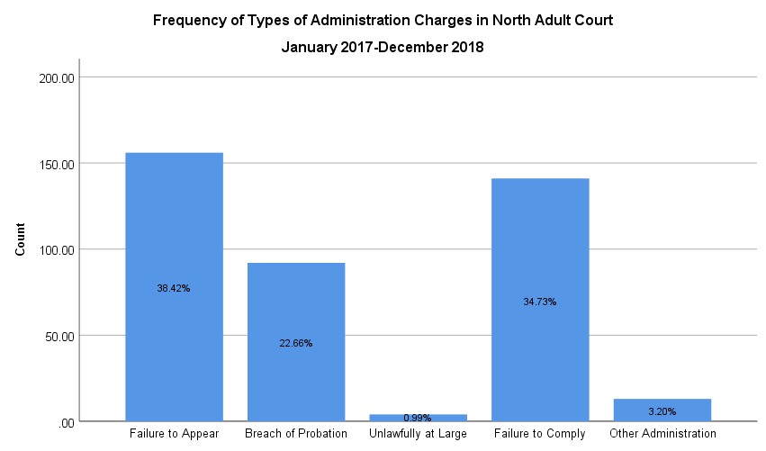

**Figure 22**. A bar graph of the frequency of various types of administration charges for defendants without minority status, as observed in North Adult Courts between January 2017 and December 2018, from a sample size of 272. Bar height corresponds to the number of respondents with a given charge (y-axis), with relative proportions of charge type categories within the bar.

**Figure 21**. A bar graph of the frequency of various types of administration charges, as observed in the North Adult Courts between January 2017 and December 2018, from a sample size of 406. Bar height corresponds to the number of respondents with a given charge (y-axis), with relative proportions of charge type categories indicated within the bar.

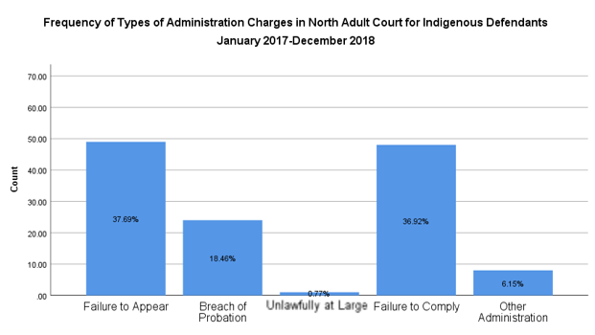**Figure 23.** A bar graph of the frequency of various types of administration charges for defendants who identify as Indigenous, as observed in the North Adult Courts between January 2017 and December 2018, from a sample size of 130. Bar height corresponds to the number of respondents with a given charge (y-axis), with relative proportions of charge type categories indicated within the bar.

Overall, the original charges preceding an administration charge in the North Adult Courts were overwhelmingly (97.54%) criminal (Figure 21). ‘Failure to appear’ and ‘failure to comply’ represented the most frequent administrative charges overall, and across individuals of Indigenous no minority status (Figure 21). Statistics for the newcomer group have been omitted, owing to limited data availability. In the Indigenous group there existed limited deviation from the frequencies observed in individuals of no minority status for the frequency of administration charges for ‘failure to appear’, ‘unlawfully at large’, and ‘failure to comply’ charges, demonstrating a maximum difference of 1.65%, 0.33%, and 3.38% respectively (Figure 23). A statistically significant difference was observed in the frequency of ‘other’ administration charges (X2 = 5.24, p-value = 0.02, p<0.05), with indigenous court attendees demonstrating 3.50X the odds of attendees without minority status of having this charge in the North Adult Courts. Notably, there was deviation from the ‘breach of probation’ charges by -16.17% (Figure 23). Too few individuals (1) in the North Adult Courts demonstrated bylaws charges to warrant further analysis.

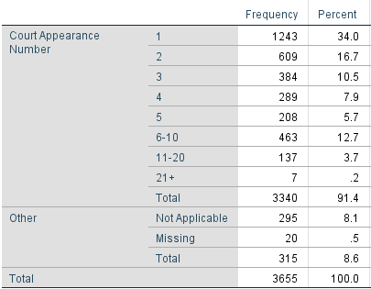Most frequently (37.22%), attendees at the North Adult Courts, for which data was available, were at their first court appearance, with an apparent inverse relationship between increasing court appearance number and attendee count (Table 8). Most (78.19%) attendees received services through the organization of a duration of 0-4 minutes, with an inverse relationship between increasing service length and attendee count (Table 9). Only 1.84% of defendants required support exceeding 15 minutes (Table 9). The majority of attendees (75.14%) reported having no legal representation at court (Table 10).

**Table 8.** Frequency and proportion of North Adult Court attendees by number of court appearances, between January 2017 and December 2018.

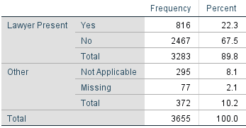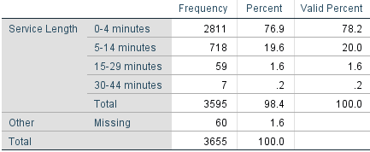

**Table 10.** Frequency and proportion of North Adult Court attendees with legal representation, between January 2017 and December 2018.

**Table 9.** Frequency and proportion of North Adult Court attendees by duration of service provision, between January 2017 and December 2018.

## South Adult Court

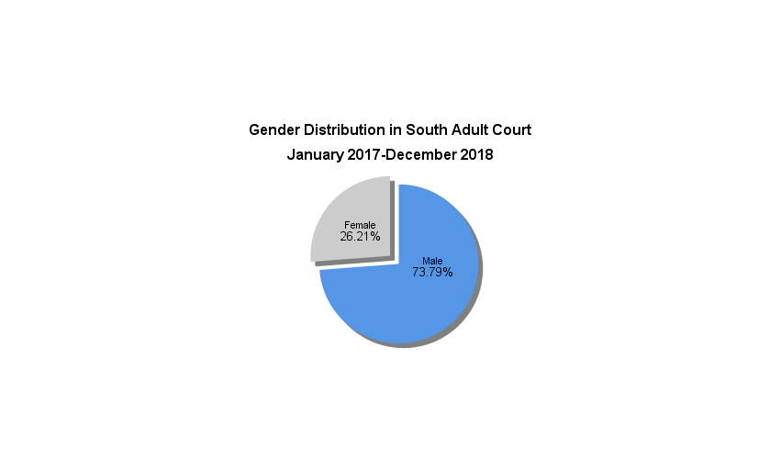

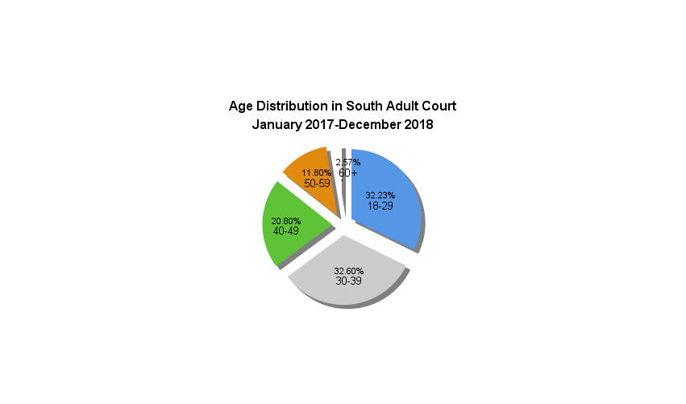

**Figure 25.** A pie chart of age distribution as observed in the South Adult Courts between January 2017 and December 2018, from a sample size of 1865. Slice size represents the relative proportion of respondents within an age category.

**Figure 24.**  A pie chart of gender distribution as observed in the South Adult Courts between January 2017 and December 2018, from a sample size of 1877. Slice sizes represent the proportion of attendees identifying as a specific gender.

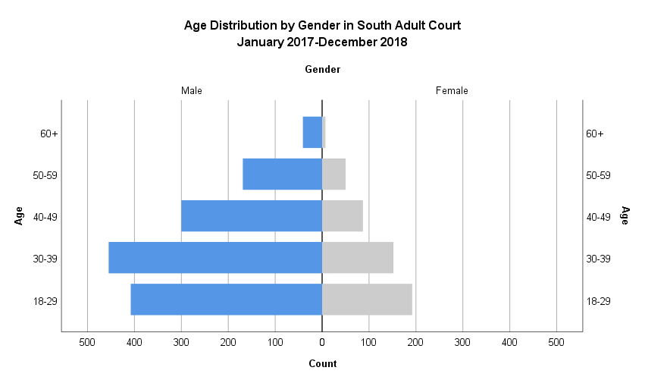

**Figure 26**. A population pyramid representing the frequency (x-axis) of attendee gender (split), stratified by age (y-axis), at the South Adult Courts between January 2017 and December 2018, from a sample size of 1861.

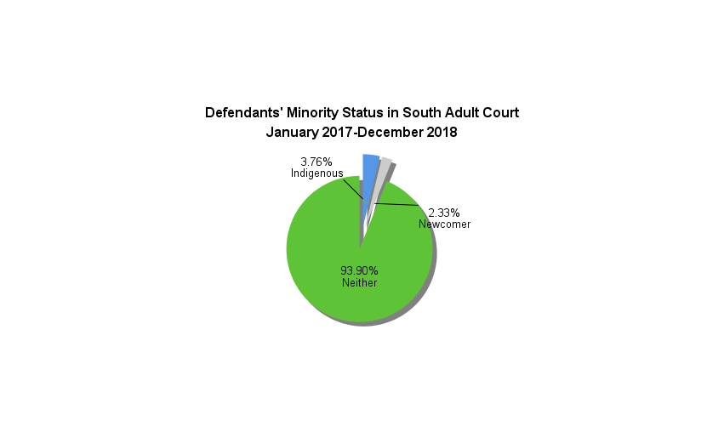It was observed that in defendants receiving services from the Elizabeth Fry Society of Calgary in the South Adult Courts, distribution was largely concentrated in younger age groups, and in men. This is reflected in the population pyramid (Figure 26), which is demonstrably bottom-heavy, suggesting a trend towards younger age groups, and left-leaning, suggesting substantial representation of male defendants. Nearly 3 in 4 (73.79%) defendants identified as male (Figure 24), while 32.23% reported being under the age of 30 and 32.60% being 30-39 (Figure 25). Men under 30, and between 30-39, represent the most common demographics supported by the organization, making up 21.92% and 24.45% of all defendants, with a prevalence 2.13X and 2.99X that of their age-matched female peers respectively (Figure 26). Progressively reduced proportions are observed in subsequent age groups of both gender categories (Figure 26).

**Figure 27.** A pie chart of minority status distribution as observed in the South Adult Courts between January 2017 and December 2018, from a sample size of 1886. Slice size represents the relative proportion of respondents identifying as part of a minority group.

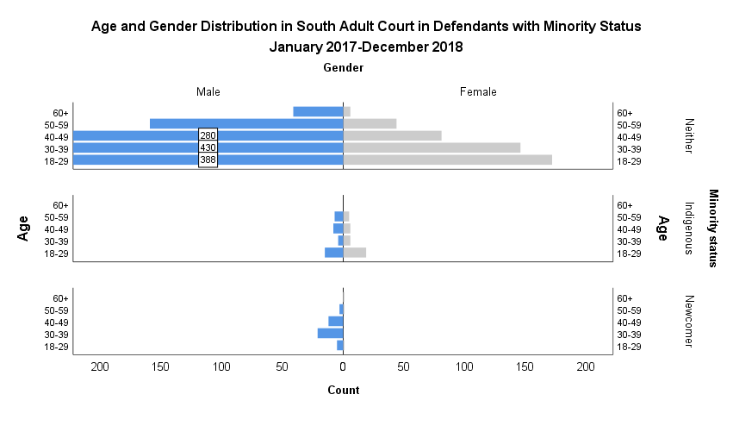

**Figure 28.** A population pyramid representing frequency (x-axis) of attendee gender (split), stratified by age (y-axis), and grouped by minority status at the South Adult Courts between January 2017 and December 2018, from a sample size of 1858 (neither: 1747, Indigenous: 70, newcomers: 41). Values exceeding the scale of the count have been indicated within their respective bar, to allow for ease of observing minority group data.

It was observed that the overwhelming majority (93.90%) of defendants receiving services from the Elizabeth Fry Society of Calgary in the South Adult Courts had no minority status (Figure 27). When stratified by minority status, distribution was concentrated in men, across all groupings. This is reflected in the population pyramids (Figure 28), which are demonstrably left-leaning, suggesting substantial representation of male defendants. Between minority status groupings, the pattern of distribution is not always clear.

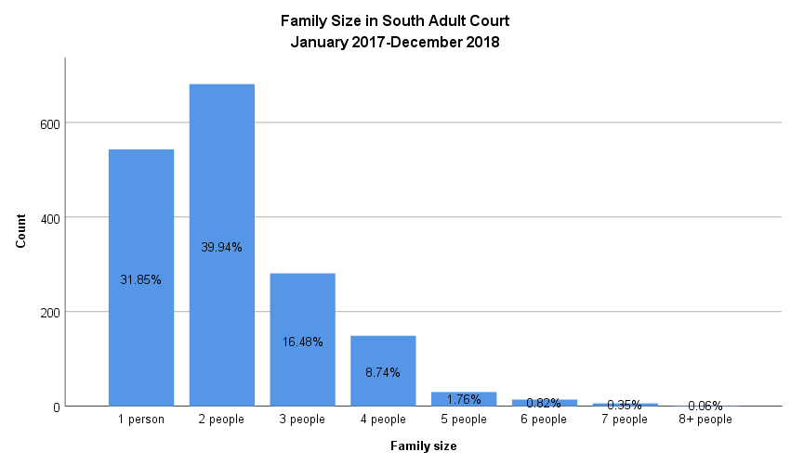In individuals without minority status, there is a trend towards younger age groupings. Men under 30, and 30-39 represent the most common demographics, amongst those without minority status supported by the organization, making up 22.21% and 24.61% of defendants with no minority status, with a prevalence 2.26X and 2.95X that of their age-matched female peers, respectively (Figure 28). The relationships observed in Indigenous and newcomer defendants are less clear owing to the relatively small sample sizes, however it appears that distribution across age groups may be more evenly distributed (Figure 28). This is not true of the newcomer group, who did not have any female defendants, with the bulk of defendants seemingly in the 30-39 and 40-49 age groups (Figure 28). More data would be necessary to better elucidate the nature and strength of these relationships.

**Figure 29.** A bar graph of attendee family size (x-axis) as observed in the South Adult Courts between January 2017 and December 2018, from a sample size of 3048. Bar height corresponds to the number of respondents reporting a given family size (y-axis), with relative proportions of family size categories indicated within the bar.

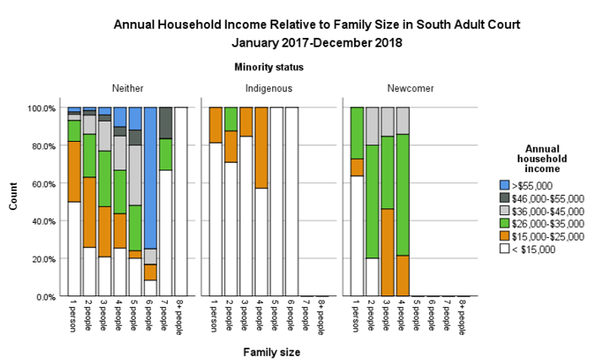

**Figure 30.** Proportion of attendee households (y-axis) in a given income category (colour legend) by family size (x-axis), grouped by minority status, at the South Adult Courts between January 2017 and December 2018. Bar height represents 100% of attendee households in a family size category. This data was generated from a sample size of 1658.

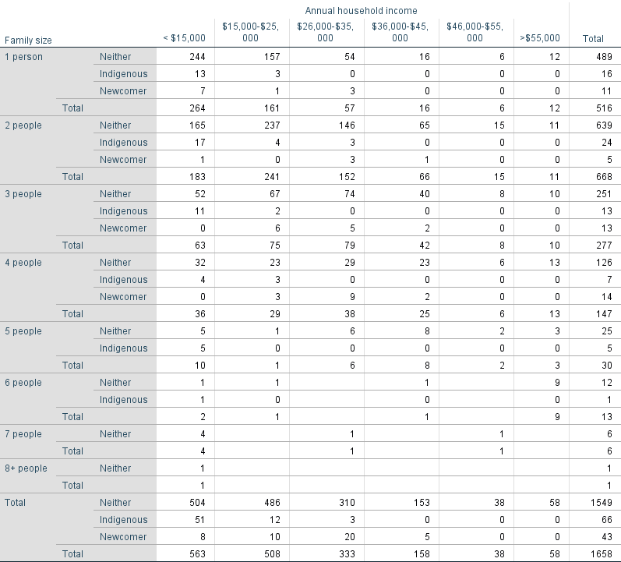It was observed that the greater portion (39.94%) of attendees indicated that they were part of a two person family unit (Figure 29). An inverse relationship is observed between family size and attendee count (Figure 29).

**Table 11**. Number of attendee households in various income categories, stratified by family size and minority status, at the South Adult Courts between January 2017 and December 2018.

There exists an observable general trend towards groups with minority status – particularly those identifying as Indigenous – demonstrating a greater proportion of individuals with an annual household income of less than $15,000, and a lesser proportion with more than $55,0000, in contrast to individuals without minority status (Figure 30, Table 11). The odds of Indigenous families falling below the Market Basket Measure (MBM, Appendix 9.1; Statistics Canada, 2015) value for a living income in rural Alberta relative to non-Indigenous families of a comparable size is considerable, however frequently impossible to quantify owing to the fact that there were no Indigenous or newcomer status families of any size living above the MBM values. The one 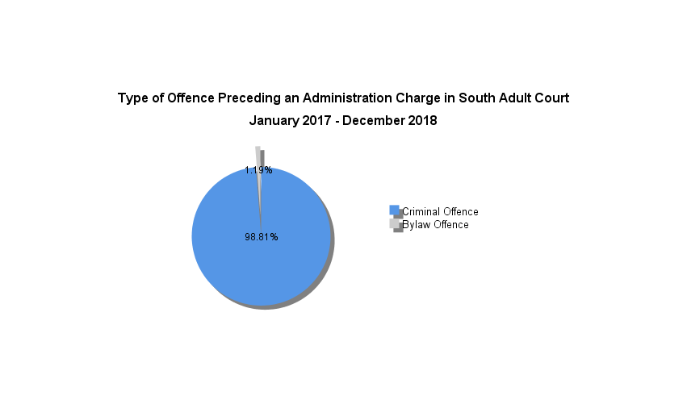calculation that could be completed suggested that attendees who are newcomers with families of 3, have 1.46X the odds of attendees with families of 3 and no minority status, of living below the MBM values for rural Alberta.

**Figure 31.** A pie chart of the type of offence preceding defendants’ administration charges, as observed in the South Adult Courts between January 2017 and December 2019, from a sample size of 84. Slice size represents the relative proportion of respondents convicted of a given offence type.

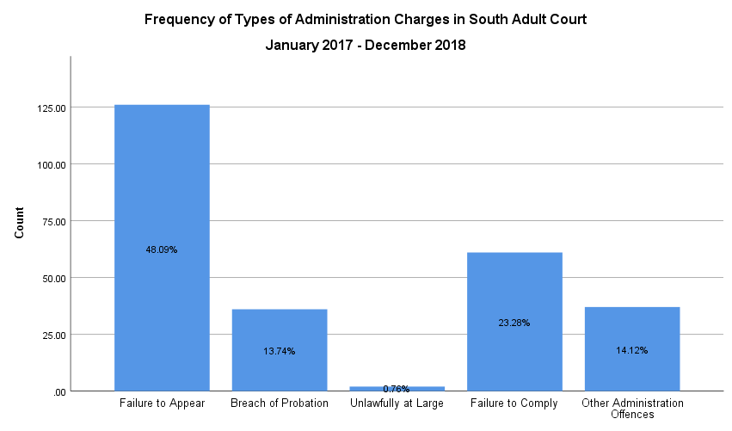

**Figure 32**. A bar graph of the frequency of various types of administration charges, as observed in the South Adult Courts between January 2017 and December 2018, from a sample size of 262. Bar height corresponds to the number of respondents with a given charge (y-axis), with relative proportions of charge type categories indicated within the bar.

Overall, the original charges preceding an administration charge in the South Adult Courts were overwhelmingly (98.81%) criminal (Figure 31). ‘Failure to appear’ represented the most frequent administrative charge overall (Figure 32). Statistics for administration and bylaw charge type by minority group have been omitted, owing to limited data availability.

It was observed that most (30.91%) attendees at the South Adult Courts, for which data was available, were at their first court appearance, with an apparent inverse relationship between increasing court appearance number and attendee count. The overwhelming majority of attendees (82.74%), for which data was available, reported having no legal representation at court (Table 13). Most (57.82%) attendees received services through the organization of a duration of 0-4 minutes, with an inverse relationship between increasing service length and attendee count (Table 14). Only 3.30% of defendants required support exceeding 15 minutes (Table 14).

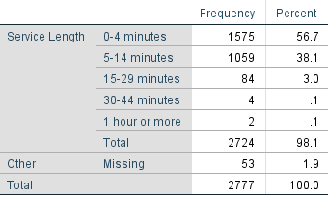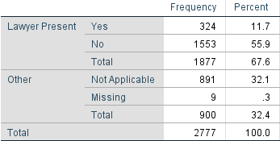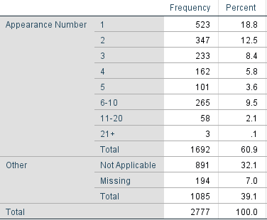

**Table 14.** Frequency and proportion of the South Adult Court attendees by duration of service provision, between January 2017 and December 2018.

**Table 13.** Frequency and proportion of the South Adult Court attendees with legal representation, between January 2017 and December 2018.

**Table 12.** Frequency and proportion of the South Adult Court attendees by number of court appearances, between January 2017 and December 2018.

## Calgary Youth Court

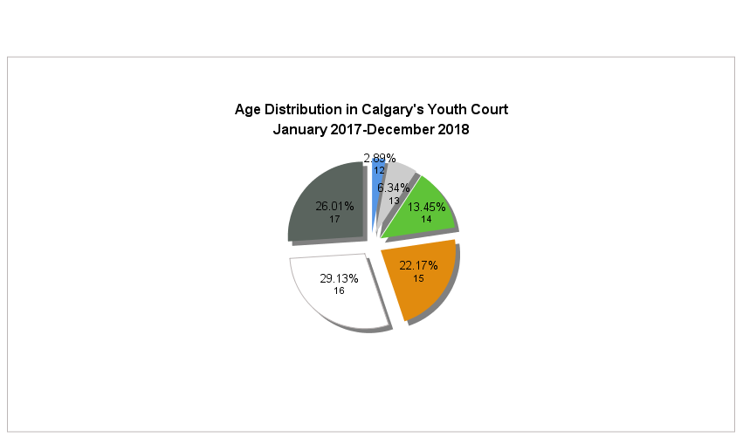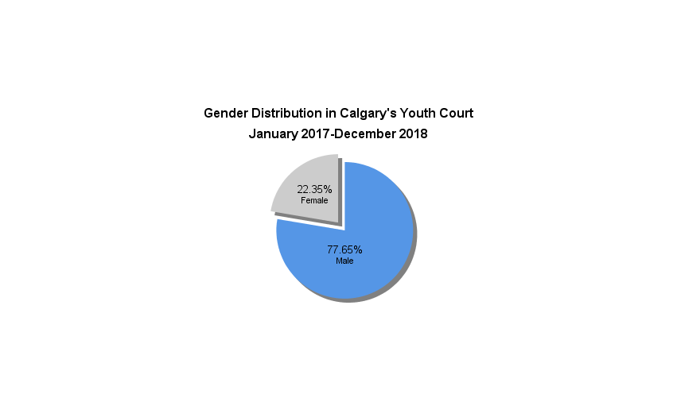

**Figure 33.**  A pie chart of gender distribution as observed in Calgary’s Youth Court between January 2017 and December 2018, from a sample size of 3951. Slice sizes represent the proportion of attendees identifying as a specific gender.

**Figure 34.** A pie chart of age distribution as observed in Calgary’s Youth Court between January 2017 and December 2019, from a sample size of 3910. Slice size represents the relative proportion of respondents within an age category.

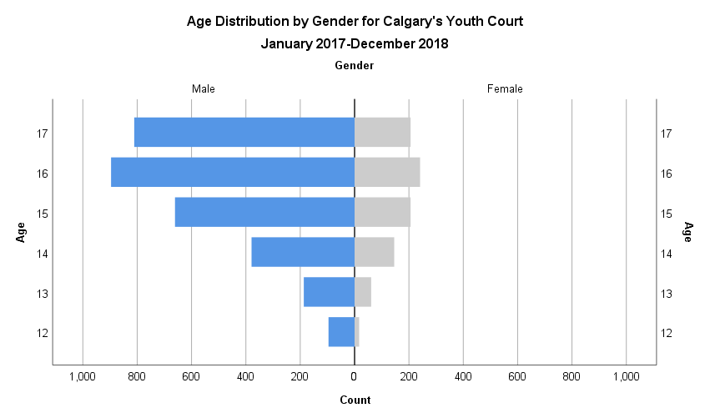

**Figure 35**. A population pyramid representing the frequency (x-axis) of attendee gender (split), stratified by age (y-axis), at Calgary’s Youth Court between January 2017 and December 2018, from a sample size of 3907.

It was observed that in defendants receiving services from the Elizabeth Fry Society of Calgary in Calgary’s Youth Court, distribution was heavily concentrated in older age categories, and in males. This is reflected in the population pyramid (Figure 35), which is demonstrably top-heavy, suggesting a trend towards older age groups, and left-leaning, suggesting substantial representation of male defendants. More than 3 in 4 (77.65%) defendants identified as male (Figure 33), while 55.14% reported being 16 or older (Figure 34). Boys aged 16 and 17 represent the most common demographic supported by the organization (Figure 35), making up 22.93% and 20.76% of all defendants, with a prevalence 3.72X and 3.94X that of their age-matched female peers, respectively (Figure 35). Progressively reduced proportions are observed with decreasing age (Figure 35).

**Figure 36.** A pie chart of minority status as observed in Calgary’s Youth Court between January 2017 and December 2018, from a sample size of 3963. Slice size represents the relative proportion of respondents identifying as part of a minority group.

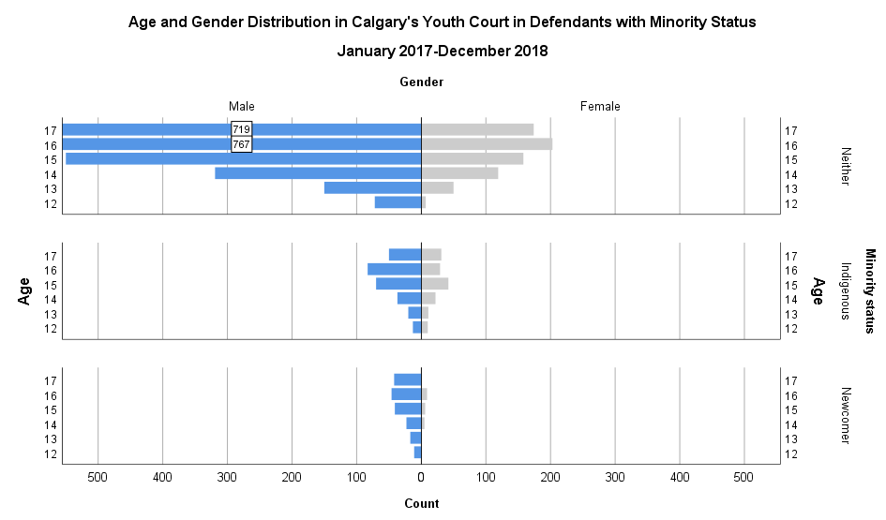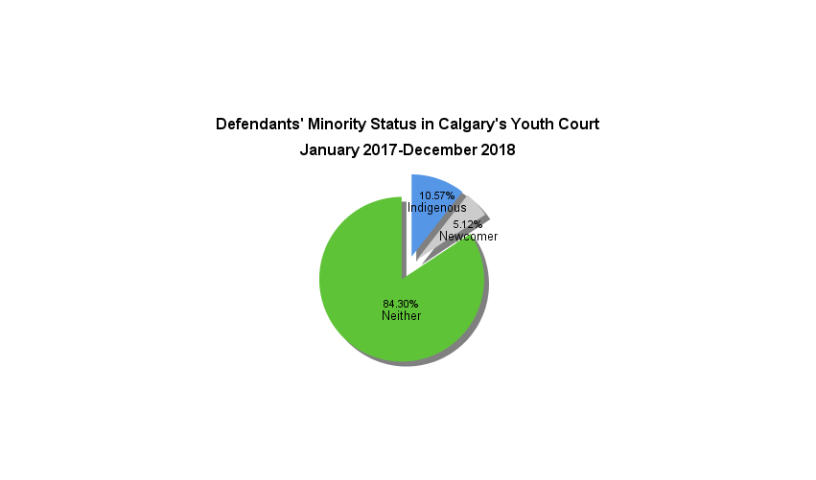It was observed that the overwhelming majority (84.30%) of defendants receiving services from the Elizabeth Fry Society of Calgary in Calgary’s Youth Court had no minority status (Figure 36). When stratified by minority status, distribution was heavily concentrated in older age categories, and in males, across all groupings. This is reflected in the population pyramids (Figure 37), which are demonstrably top-heavy, suggesting a trend towards older age groups, and left-leaning, suggesting substantial representation of male defendants. Male defendants aged 15-17 represented the most common demographics supported by the organization (Figure 37).

**Figure 37.** A population pyramid representing frequency (x-axis) of attendee gender (split), stratified by age (y-axis), and grouped by minority status at Calgary’s Youth Court between January 2017 and December 2018, from a sample size of 3906 (neither: 3288, Indigenous: 418, newcomers: 200). Values exceeding the scale of the count have been indicated on their respective bar, to allow for ease of observing minority group data.

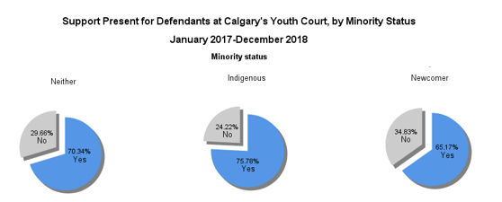Male defendants aged 16 and 17 made up 23.33% and 21.87% of defendants with no minority status, with a prevalence 3.78X and 4.13X that of their age-matched female peers, respectively (Figure 37). Male defendants aged 15 and 16 only made up 16.75% and 19.86% of defendants with Indigenous status, with a prevalence 1.69X and 2.86X, that of their age-matched female peers, respectively (Figure 37). While the newcomer group did not demonstrate distinct age groups encompassing a significant majority of defendants, there exists a visible and gradual trend towards older age groups, with males aged 15 and older cumulatively accounting for 64.50% of defendants, with an overall prevalence 8.60X that of their age-matched female peers, respectively (Figure 37). Reflecting these differences in prevalence ratios, male:female representation is least, and most, divergent in the Indigenous and newcomer groupings, respectively (Figure 37).

**Figure 38.** Pie charts representing the presence of support in court as observed in Calgary’s Youth Court, by minority status, between January 2017 and December 2018, from a sample size of 3929 (3311 attendees without minority status, 417 Indigenous, and 201 attendees who are newcomers). Slice size represents the relative proportion of respondents reporting the presence or absence of supports on the day of data acquisition.

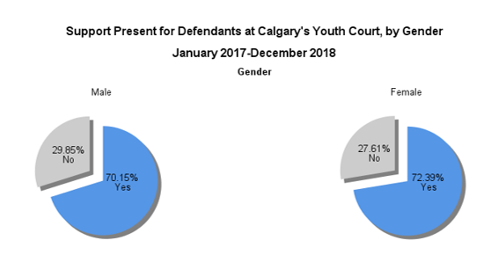

Figure 39. Pie charts representing the presence of support in court by gender as observed in Calgary’s Youth Court between January 2017 and December 2018, from a sample size of 3925 (3052 male and 873 female attendees). Slice size represents the relative proportion of respondents reporting the presence or absence of supports on the day of data acquisition.

It was observed that most attendees in Calgary’s Youth Court attended with support, across all minority status categories (Figure 38). Of the minority classifications, Indigenous youth most frequently reported support (75.78%), while newcomer youth least frequently (65.17%) reported support (Figure 38). It was discovered that a statistically significant relationship existed between Indigenous status and the presence of support (X2=5.31, p=0.02 at p<0.05), with Indigenous youth having 1.32X the odds of having support relative to youth without minority status. It was discovered that no statistically significant relationship existed between newcomer status and the presence of support (X2=5.31, p=0.02 at p<0.05).

Between the genders of Calgary youth court attendees (Figure 39), female attendees were marginally more likely to report having support present (72.39%) than male attendees (70.15%). However, it was discovered that no statistically significant relationship existed between gender and the presence of support in youth court (X2=1.65, p=0.20 at p<0.05).

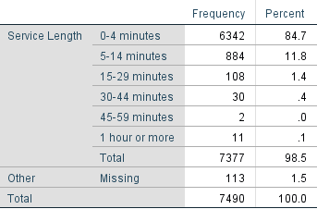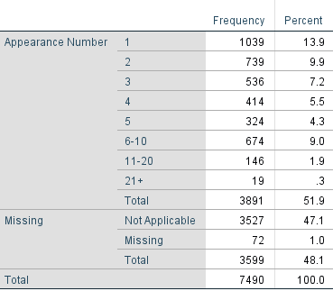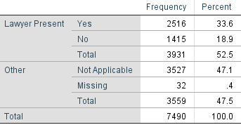It was observed that most (26.70%) of the attendees at Calgary’s Youth Court were at their first court appearance, with an apparent inverse relationship between increasing court appearance number and attendee count (Table 15). Most attendees (64.00%), for which data was available, reported having legal representation at court (Table 16). Most (85.97%) of the attendees received services through the organization of a duration of 0-4 minutes, with an inverse relationship between increasing service length and attendee count (Table 17). Only 2.05% of defendants required support exceeding 15 minutes (Table 17).

**Table 17.** Frequency and proportion of Calgary’s Youth Court attendees by duration of service provision, between January 2017 and December 2018.

**Table 16.** Frequency and proportion of Calgary’s Youth Court attendees with legal representation, between January 2017 and December 2018.

**Table 15.** Frequency and proportion of Calgary’s Youth Court attendees by number of court appearances, between January 2017 and December 2018.

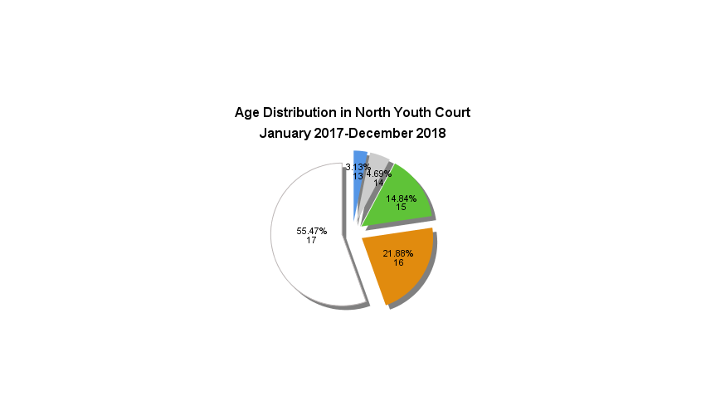

## North Youth Courts

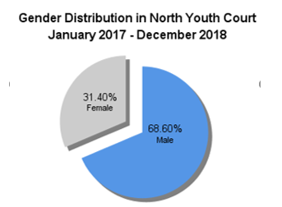

**Figure 41.** A pie chart of age distribution as observed in the North Youth Courts between January 2017 and December 2018, from a sample size of 128. Slice size represents the relative proportion of respondents within an age category.

**Figure 40.**  A pie chart of gender distribution as observed in the North Youth Courts between January 2017 and December 2018, from a sample size of 172. Slice sizes represent the proportion of attendees identifying as a specific gender.

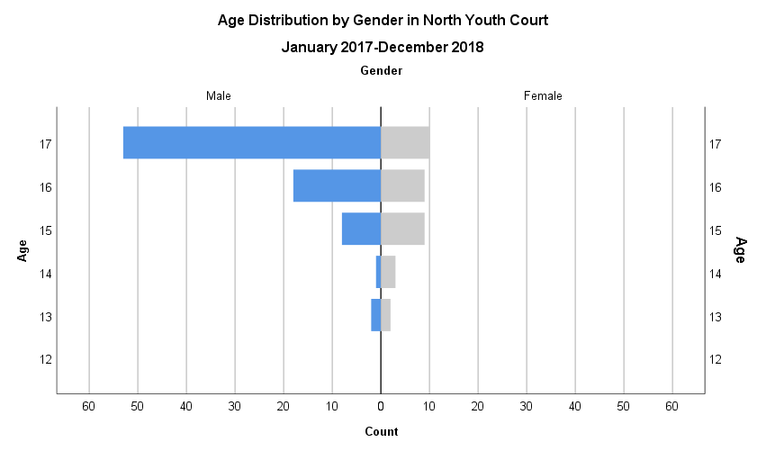

**Figure 42**. A population pyramid representing the frequency (x-axis) of attendee gender (split), stratified by age (y-axis), at the North Youth Courts between January 2017 and December 2018, from a sample size of 115.

It was observed that in defendants receiving services from the Elizabeth Fry Society of Calgary in the North Youth Courts, distribution was heavily concentrated in older age categories, and in males. This is reflected in the population pyramid (Figure 42), which is demonstrably top-heavy, suggesting a trend towards older age groups, and left-leaning, suggesting substantial representation of male defendants. More than two thirds (68.60%) of defendants identified as male (Figure 40). Boys aged 17 represent the most common demographic supported by the organization by a large margin, making up 55.47% of all defendants, with a prevalence 5.30X that of their age-matched female peers (Figure 42). Progressively reduced proportions are observed with decreasing defendant age (Figure 41).

**Figure 43.** A pie chart of minority status as observed in the North Youth Courts between January 2017 and December 2018, from a sample size of 186. Slice size represents the relative proportion of respondents identifying as part of a minority group.

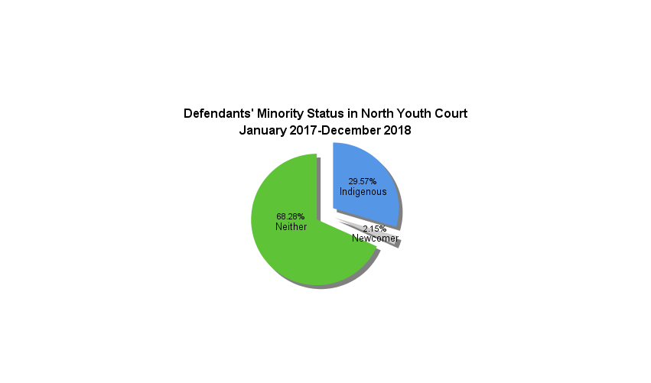

**Figure 44.** A population pyramid representing frequency (x-axis) of attendee gender (split), stratified by age (y-axis), and grouped by minority status at the North Youth Courts between January 2017 and December 2018, from a sample size of 113 (neither: 77, Indigenous: 36, newcomers: 0).

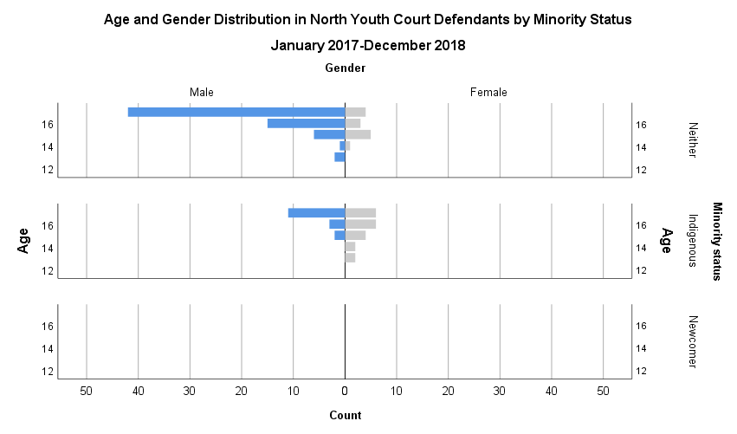

The North Youth Courts yielded a smaller sample size; for this reason, there are no newcomer cases to analyze. Similarly, data generated on Indigenous defendants reports on a sample of only 36 individuals. For this reason, the relationships described below may be better elucidated with further data collection. It was observed that more than two thirds (68.28%) of defendants receiving services from the Elizabeth Fry Society of Calgary in North Youth Court had no minority status (Figure 43). When stratified by minority status, distribution was heavily concentrated in older age categories in both individuals without minority status, and those identifying as Indigenous. This is reflected in the population pyramids (Figure 44), which are demonstrably top-heavy, suggesting a trend towards older age groups.

The population pyramid for individuals of no minority status is notably left- leaning, suggesting an overrepresentation of male defendants (Figure 44). Male defendants aged 17 made up 54.55% of defendants with no minority status, with a prevalence 10.50X that of their age-matched female peers (Figure 44). In contrast, the population pyramid for Indigenous individuals did not demonstrate a clear pattern; while right-leaning overall, suggesting significant representation of female defendants, the single gender and age group accounting for the majority of defendants was 17 year-old males (Figure 44). Consequently, while half of defendants were female, females aged 15-17 cumulatively made up 44.44% of the sample, with a prevalence ­­­1.00X that of their male peers, males aged 17 alone made up 30.56% of the sample, with a prevalence 1.83X that of their age-matched female peers. Additional data collection may prove useful in further exploring the nature of the relationship between gender, age, and minority status as it pertains to Indigenous youth.

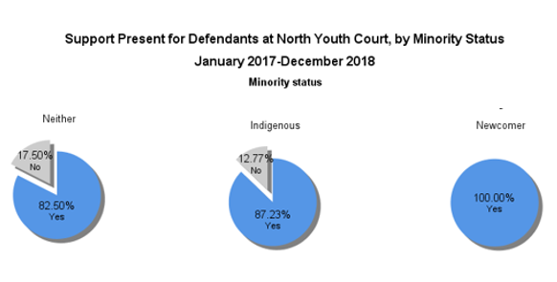

**Figure 45.** Pie charts representing the presence of support in court, by minority status, as observed in the North Youth Courts between January 2017 and December 2018, from a sample size of 169 (120 attendees without minority status, 47 Indigenous, and 4 attendees who are newcomers). Slice size represents the relative proportion of respondents reporting the presence or absence of supports on the day of data acquisition.

It was observed that many attendees in North Youth Court attended with support, across all minority status categories (Figure 45). As only four individuals were part of the newcomer group, this group was omitted from data analysis. Of the minority classifications, Indigenous youth most frequently reported support (87.23%), while youth without minority status least frequently (82.50%) reported support.

However, it was discovered that no statistically significant relationship existed between Indigenous status and the presence of support (X2=0.56, p=0.45 at p<0.05). Between the genders of Calgary youth court 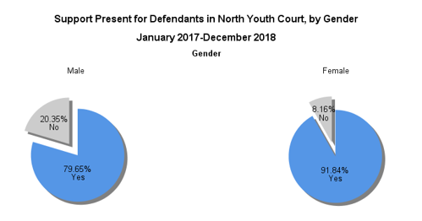attendees (Figure 46), female attendees were more likely to report having support present (91.84%) than male attendees (79.65%). However, it was discovered that no statistically significant relationship existed between gender and the presence of support in court (X2=3.66, p=0.06 at p<0.05)

Figure 46. Pie charts representing the presence of support in court by gender as observed in the North Youth Courts between January 2017 and December 2018, from a sample size of 162 (113 male and 49 female attendees). Slice size represents the relative proportion of respondents reporting the presence or absence of supports on the day of data acquisition.

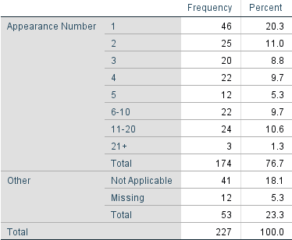It was observed that most (26.44%) of the attendees at North Youth Court, for which data was available, were at their first court appearance; likely owing to the small sample size, it is challenging to comment on the nature of the relationship between court appearance number and attendee count (Table 18). The majority of attendees (52.46%) for which data was available, reported having no legal representation at court (Table 20). Most attendees (76.58%) received services through the organization of a duration of 0-4 minutes, with an inverse relationship between increasing service length and attendee count (Table 19). Only 3.60% of defendants required support exceeding 15 minutes (Table 19).

**Table 18.** Frequency and proportion of North Youth Court attendees by number of court appearances, between January 2017 and December 2018.

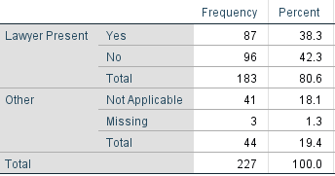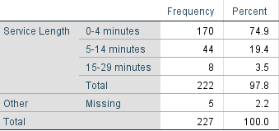

**Table 20.** Frequency and proportion of North Youth Court attendees with legal representation, between January 2017 and December 2018.

**Table 19.** Frequency and proportion of service length for North Youth Court attendees, between January 2017 and December 2018.

## South Youth Court

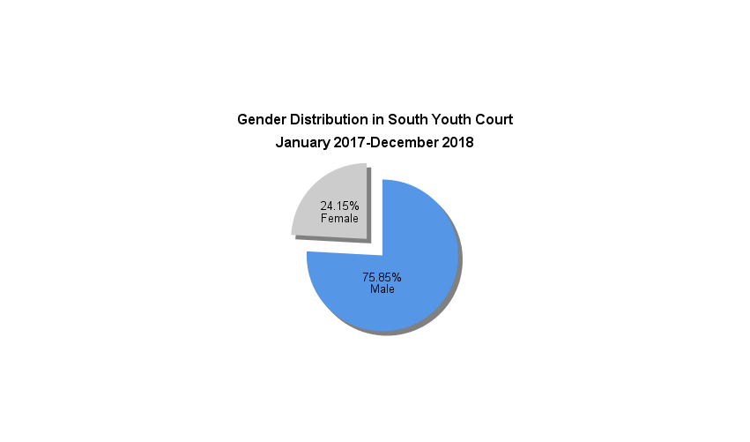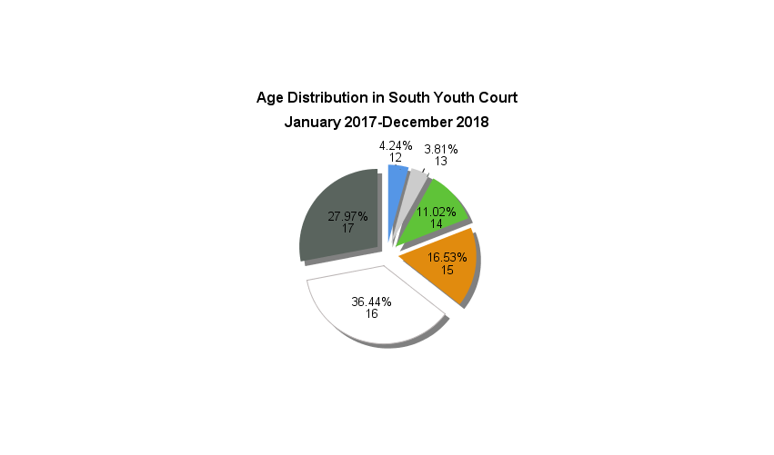

**Figure 47.**  A pie chart of gender distribution as observed in the South Youth Courts between January 2017 and December 2018, from a sample size of 236. Slice sizes represent the proportion of attendees identifying as a specific gender.

**Figure 48.** A pie chart of age distribution as observed in the South Youth Courts between January 2017 and December 2018, from a sample size of 236. Slice size represents the relative proportion of respondents within an age category.

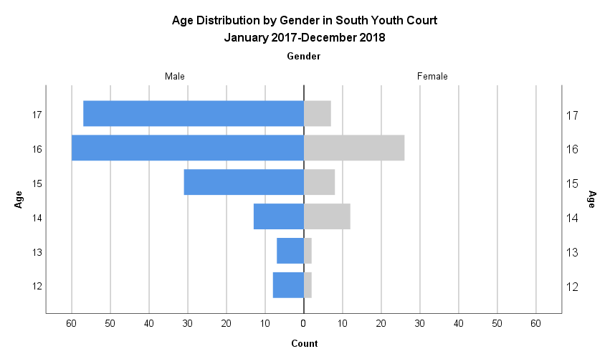

**Figure 49**. A population pyramid representing the frequency (x-axis) of attendee gender (split), stratified by age (y-axis), at the South Youth Courts between January 2017 and December 2018, from a sample size of 233.

It was observed that in defendants receiving services from the Elizabeth Fry Society of Calgary in the South Youth Courts, distribution was heavily concentrated in older age categories, and in males. This is reflected in the population pyramid (Figure 49), which is demonstrably top-heavy, suggesting a trend towards older age groups, and left-leaning, suggesting substantial representation of male defendants. More than 3 in 4 (75.85%) defendants identified as male (Figure 47), while 64.41% reported being 16 or older (Figure 48). Boys aged 16 and 17 represent the most common demographic supported by the organization, making up 25.75% and 24.46% of all defendants, with a prevalence 2.31X and 8.14X that of their age-matched female peers, respectively (Figure 49). As a trend, progressively reduced proportions are observed with decreasing age (Figure 49.

**Figure 50.** A pie chart of minority status as observed in the South Youth Courts between January 2017 and December 2018, from a sample size of 240. Slice size represents the relative proportion of respondents identifying as part of a minority group.

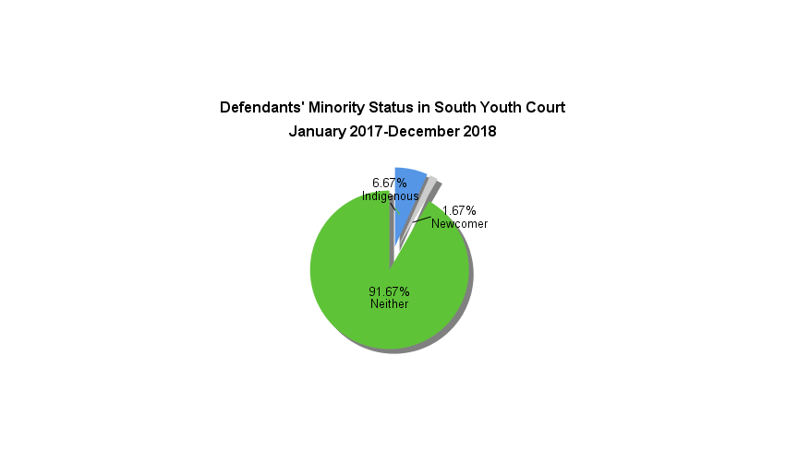

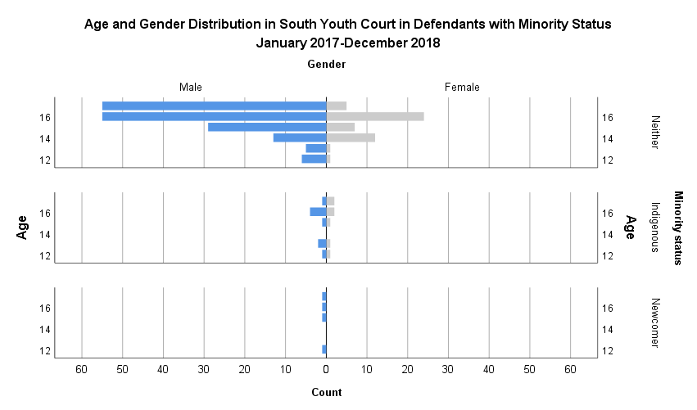

**Figure 51.** A population pyramid representing frequency (x-axis) of attendee gender (split), stratified by age (y-axis), and grouped by minority status at the South Youth Courts between January 2017 and December 2018, from a sample size of 232 (neither: 213, Indigenous: 15, newcomers: 4).

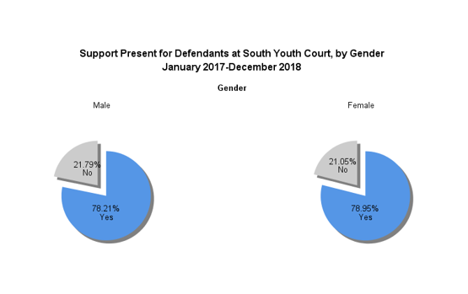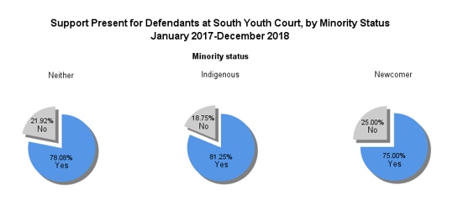For the South Youth Courts, the data generated on age and minority status pulls from a notably small sample size; for this reason, it is not possible to effectively analyze the limited data generated on Indigenous defendants and those of newcomer status. It was observed that the overwhelming majority (91.67%) of defendants receiving services from the Elizabeth Fry Society of Calgary in the South Youth Courts had no minority status (Figure 50). For individuals with no minority status, distribution was concentrated in men, reflected in the associated left-leaning population pyramids (Figure 51). There is a visible trend towards older age groupings. Males aged 16 and 17 represent the most common demographics, amongst those without minority status supported by the organization, making up 25.82% and 25.82% of defendants with no minority status, with a prevalence 2.29X and 11.00X that of their age-matched female peers, respectively (Figure 51). Given the small sample size, additional data collection could prove invaluable to further exploring the strength and nature of this relationship.

**Figure 53.** Pie charts representing the presence of support in court by gender as observed in the South Youth Courts between January 2017 and December 2018, from a sample size of 136 (79 male, and 57 female attendees). Slice size represents the relative proportion of respondents reporting the presence or absence of supports on the day of data acquisition.

**Figure 52.** Pie charts representing the presence of support in court, by minority status, as observed in the South Youth Courts between January 2017 and December 2018, from a sample size of 239 (219 attendees without minority status, 16 Indigenous, and 4 attendees who are newcomers). Slice size represents the relative proportion of respondents reporting the presence or absence of supports on the day of data acquisition.

It was observed that the majority of attendees in South Youth Court attended with support, across all minority status categories (Figure 52). Of the minority classifications, Indigenous youth most frequently reported support (81.25%), while youth without minority status least frequently (78.06%) reported support. The newcomer group was omitted from data analysis, owing to a small sample size; similarly, the interpretation of a chi-squared analysis was impossible owing to small sample size for specific count categories.

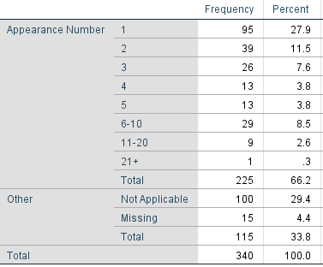Between the genders of the South Youth Court attendees (Figure 53), male and female attendees were similarly likely to report having support present (78.12% and 78.95% respectively). Similarly, it was discovered that no statistically significant relationship existed between gender and the presence of support in the South Youth Courts (X2=0.01, p=0.91 at p<0.05).

**Table 21.** Frequency and proportion of South Youth Court attendees by number of court appearances, between January 2017 and December 2018.

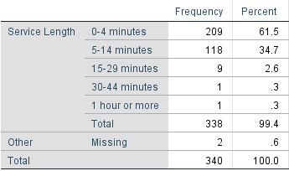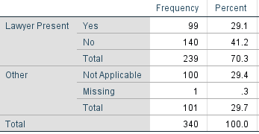It was observed that the largest proportion (42.22%) of attendees at the South Youth Courts, for which data was available, were at their first court appearance, with an apparent inverse relationship between increasing court appearance number and attendee count (Table 21). The majority of attendees (58.58%), for which data was available, reported having no legal representation at court (Table 22). Most attendees (61.83%) received services through the organization of a duration of 0-4 minutes, with an inverse relationship between increasing service length and attendee count (Table 23). Only 3.25% of defendants required support exceeding 15 minutes (Table 23).

**Table 23.** Frequency and proportion of service length for South Youth Court attendees, between January 2017 and December 2018.

**Table 22.** Frequency and proportion of South Youth Court attendees with legal representation, between January 2017 and December 2018.

## Traffic Court

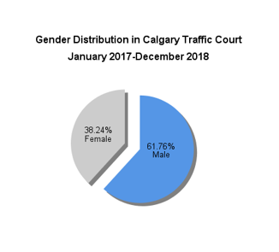

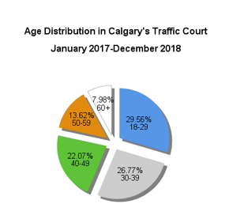

**Figure 55.** A pie chart of age distribution as observed in Traffic Court between January 2017 and December 2018, from a sample size of 13,689. Slice size represents the relative proportion of respondents within an age category.

**Figure 54.**  A pie chart of gender distribution as observed in Calgary’s Traffic Court between January 2017 and December 2018, from a sample size of 14,347. Slice sizes represent the proportion of attendees identifying as a specific gender.

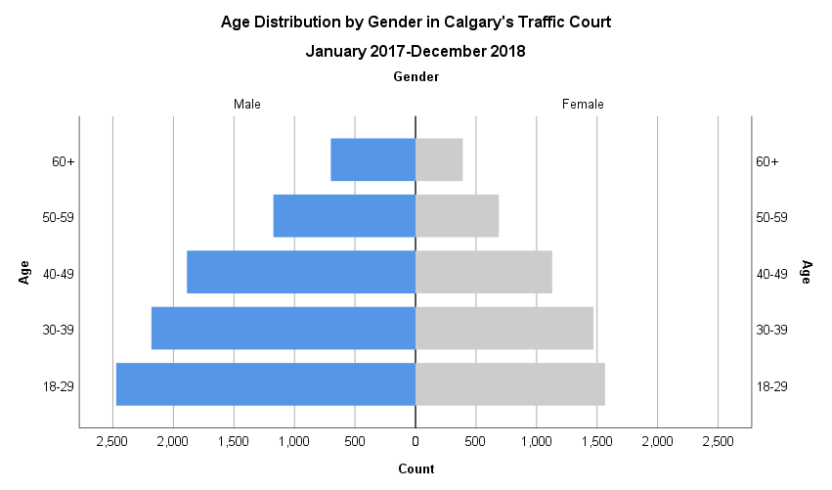

**Figure 56**. A population pyramid representing the frequency (x-axis) of attendee gender (split), stratified by age (y-axis), at Calgary’s Traffic Court between January 2017 and December 2018, from a sample size of 13,664.

It was observed that in defendants receiving services from the Elizabeth Fry Society of Calgary in Calgary’s Traffic Court, distribution was moderately concentrated in younger age groups, and in men. More than half (61.76%) of defendants identified as male (Figure 54), while 29.56% reported being under the age of 30 (Figure 55). With men aged 30-39 making up the second largest demographic observed, more than half of defendants served (56.33%) were under the age of 40, with progressively reduced proportions in subsequent age groups (Figure 56). This is reflected in the population pyramid, which is bottom-heavy, suggesting a trend towards younger age groups, and slightly left-leaning, suggesting a greater representation of male defendants (Figure 56). Men under 30, and between ages 30-39, represent the most common demographics supported by the organization, making up 18.10% and 15.97% of all defendants, with a prevalence 1.58X and 1.48X that of their age-matched female peers, respectively (Figure 56).

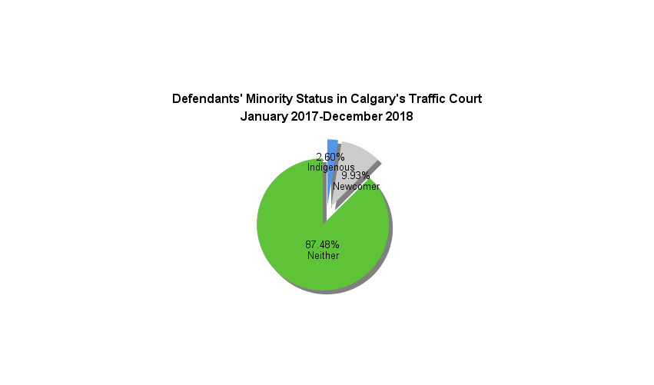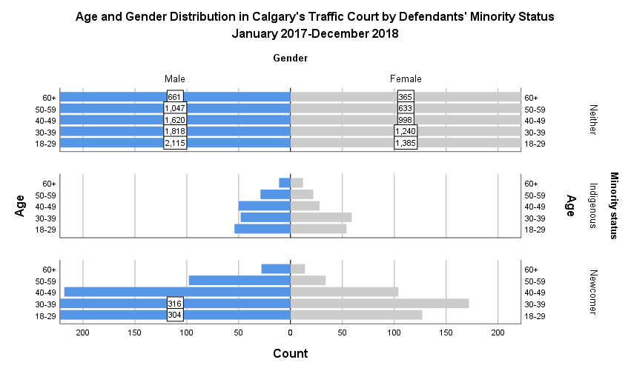

**Figure 57.** A pie chart of minority status as observed in Calgary’s Traffic Court between January 2017 and December 2018, from a sample size of 14,397. Slice size represents the relative proportion of respondents identifying as part of a minority group.

**Figure 58.** A population pyramid representing frequency (x-axis) of attendee gender (split), stratified by age (y-axis), and grouped by minority status at Calgary’s Traffic Court between January 2017 and December 2018, from a sample size of 13,664 (neither: 11,882, Indigenous: 367, newcomers: 1415). Values exceeding the scale of the count have been indicated on their respective bar, to allow for ease of observing minority group data.

It was observed that the majority (87.48%) of defendants receiving services from the Elizabeth Fry Society of Calgary in Calgary’s Traffic Court had no minority status (Figure 57). When stratified by minority status, distribution was moderately concentrated in younger age categories, and in men, across the no minority status and newcomer status groupings. This is reflected in the population pyramids (Figure 58), which are somewhat bottom-heavy, suggesting a trend towards younger age groups, and left-leaning, suggesting greater representation of male defendants.

Male defendants aged 18-29 made up 17.80% of defendants with no minority status, with a prevalence 1.53X that of their age-matched female peers (Figure 58). In contrast, the population pyramid for Indigenous individuals was balanced overall, suggesting relatively equal representation of both genders (Figure 58); 47.68% of defendants identified as being male, while 52.32% identified as being female. There is still a visible trend towards younger age groups, with the 18-29 and 30-39 age groups accounting for 30.86% and 33.71% of Indigenous male defendants, and 28.13% and 25.00% of Indigenous female age groups (Figure 58). Cumulatively, the male:female prevalence ratio for these groups is 1.11, suggesting that there exists relatively equal representation between genders. Additional data collection may prove useful in further exploring the nature of the relationship between gender, age, and minority status as it pertains to Indigenous youth. Male defendants aged 18-29 and 30-39 made up 21.48% and 22.33% of defendants with newcomer status, with a prevalence 2.39X and 1.84X that of their age-matched female peers, respectively (Figure 58). Reflecting these differences in prevalence ratios, male:female representation appears least divergent in the Indigenous grouping (Figure 58).

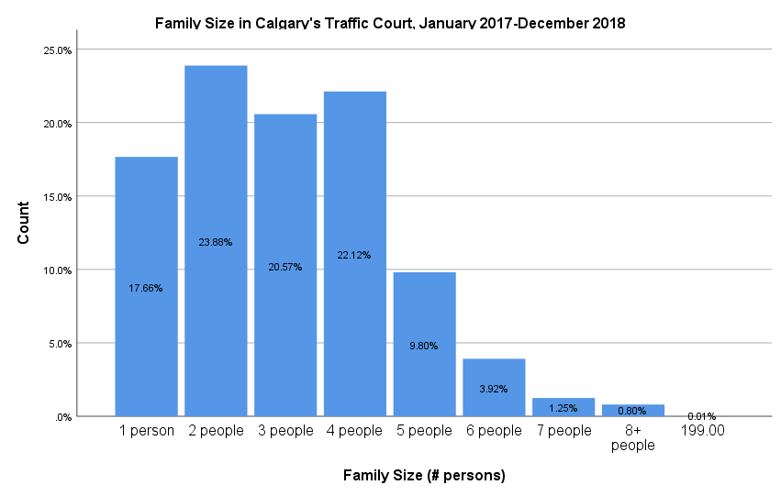

**Figure 59.** A bar graph of attendee family size as observed in Calgary’s Traffic Court between January 2017 and December 2018, from a sample size of 13,401. Bar height corresponds to the number of respondents reporting a given family size (y-axis), with relative proportions of family size categories indicated within the bar.

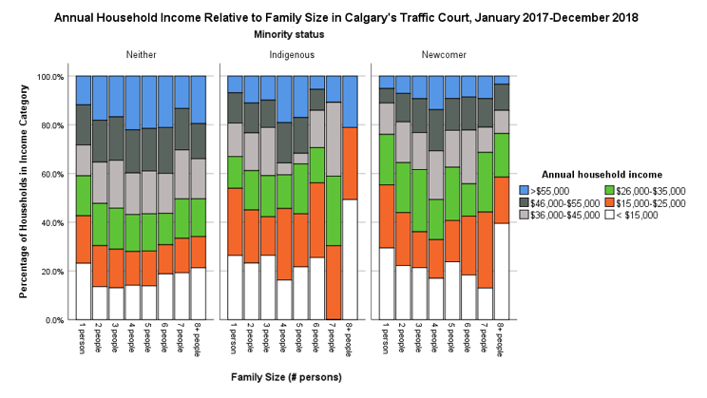

**Figure 60**. Proportion of attendee households (y-axis) in a given income category (colour legend) by family size (x-axis), grouped by minority status, at Calgary’s Traffic Court between January 2017 and December 2018. Bar height represents 100% of attendee households in a family size category. This data was generated from a sample size of 4474.

.

**Table 23**. Number of attendee households in various income categories, stratified by family size and minority status, at Calgary’s Traffic Court between January 2017 and December 2018.

|  |  |  |  |  |  |  |  |  |  |
| --- | --- | --- | --- | --- | --- | --- | --- | --- | --- |
| **Annual Household Income by Family Size and Minority Status Crosstabulation for Calgary's Traffic Court, January 2017-December 2018** | | | | | | | | | |
| Count | | | | | | | | | |
| Family size | | | Annual household income | | | | | | Total |
| < $15,000 | $15,000-$25,000 | $26,000-$35,000 | $36,000-$45,000 | $46,000-$55,000 | >$55,000 |
| 1 person |  | Indigenous | 23 | 20 | 10 | 10 | 8 | 14 | 85 |
| Newcomer | 74 | 54 | 46 | 27 | 11 | 30 | 242 |
| Neither | 428 | 299 | 267 | 195 | 225 | 509 | 1923 |
| Total | | 525 | 373 | 323 | 232 | 244 | 553 | 2250 |
| 2 people |  | Indigenous | 18 | 14 | 11 | 10 | 7 | 20 | 80 |
| Newcomer | 59 | 48 | 48 | 37 | 23 | 44 | 259 |
| Neither | 327 | 338 | 369 | 342 | 306 | 1024 | 2706 |
| Total | | 404 | 400 | 428 | 389 | 336 | 1088 | 3045 |
| 3 people |  | Indigenous | 16 | 8 | 9 | 10 | 5 | 14 | 62 |
| Newcomer | 54 | 31 | 57 | 32 | 26 | 55 | 255 |
| Neither | 272 | 274 | 309 | 340 | 274 | 813 | 2282 |
| Total | | 342 | 313 | 375 | 382 | 305 | 882 | 2599 |
| 4 people |  | Indigenous | 8 | 12 | 6 | 2 | 6 | 22 | 56 |
| Newcomer | 49 | 38 | 42 | 48 | 36 | 93 | 306 |
| Neither | 294 | 240 | 278 | 296 | 272 | 1073 | 2453 |
| Total | | 351 | 290 | 326 | 346 | 314 | 1188 | 2815 |
| 5 people |  | Indigenous | 6 | 5 | 5 | 1 | 3 | 11 | 31 |
| Newcomer | 32 | 19 | 26 | 17 | 13 | 29 | 136 |
| Neither | 127 | 109 | 123 | 134 | 118 | 460 | 1071 |
| Total | | 165 | 133 | 154 | 152 | 134 | 500 | 1238 |

**Table 24.** Odds of Indigenous and newcomer attendees in Calgary’s Traffic Court, from January 2017-December 2018, living below the Market Basket Measure (MBM) value for Calgary, relative to attendees without minority status.



It was observed that the majority of attendees (84.23%) indicated that they were part of an immediate family unit of four or fewer (Figure 59). Beyond families of four, an inverse relationship is observed between family size and attendee count (Figure 59).

Visually, there is a slight trend towards groups with minority status demonstrating a greater proportion of individuals with an annual household income of less than $15,000, and a lesser proportion with more than $55,0000, in contrast to individuals without minority status (Figure 60, Table 23). This observation is corroborated by the odds ratio values for Indigenous families’ annual household income, relative to families without minority status. The odds of Indigenous families of one to five members falling below the Market Basket Measure (MBM, Appendix 9.1; Statistics Canada, 2015) value for a living income in Calgary are 1.53X, 2.98X, 1.83X, 1.54X, and 1.34X that of non-Indigenous families of a comparable size, respectively (Table 24). Similarly, the odds of newcomer families of one to five members falling below the Market Basket Measure (MBM, Appendix 9.1; Statistics Canada, 2015) value for a living income in Calgary are 1.81X, 2.59X, 2.03X, 1.66X, and 2.62X that of non-Indigenous families of a comparable size, respectively (Table 24). These values are artificially depressed, owing to limitations associated with data collection. Counts are derived from preestablished income categories (discrete variables), necessitating that categories inclusive of MBM values be excluded. This excludes families whose income falls marginally below the MBM values. Odds ratios have been related to a specific value, such that a group has ‘X odds of being below the appropriate MBM value by at least $Y’. For further information on the calculation and interpretation of these values, please see Appendix 9.2.

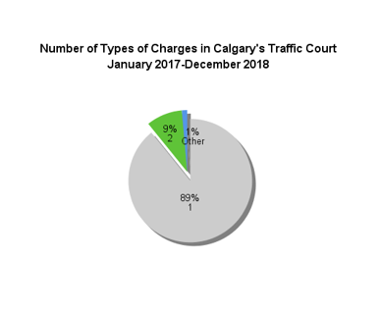

**Figure 61.** A pie chart of the number of types of charges per individual as observed in Calgary’s Traffic Court between January 2017 and December 2018, from a sample size of 13,470. Slice size represents the relative proportion of respondents with a given number of charges.

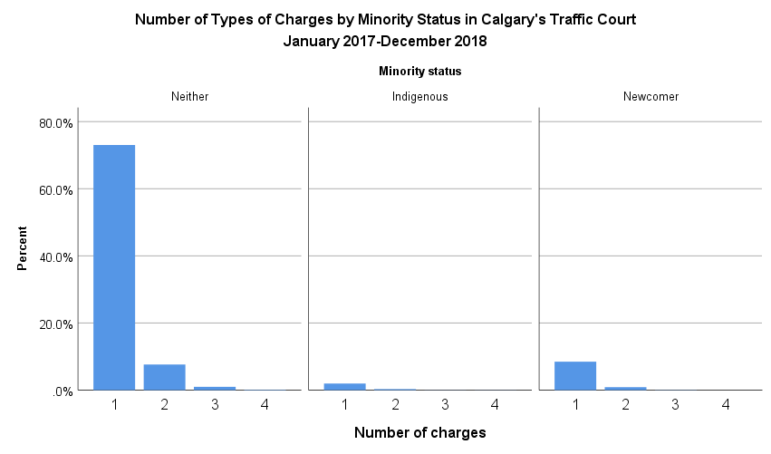

**Figure 62.** A bar graph of the frequency of the number of individual attendee charges, by minority status, as observed in Calgary’s Traffic Court between January 2017 and December 2018, from a sample size of 14,349 (12,569 individuals without minority status, 363 Indigenous, and 1417 individuals who are newcomers). Bar height corresponds to the percentage of respondents reporting a given number of charges (y-axis), against charge number (x-axis). Results are grouped by minority status.

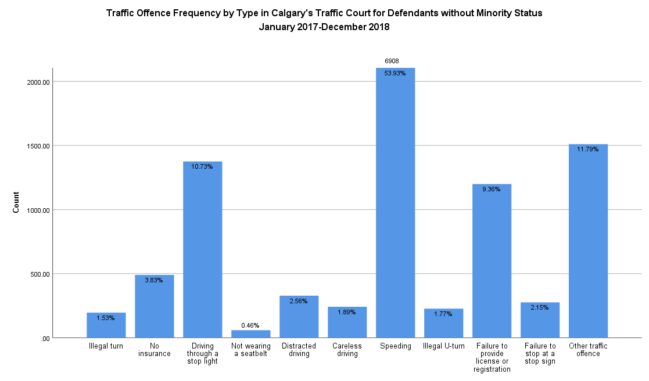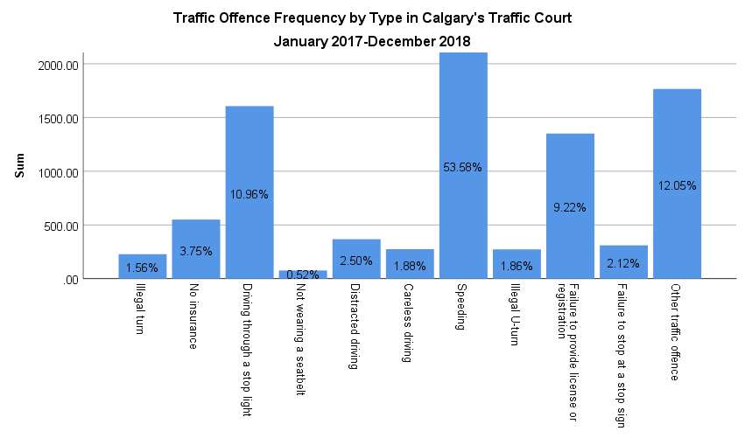

Figure 63. A bar graph of the frequency of various types of Traffic charges, as observed in Calgary’s Traffic Court between January 2017 and December 2018, from a sample size of 14,652. Bar height corresponds to the number of respondents with a given charge (y-axis), with relative proportions of charge type categories indicated within the bar.

**Figure 64**. A bar graph of the frequency of various types of Traffic charges in court attendees without minority status, as observed in Calgary’s Traffic Court between January 2017 and December 2018, from a sample size of 12,810. Bar height corresponds to the number of respondents with a given charge (y-axis), with relative proportions of charge type categories indicated within the bar.

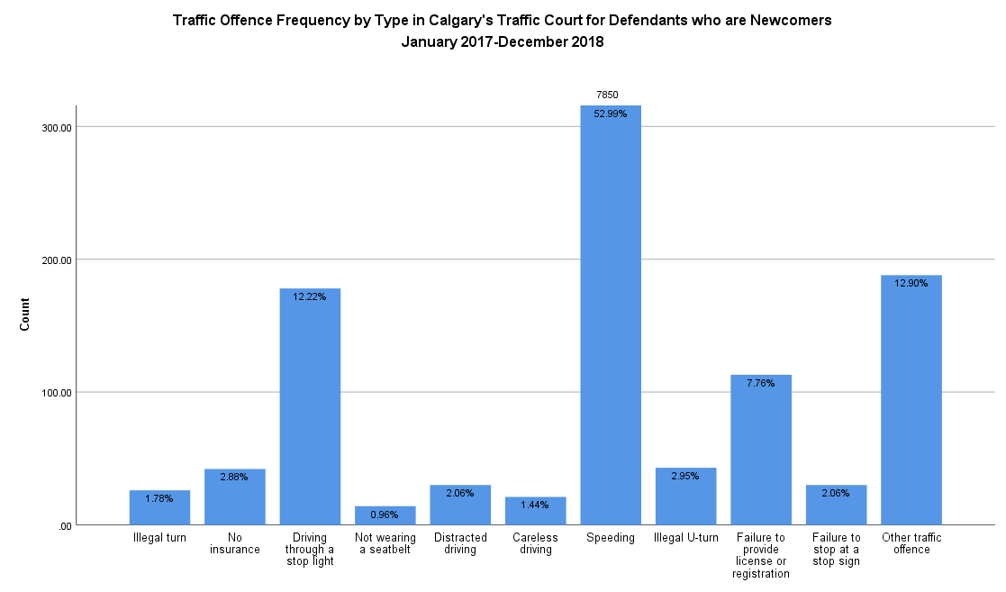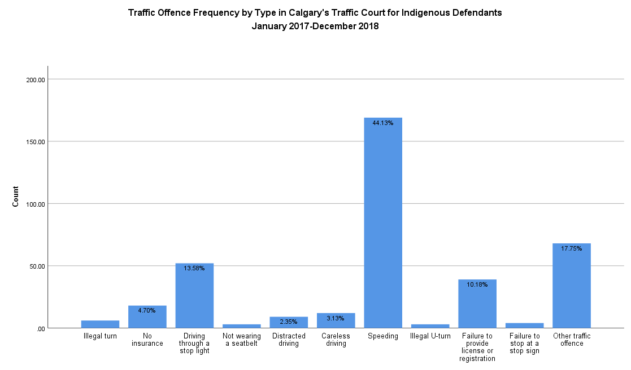

**Figure 65**. A bar graph of the frequency of various types of Traffic charges in court attendees who are Indigenous, as observed in Calgary’s Traffic Court between January 2017 and December 2018, from a sample size of 383. Bar height corresponds to the number of respondents with a given charge (y-axis), with relative proportions of charge type categories indicated within the bar.

**Figure 66**. A bar graph of the frequency of various types of Traffic charges in court attendees who are newcomers, as observed in Calgary’s Traffic Court between January 2017 and December 2018, from a sample size of 1287. Bar height corresponds to the number of respondents with a given charge (y-axis), with relative proportions of charge type categories indicated within the bar.

|  |  |  |  |
| --- | --- | --- | --- |
| Court Attendees of Indigenous Status | | | |
|  | **X2 Value** | **p-value** | **Odds Ratio** |
| Driving Through a Stoplight | 8.63 | <0.01 | 1.54 |
| Careless Driving | 5.10 | 0.02 | 1.95 |
| Other Traffic offence | 22.92 | <0.01 | 1.90 |
| Court Attendees of Newcomer Status | | | |
|  | **X2 Value** | **p-value** | **Odds Ratio** |
| Driving Through a Stoplight | 13.33 | <0.01 | 1.36 |
| Not Wearing a Seatbelt | 9.39 | <0.01 | 2.43 |
| Careless Driving | 32.51 | <0.01 | 0.88 |
| Speeding | 21.40 | <0.01 | 1.29 |
| Illegal U-turn | 16.35 | <0.01 | 1.95 |
| Failure to Provide License or Registration | 216.87 | <0.01 | 0.95 |
| Other Traffic offence | 568.81 | <0.01 | 1.30 |

Overall, the overwhelming majority of attendees at Calgary’s Traffic Court (89%) had one Traffic offence (Figure 61), an observation that is true of individuals of all minority classifications (Figure 62). ‘Speeding’ represented the most frequent (53.58%) Traffic offence overall (Figure 63), and across individuals of all minority statuses (Figure 64, 65, 66).

It was noted that in comparison to individuals without minority status, Indigenous attendees were more likely to have offences related to driving through stoplights, careless driving, or ‘other’ Traffic offences in Traffic Court, demonstrating 2.85%, 1.24%, and 5.96% deviation from proportions in individuals without minority status respectively (Figure 64, 65). The odds of Indigenous attendees in Traffic Court having these charges were 1.54X, 1.95X, and 1.90X that of individuals without minority status, respectively (Table 25).

It was noted that in comparison to individuals without minority status, attendees with newcomer status were more likely to have offences related to driving through stoplights, not wearing seatbelts, speeding, illegal U-turns, and other offences in Traffic Court, demonstrating 1.49%, 0.50%, 6.35%, 1.18%, and 1.11% deviation from proportions in individuals without minority status, respectively (Figures 64, 66). The odds of newcomer attendees in Traffic Court having these charges were 1.36X, 2.43X, 1.29X, 1.95X, and 1.30X that of individuals without minority status, respectively (Table 25). Attendees with newcomer status were statistically less likely to have offences related to careless driving and failing to provide a license or registration in Traffic Court, demonstrating 0.45% and 1.60% deviation from proportions in individuals without minority status, respectively (Figure 64, 66). The odds of attendees of newcomer status in Traffic Court having these charges were 0.88X and 0.95X that of individuals without minority status, respectively (Table 25).

**Table 25.** Statistically significant (p<0.05) relationships observed between minority status and frequency of specific offences in Calgary’s Traffic Court, between January 2017 and December 2018. Chi-squared values of p<0.05 indicate the presence of a relationship between minority status and a Traffic offence, using frequencies of individuals without minority status for a null hypothesis. Odds ratios indicate the odds of a minority status having a given offence in Calgary’s Traffic Court, relative to individuals without minority status.

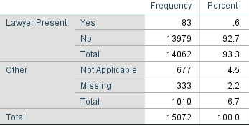It was observed that the overwhelming majority of attendees (99.41%) at Calgary’s Traffic Court, for which data was available, reported having no legal representation at court (Table 26). Most (94.23%) of the attendees received services through the organization of a duration of 0-4 minutes; thought there was an inverse relationship between increasing service length and attendee count overall, there is a slight deviation from this trend in the 30-44 minutes and 1 hour+ groups (Table 27). Only 0.59% of defendants required support exceeding 15 minutes (Table 27).

**Table 26.** Frequency and proportion of Calgary’s Traffic Court attendees with legal representation, between January 2017 and December 2018.

**Table 27.** Frequency and proportion of service length for Calgary’s Traffic Court attendees, between January 2017 and December 2018.

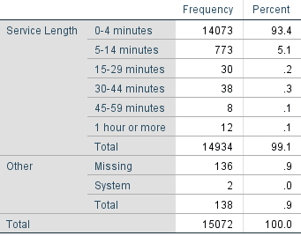

## South Traffic Courts

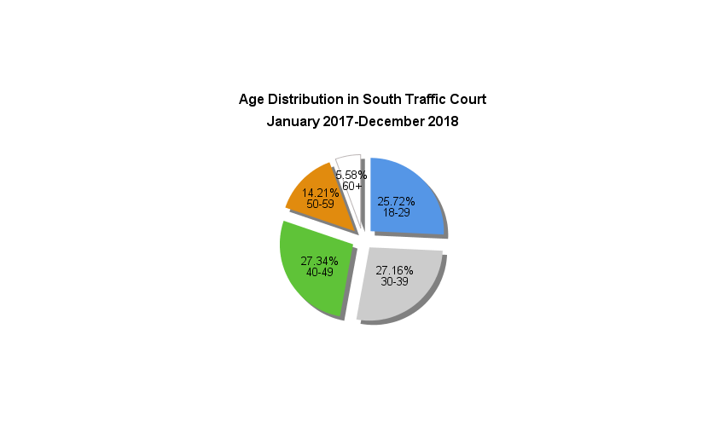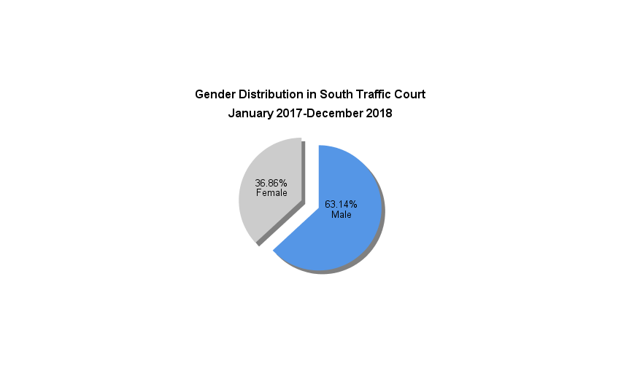

**Figure 68.** A pie chart of age distribution as observed in the South Traffic Courts between January 2017 and December 2018, from a sample size of 556. Slice size represents the relative proportion of respondents within an age category.

**Figure 67.**  A pie chart of gender distribution as observed in the South Traffic Courts between January 2017 and December 2018, from a sample size of 567. Slice sizes represent the proportion of attendees identifying as a specific gender.

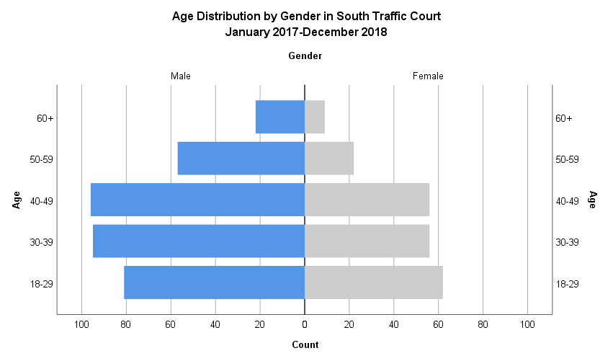

**Figure 69**. A population pyramid representing the frequency (x-axis) of attendee gender (split), stratified by age (y-axis), at the South Traffic Courts between January 2017 and December 2018, from a sample size of 556.

It was observed that in defendants receiving services from the Elizabeth Fry Society of Calgary in the South Traffic Courts, distribution was moderately concentrated in individuals in central age categories, and in men. More than half (63.14%) of defendants identified as male (Figure 67). Defendants aged 18-49 account for 80.22% of defendants served (Figure 68). This is reflected in the population pyramid (Figure 69) which demonstrates bulk around the middle with a mildly bottom-heavy distribution, suggesting a trend towards young to middle age groups, and left-leaning, suggesting a greater representation of male defendants. Men under 30, age 30-39, and age 40-49 represent the most common demographics supported by the organization, making up 14.57%, 17.09%, and 17.27% of all defendants, with a prevalence 1.31X, 1.70X, and 1.71X that of their age-matched female peers, respectively (Figure 69).

**Figure 70.** A pie chart of minority status as observed in the South Traffic Courts between January 2017 and December 2018, from a sample size of 567. Slice size represents the relative proportion of respondents identifying as part of a minority group.

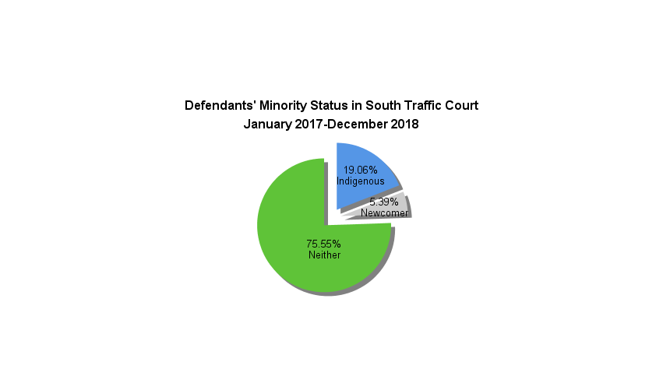

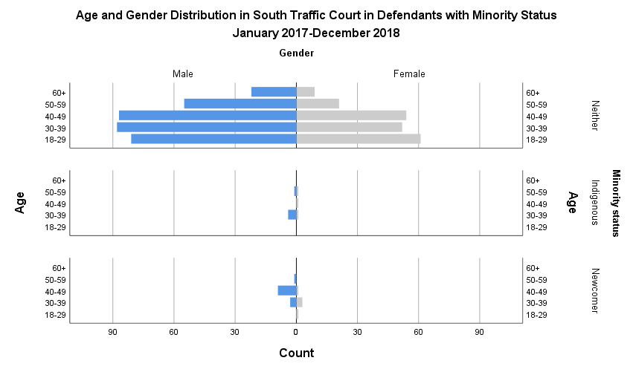

Given that the South Traffic Courts commenced in 2018, the data generated on age and minority status pulls from a smaller sample size; for this reason, it is not possible to effectively analyze the limited data generated on Indigenous defendants and those of newcomer status. It was observed that more than three in four (75.55%) defendants receiving services from the Elizabeth Fry Society of Calgary in the South Traffic Courts had no minority status (Figure 70). In defendants without minority status, there exists a trend towards a greater representation of males and younger age groups in court, as suggested by the corresponding population pyramid (Figure 71). Male defendants in the 18-29, 30-39, and 40-49 age categories made up 15.28%, 16.60%, and 16.42% of defendants with no minority status respectively, with a prevalence 1.33X, 1.69X, and 1.61X that of their age-matched female peers (Figure 71).

**Figure 71.** A population pyramid representing frequency (x-axis) of attendee gender (split), stratified by age (y-axis), and grouped by minority status at the South Traffic Courts between January 2017 and December 2018, from a sample size of 548 (neither: 530, Indigenous: 5) newcomers: 13).

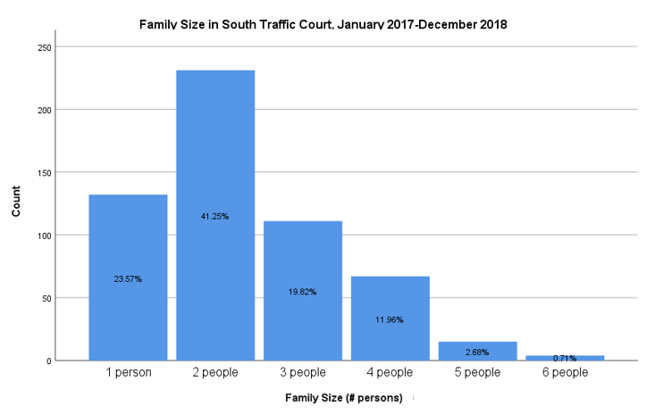

**Figure 72.** A bar graph of attendee family size as observed in the South Traffic Courts between January 2017 and December 2018, from a sample size of 560. Bar height corresponds to the number of respondents reporting a given family size (y-axis), with relative proportions of family size categories indicated within the bar.

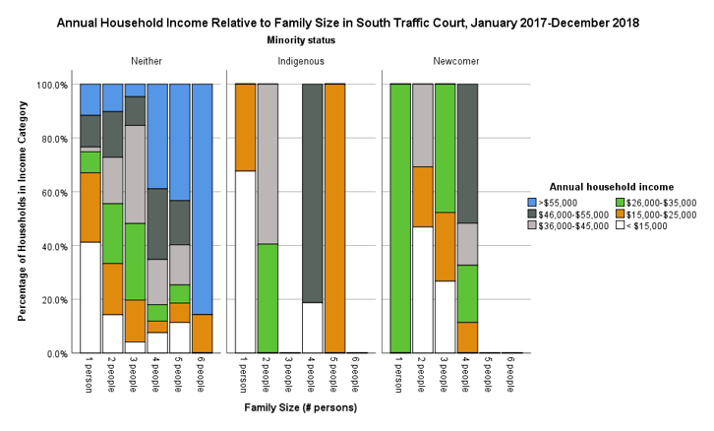It was observed that the majority of attendees (41.25%) indicated that they were part of an immediate family unit of two (Figure 72). Beyond families of two, an inverse relationship is observed between family size and attendee count (Figure 72). Visually, it is challenging to speak to relationships that exist between family size and annual income between minority status groups, though notable that no one in the Indigenous or newcomer minority groups reported an income in excess of $55,000 (Figure 73, Table 28). While it is not possible to calculate odds ratios for families with minority status’ annual household income, relative to those without minority status owing to limited data availability, additional data collection may present the opportunity to better elucidate any potential relationships.

**Figure 73.** Proportion of attendee households (y-axis) in a given income category (colour legend) by family size (x-axis), grouped by minority status, at the South Traffic Courts between January 2017 and December 2018. Bar height represents 100% of attendee households in a family size category. This data was generated from a sample size of 546.

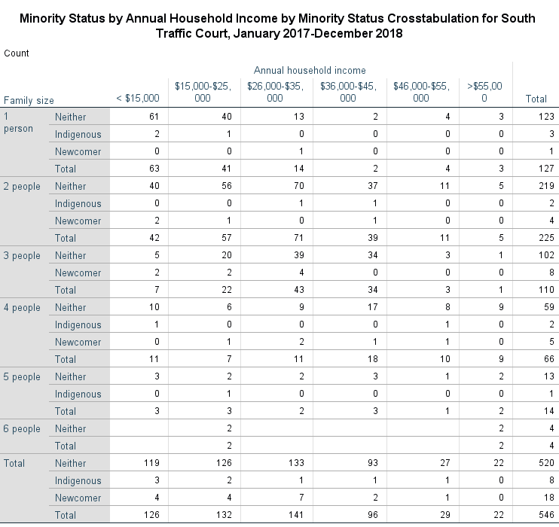

Table 28. Number of attendee households in various income categories, stratified by family size and minority status, at the South Traffic Courts between January 2017 and December 2018.

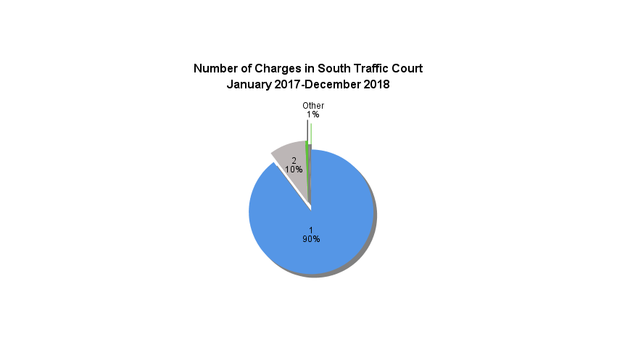Overall, the overwhelming majority of attendees at the South Traffic Courts (90%) had one traffic offence (Figure 74), an observation that is true of individuals of all minority classifications. ‘Speeding’ represented the most frequent (44.88%) traffic offence overall (Figure 75). Owing to exceedingly small sample sizes, data analysis by minority group was not possible.

**Figure 74.** A pie chart of the number of types of charges per individual as observed in the South Traffic Courts between January 2017 and December 2018, from a sample size of 536. Slice size represents the relative proportion of respondents with a given number of charges.

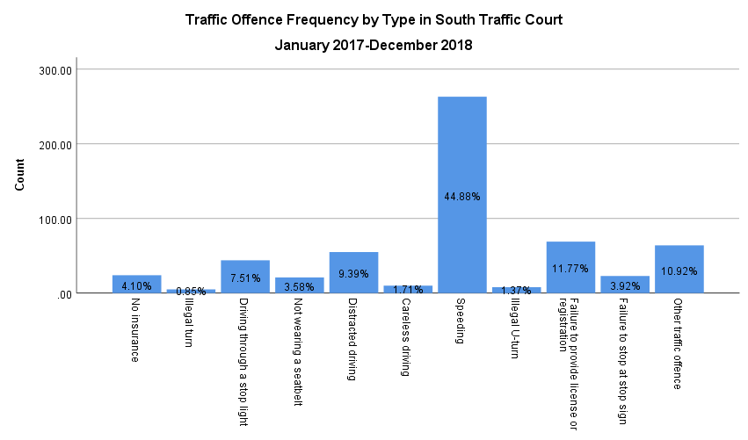

**Figure 75**. A bar graph of the frequency of various types of traffic charges, as observed in the South Traffic Courts between January 2017 and December 2018, from a sample size of 586. Bar height corresponds to the number of respondents with a given charge (y-axis), with relative proportions of charge type categories indicated within the bar.

It was observed that the overwhelming majority of attendees (96.10%) of the South Traffic Courts, for which data was available, reported having no legal representation at court (Table 29). Most (62.15%) of the attendees received services through the organization of a duration of 0-4 minutes, with an inverse relationship apparent between increasing service length and attendee count (Table 30). Only 2.50% of defendants required support exceeding 15 minutes (Table 30).

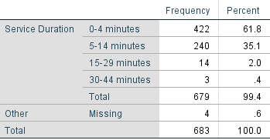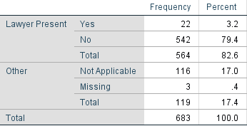

**Table 30.** Frequency and proportion of service length for South traffic court attendees, between January 2017 and December 2018

**Table 29.** Frequency and proportion of South Traffic Court attendees with legal representation, between January 2017 and December 2018.

## Domestic Court

**Figure 77.** A pie chart of age distribution as observed in Domestic Court between January 2017 and December 2018, from a sample size of 5778. Slice size represents the relative proportion of respondents within an age category.

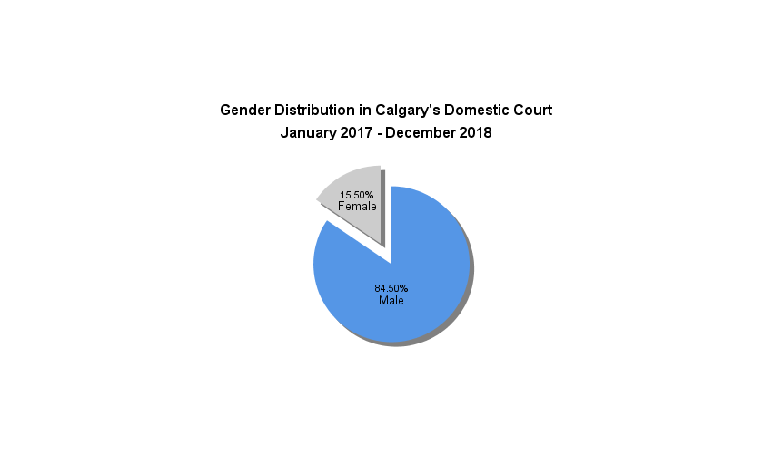

**Figure 76.**  A pie chart of gender distribution as observed in Calgary’s Domestic Court between January 2017 and December 2018, from a sample size of 5715. Slice sizes represent the proportion of attendees identifying as a specific gender.

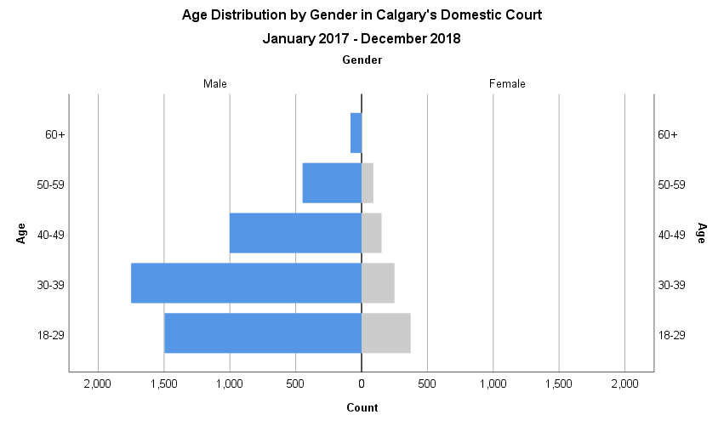

**Figure 78**. A population pyramid representing the frequency (x-axis) of attendee gender (split), stratified by age (y-axis), at Calgary’s Domestic Court between January 2017 and December 2018, from a sample size of 5651.

It was observed that in defendants receiving services from the Elizabeth Fry Society of Calgary in Domestic Court, distribution was markedly concentrated in younger age groups, and in men. This is reflected in the population pyramid (Figure 78), which is demonstrably bottom-heavy, suggesting a trend towards younger age groups, and left-leaning, suggesting substantial representation of male defendants. 84.50% of defendants identified as male (Figure 76), while 33.03% reported being under the age of 30 and 35.46% being 30-39 (Figure 77). Men under 30, and between 30-39, represent the most common demographics supported by the organization, making up 26.47% and 30.96% of all defendants, with a prevalence 4.01X and 6.94X that of their age-matched female peers, respectively (Figure 78). Progressively reduced proportions are observed in subsequent age groups of both gender categories (Figure 78).

It was observed that the majority (81.95%) of defendants receiving services from the Elizabeth Fry Society of Calgary in Calgary’s Domestic Court had no minority status (Figure 79). When stratified by minority status, distribution was heavily concentrated in younger age categories, and in men, across all groupings.

This is reflected in the population pyramids (Figure 80), which are demonstrably bottom-heavy, suggesting a trend towards younger age groups, and left-leaning, suggesting substantial representation of male defendants.

**Figure 79.** A pie chart of minority status as observed in Calgary’s Domestic Court between January 2017 and December 2018, from a sample size of 5934. Slice size represents the relative proportion of respondents identifying as part of a minority group.

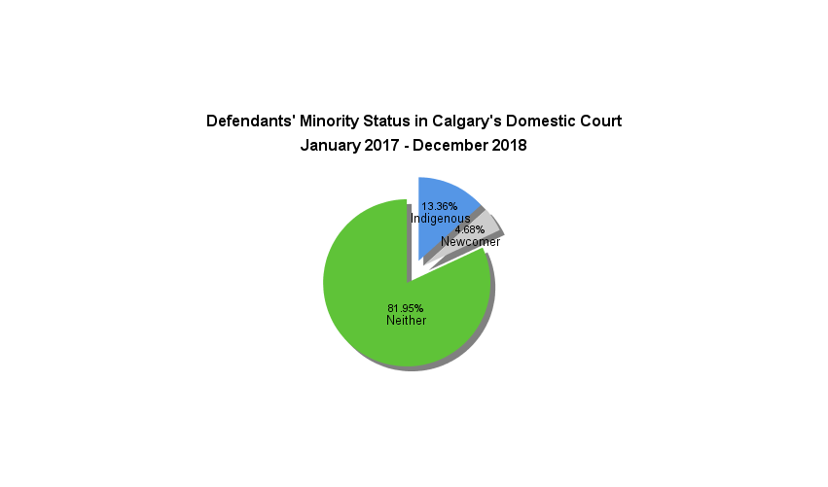

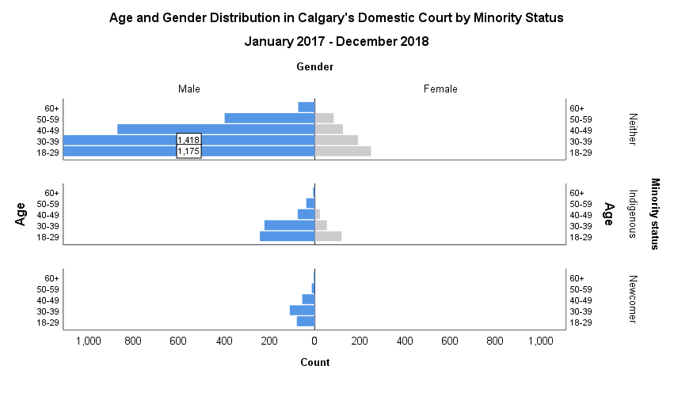

**Figure 80.** A population pyramid representing frequency (x-axis) of attendee gender (split), stratified by age (y-axis), and grouped by minority status at Calgary’s Domestic Court between January 2017 and December 2018, from a sample size of 5626 (neither: 4586, Indigenous: 779, newcomers: 261). Values exceeding the scale of the count have been indicated on their respective bar, to allow for ease of observing minority group data.

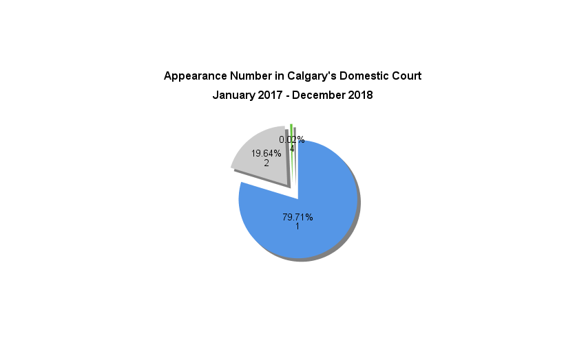

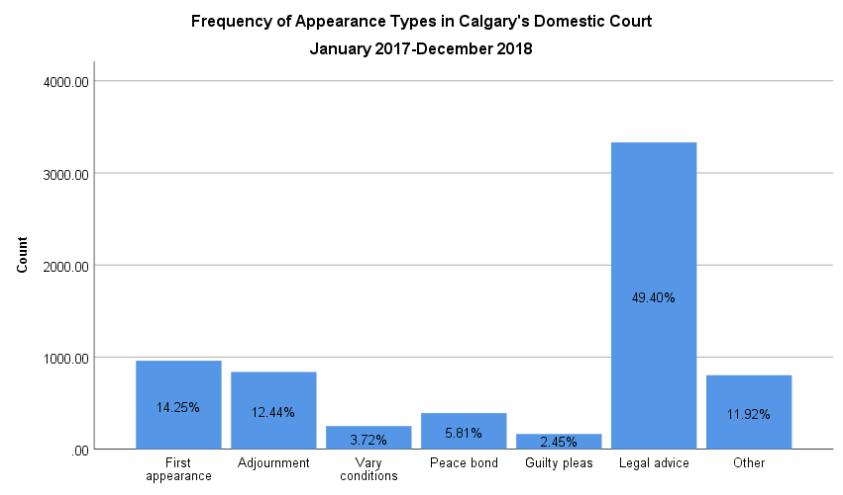Of defendants without minority status, men under 30, and 30-39, represent the most common demographics supported by the organization, making up 25.62% and 30.92%, with a prevalence 4.72X and 7.38X those of their age-matched female peers, respectively (Figure 80). These demographic groups encompass the majority of defendants of Indigenous and newcomer status. In Indigenous defendants, they account for 31.07% and 28.50% of the sample, with a prevalence 2.03X and 4.11X that of their age-matched female peers, respectively (Figure 80). In defendants who are newcomers, they account for 30.23% and 42.15% of the sample (Figure 80). There are no female defendants who are newcomers. Reflecting these differences in prevalence ratios and population distribution, male: female representation is visibly the most divergent in the newcomer grouping (Figure 80).

**Figure 82**. A bar graph of the frequency of various appearance types, as observed in Calgary’s Domestic Court between January 2017 and December 2018, from a sample size of 6743. Bar height corresponds to the number of respondents present for a given appearance (y-axis), with relative proportions of appearance type categories indicated within the bar.

**Figure 81.** A pie chart of Calgary Domestic Court attendees’ appearance number, between January 2017 and December 2018, from a sample size of 5934. Slice size represents the relative proportion of respondents present for a given appearance number.

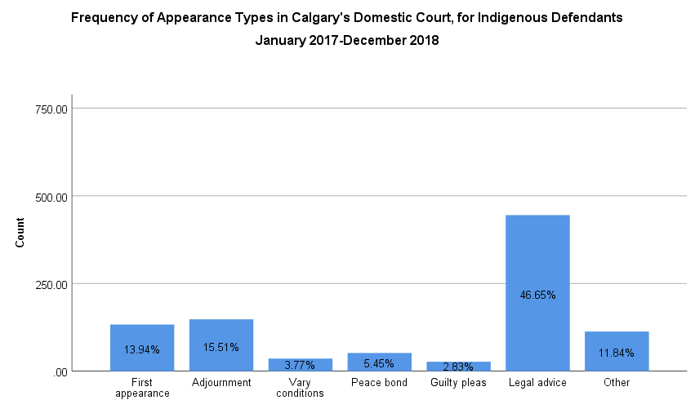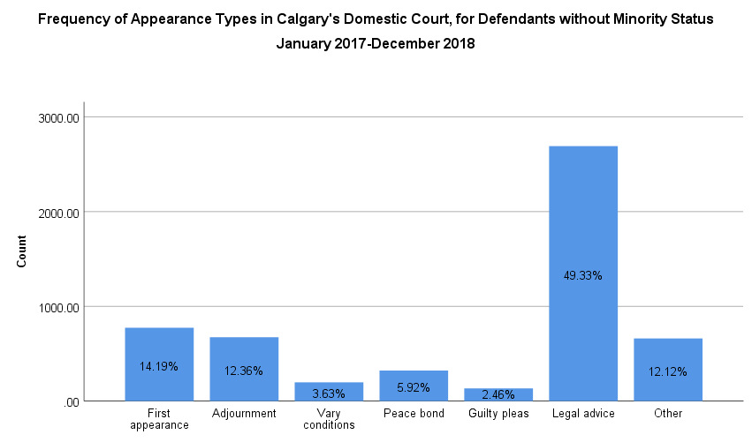

**Figure 84**. A bar graph of the frequency of various appearance types in Indigenous defendants, as observed in Calgary’s Domestic Court between January 2017 and December 2018, from a sample size of 934. Bar height corresponds to the number of respondents present for a given appearance (y-axis), with relative proportions of appearance type categories indicated within the bar.

**Figure 83**. A bar graph of the frequency of various appearance types in defendants without minority status, as observed in Calgary’s Domestic Court between January 2017 and December 2018, from a sample size of 5455. Bar height corresponds to the number of respondents present for a given appearance (y-axis), with relative proportions of appearance type categories indicated within the bar.

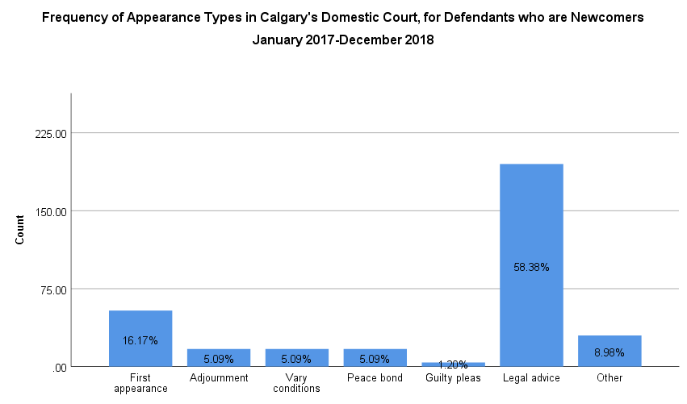

**Figure 85**. A bar graph of the frequency of various appearance types in defendants with newcomer status, as observed in Calgary’s Domestic Court between January 2017 and December 2018, from a sample size of 334. Bar height corresponds to the number of respondents present for a given appearance (y-axis), with relative proportions of appearance type categories indicated within the bar.

|  |  |  |  |
| --- | --- | --- | --- |
| Court Attendees of Indigenous Status | | | |
|  | **X2 Value** | **p-value** | **Odds Ratio** |
| Adjournment | 8.67 | <0.01 | 0.13 |
| Court Attendees of Newcomer Status | | | |
|  | **X2 Value** | **p-value** | **Odds Ratio** |
| Adjournment | 15.81 | <0.01 | 0.38 |
| Legal Advice | 10.32 | <0.01 | 1.44 |

It was observed that attendees of Calgary’s Domestic Court, for which data was available, were most often (79.71%) present for their first appearance in court, with an inverse relationship between attendee count and increasing appearance number (Figure 81). Across all minority status classifications, the most common appearance type amongst defendants was ‘legal advice’ (Figure 82, 83, 84, 85); this is particularly true of newcomers, of which 58.38% sought legal advice (Figure 85). Statistically significant relationships between appearance type and minority status were noted. Indigenous defendants had 0.13X the odds of defendants without minority status of being present for adjournment in Calgary’s Domestic Court (Table 31). Similarly, defendants who were newcomers had 0.38X, and 1.44X the odds of defendants without minority status of being present for adjournment or legal advice in Calgary’s Domestic Court, respectively (Table 31).Most (62.15%) attendees received services through the organization for a duration of 0-4 minutes; an inverse relationship between increasing service length and attendee count was apparent (Table 32). Only 0.04% of defendants required support exceeding 15 minutes (Table 32).

**Table 31.** Statistically significant (p<0.05) relationships observed between minority status and frequency of specific appearance types in Calgary’s Domestic Court, between January 2017 and December 2018. Chi-squared values of p<0.05 indicate the presence of a relationship between minority status and an appearance type, using frequencies of individuals without minority status for a null hypothesis. Odds ratios indicate the odds of a minority status having a given appearance type in Calgary’s Domestic Court, relative to individuals without minority status.

**Table 32.** Frequency and proportion of service length for Calgary’s Domestic Court attendees, between January 2017 and December 2018

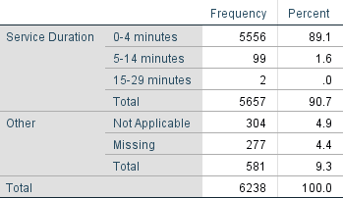

# Discussion

## Gender Distribution

### Gender Distribution

A trend towards the overrepresentation of male defendants was apparent across all Adult (73.00-75.61%), Youth (68.60-77.65%), Traffic (61.76-63.14%), and Domestic (84.50%) Courts (Figures 1, 14, 24, 33, 40, 47, 54, 67, and 76). Of all courts examined, men were most disproportionately represented in Domestic Court (Figure 76). These findings are congruent with those of Hotton Mahony et al. (2017), who observed that on a national level the number of completed cases in adult court involving a male defendant were greater than the number of cases involving a female defendant, for all offence types (Statistics Canada, 2017). In fact, as per the findings of the Integrated Criminal Court Survey, in 2014/2015 only one in five adult court cases in Canada involved a female attendee (Statistics Canada, 2017). While the gender distribution observed in court attendees receiving services from the Elizabeth Fry Society is slightly divergent from this value – demonstrating a higher proportion of female attendees than the national average, which remains the only available data for comparison in the absence of more current provincial statistics. This discrepancy between local and national statistics might be attributable to the effects of confounders - such as the dissimilar prevalence of minority populations between provinces and municipalities. Similarly, as national data represents attendee gender distribution for 2014/2015, the discrepancy might simply reflect the ongoing national trend towards an increasing number of female defendants across adult criminal courts over time (Statistics Canada, 2017).

### Gender and Age Distribution

Overall, there existed a heavier distribution of individuals in younger age categories in the adult, Traffic, and Domestic Courts, for attendees of both genders (Figures 3, 16, 26, 56, 69, and 78). Not unlike what has been observed on a national level (Statistics Canada, 2018), young men were consistently the most significantly overrepresented group across the adult courts in particular (Figures 3, 16, and 26). Similarly, female offenders in adult court tended to belong to younger age categories (Figures 3, 16, and 26); this is congruent with the finding that women in provincial and federal custody are overwhelmingly younger than 35 years of age (Statistics Canada, 2017).There was a trend towards a heavier distribution of individuals in older age categories in the youth courts , for individuals of both genders (Figures 35, 42, and 49). It is challenging to interpret any relationship between gender status and age in female defendants in the South Youth Courts, likely owing to a relatively small (57 member) sample size for this demographic (Figure 49). Young men aged 16-17 tended to be particularly overrepresented (Figures 35, 42, and 49), which is not unexpected. In 2017/2018, male youth aged 16-17 accounted for 42% of youth admissions to correctional services (Statistics Canada, 2018). While Hotton Mahony et al. (2017) makes reference to the existence of a greater proportion of cases with female defendants in youth court than in adult court, interestingly this was not a trend observed in attendees receiving services from the Elizabeth Fry Society.

### Gender and Minority Status

Indigenous defendants consistently demonstrated greater proportionality in gender representation than any other minority status classification, while defendants who identified as newcomers demonstrated the most significant overrepresentation of men (Figures 5, 18, 37, 44, 51, 58, 71, and 80); this is true across all courts that demonstrated a sufficient dataset for analysis by minority status classification, with the exception of the South Adult Courts (Figure 28). This is in keeping with the observation that Indigenous women are broadly more likely to interact with the criminal justice system than women without minority status, owing to the legacy effects of colonialism (Statistics Canada, 2017). Consistent with this observation, despite demonstrating a trend towards male overrepresentation overall (73.79%), the South Adult Courts is an outlier exhibiting a greater proportion of female than male attendees of Indigenous status (Figurer 28). However, this court also demonstrates a relatively small sample size (70 individuals, 3.76% of the attendee population), which might also account for this deviation. The trend towards a more comparable gender distribution in Indigenous attendees is particularly pronounced in Calgary’s Youth Court, in which the age-matched gender ratios for the most contributory age strata were 1.69-2.86X and 8.60X for Indigenous and newcomer attendees respectively (Figure 37). This finding is congruent with historical data which suggests that rates of certain offences among female adolescents with Indigenous status are significantly higher than their older peers (Statistics Canada, 2017). At this time, limited literature exists to comment on the often profound overrepresentation of male newcomers relative to female newcomers across all courts; this remains a worthwhile area for future exploration.

## Age Distribution

### Adult courts

A consistent trend existed towards a heavier distribution of individuals in younger age categories in the Calgary, North, and South Adult Courts, with 39.32%, 43.99%, and 32.23% of attendees identifying as being under the age of 30, respectively (Figures 2, 15, and 25). This is congruent with what is observed in adult courts on a national level (Statistics Canada, 2018). Similarly, it has been noted that the number of offenders aged 40 and older has been decreasing nationally since 2007, which may also be reflected in the age distributions observed (Public Safety Canada Portfolio Corrections Statistics Committee, 2018). This trend is equally apparent across gender categories (Figures 5, 18, and 28), and the age distribution between genders is quite comparable to that observed in national admission statistics (Public Safety Canada Portfolio Corrections Statistics Committee, 2018). Within minority status groups, this trend is especially pronounced in the North Adult Courts, where 50.26% of male Indigenous defendants were under the age of 30 (Figure 15). This is not unexpected, given that the proportion of Calgary’s population that identified as being of Indigenous status was considerably younger than the overall population in 2016, with 44.00% being under the age of 25, in contrast to 31.00% of Calgary’s population as a whole (Statistics Canada, 2013). In 2016, the median age for Calgarians with Indigenous status was 28, in contrast to those without Indigenous status at 36.4 (Statistics Canada, 2013).

### Youth courts

Within the Calgary, North, and South Youth Courts a trend existed towards a heavier distribution of attendees in older age categories, with 55.17%, 77.35%, and 64.41% of attendees identifying as 16 or older respectively (Figures 34, 41, and 48). This trend is apparent across gender categories, and broadly within minority status groups (Figures 37, 44, and 51). A tendency towards a higher density of older attendees was particularly apparent in male attendees without minority status, in both the Calgary and North Youth Courts, where 57.66% and 86.37% of attendees were 16 or older, respectively (Figures 34 and 41). Given the small sample size, it is challenging to draw strong conclusions on age distribution within minority status categories in the South Youth Courts (Figure 51).

### Traffic courts

Amongst both the Calgary and South Traffic Courts, attendee age distribution was relatively even, though there existed a modestly heavier distribution between the middle and younger age categories, respectively (Figures 56 and 69). The oldest age groups consistently demonstrated the lowest attendee counts (Figures 56 and 69); it is likely that the lower proportion of drivers of this demographic is at least partly accounted for by the lower proportion of drivers in this age category as a whole who regularly drive, and possess valid licenses. These same trends are observed in both gender groups (Figures 56 and 69). Within minority status groups, disproportionate representation can be observed in Calgary’s Traffic Court, where 31.50% and 32.78% of male newcomers were aged 18-29 and 30-39, respectively (Figure 58).

### Domestic Court

In Domestic Court, attendee age distribution was highly concentrated in the younger age categories, with 33.03% and 35.46% of defendants aged 18-29 and 30-39, respectively (Figure 78). This trend is apparent across gender categories (Figure 78). Similarly, within minority status groups there is a tendency towards younger ages of defendants, particularly in Indigenous attendees, for which 41.51% of individuals were under the age of 30 (Figure 80). This is likely at least partly attributable to the fact that Alberta’s Indigenous population is significantly younger than the general population (Statistics Canada, 2013). In 2016, the median age for Calgarians with Indigenous status was 28, in contrast to those without Indigenous status at 36.4 (Statistics Canada, 2013).

## Minority Status

### Adult courts

Within the Calgary, North, and South Adult Courts there existed significant divergence in the representation of minority status groups.

In Calgary’s Adult Court, 19.06% and 5.39% of attendees identified as Indigenous or as a newcomer, respectively (Figure 4). According to the 2011 Civic Census, only 2.7% of Calgarians identified as being of Indigenous status (Statistics Canada, 2013). By these numbers, there exists profound overrepresentation of Indigenous individuals in Calgary’s Adult Court. This is congruent with conclusions drawn from national data as recent as 2018, which indicated that Indigenous adults accounted for approximately 30% of admissions to provincial and federal custody, despite representing only 4% of the overall Canadian adult population (Statistics Canada, 2018). The overrepresentation of Indigenous adults in the criminal justice system is longstanding, and well documented, understood to be predominantly attributable to the legacy effects of colonization (Statistics Canada, 2017); along a related vein, previous research has suggested that the broadly younger age of Indigenous populations, and certain education and employment characteristics, may account for some of this overrepresentation in the criminal justice system (Statistics Canada, 2017). When examining gender categories across minority status classifications, it is apparent that while the overrepresentation of men is common to all groups, in Indigenous attendees the gender distribution is the most even, with male attendees demonstrating a prevalence of 1.65X that of their age-matched female peers for the most contributory age groups (Figure 5). This is consistent with the finding that Indigenous women are broadly more likely to interact with the criminal justice system than women without minority status, owing to the legacy effects of colonization (Statistics Canada, 2017).

According to the 2016 National Census, Calgary accepted 93,255 immigrants between 2011 and 2016 (Statistics Canada, 2017). Of this new immigrant population, individuals aged 15-24 and 25-44 made up 19.61% and 44.82% of all individuals (Statistics Canada, 2017). In 2016, this demographic made up 6.70% of Calgary’s population. By these statistics, it would appear that attendees who immigrated to Calgary in the past 5 years would be underrepresented in Calgary’s Adult Court (Figure 4), however, there exists a paucity of data relating to immigration rates in 2017 and 2018, rendering it challenging to ascertain if this is accurate. When examining gender groupings across minority status, it is apparent that the gender distribution of newcomer attendees is the most disproportionate of all groups, with male attendees demonstrating a prevalence 3.86X that of their age-matched female peers for the most contributory age groups (Figure 5). The significance of this overrepresentation presents a promising area for future study.

In the North Adult Courts, 24.97% and 3.54% of attendees identified as Indigenous or as a newcomer, respectively (Figure 17); the North Adult Courts demonstrated the greatest proportion of attendees with Indigenous status of any court examined. While demographic-specific information is not available for the jurisdiction of the North Adult Courts, according to the 2018 data, 4% of Canadians identified as being of Indigenous status (Statistics Canada, 2019). By these numbers, there exists significant overrepresentation of Indigenous individuals in the North Adult Courts (Figure 17). This is consistent with the trend observed in Calgary’s Adult Court, and likely owing to the same factors previously explored. However, this particularly disproportionate representation is also likely attributable to the municipality of Morley – a First Nations community – falling within the jurisdiction of the North Courts. When examining gender groupings across minority status classifications within the North Adult Courts, the gender distribution of Indigenous attendees is the most even of all groups, with male attendees demonstrating a prevalence of 2.79X that their age-matched female peers in the most contributory age groups (Figure 18). This is consistent with the trend observed in Calgary’s Adult Court, and likely attributable to the same factors previously discussed.

While demographic-specific information is not available specific to the jurisdiction of the North Adult Courts, according to the 2016 National Census, 5.2% of Albertans identified as being newcomers to Canada within the preceding 5 years (Statistics Canada, 2017). By these statistics, it would appear that newcomer attendees are underrepresented in the North Adult Courts, though the strength of this evidence is limited owing to a small sample size. When examining gender groupings across minority status classifications, it is apparent that the gender distribution of newcomer attendees is the most disproportionate of all groups, with male attendees demonstrating a prevalence of 3.71X and 5.86X that of their age-matched female peers for the most contributory age groups (Figure 18). This trend is reminiscent of that observed in Calgary’s Adult Court.

In the South Adult Courts, 3.76% and 2.33% of attendees identified as Indigenous or as a newcomer, respectively (Figure 27); the South Adult Courts demonstrated the smallest proportion of attendees with Indigenous status of the adult courts examined. While demographic-specific information is not available for the jurisdiction of the South Adult Courts, knowing that as of 2018 4% of Canadians identified as being of Indigenous status (Statistics Canada, 2019), these findings are not unexpected. This is inconsistent with the trend observed in the other adult courts. It is worth noting that the South Adult Courts (Airdrie and Okotoks) are not in close proximity to any Nation; adult court program advocates have noted that in the past, before the establishment of the Turner Valley Court, many Indigenous attendees failed to appear owing to having no viable option to get to court. When examining gender groupings across minority status classifications within the South Adult Courts, the gender distribution of Indigenous attendees appears to be the most even of all groups, with female defendants modestly outnumbering male defendants (Figure 28). As it stands, it challenging to determine if this reflects the fact that Indigenous women are more likely to interact with the criminal justice system than women without minority status (Statistics Canada, 2017), or the relatively small sample size for this demographic (Figure 28).

While demographic-specific information is not available specific to the jurisdiction of the South Adult Courts, according to the 2016 National Census, 5.2% of Albertans identified as being newcomers to Canada within the preceding 5 years (Statistics Canada, 2017). By these statistics, it would appear that newcomer attendees are also significantly underrepresented in the South Adult Courts, however, the paucity of demographic data for the region renders it challenging to ascertain if this is in fact the case. When examining gender groupings across minority status classifications, it is apparent that the gender distribution of newcomer attendees is the most disproportionate of all groups, with no female attendees noted in any age group (Figure 28). This trend is reminiscent of the patterns observed in other adult courts.

### Youth courts

The Calgary, North, and South Youth Courts demonstrated significant divergence in the representation of minority status groups.

In Calgary’s Youth Court, 10.57% and 5.12% of attendees identified as Indigenous or as a newcomer, respectively (Figure 36). In 2018, Indigenous youth made up 8% of all Canadian youth, and while this statistical overrepresentation is significant, it is also not unexpected (Statistics Canada, 2019); data from 2018 suggests that Indigenous youth represent 43% of admissions to correctional facilities nationally (Statistics Canada, 2019), and the average age of admission has historically been lower for Indigenous youth than for the general adolescent population (Public Safety Canada Portfolio Corrections Statistics Committee, 2018). The overrepresentation of Indigenous youth in the criminal justice system has been longstanding, and well documented, understood to be predominantly attributable to the legacy effects of colonization (Statistics Canada, 2017); along a related vein, previous research has suggested that the broadly younger age of Indigenous populations, and certain education characteristics, may account for some of this overrepresentation in the criminal justice system (Statistics Canada, 2017). When examining gender categories across minority status classifications, it is apparent that while the overrepresentation of young men is common to all groups, in Indigenous attendees the gender distribution is the most even, with male attendees demonstrating a prevalence of 1.69X and 2.86X that of their age-matched female peers for the most contributory age groups (Figure 37). This is consistent with the finding that Indigenous young women are more likely to interact with the criminal justice system than young women without minority status, and similarly more likely to than Indigenous women for several offences (Statistics Canada, 2017). This is believed to be attributable to the factors discussed previously.

According to the 2016 National Census, Calgary accepted 93,255 immigrants between 2011 and 2016 (Statistics Canada, 2017). Of this new immigrant population, individuals aged 15-24 made up 19.61% of all new immigrants (Statistics Canada, 2017). While newcomer youth made up 5.12% of all Calgary Youth Court attendees (Figure 36), it is challenging to draw conclusions regarding the relative representation of newcomers in Calgary’s Youth Court from this report alone, owing to a paucity of appropriate data for comparison. However, previous research conducted by the Elizabeth Fry Society has suggested that youth who are newcomers disproportionately experience a number of factors that confer vulnerability to interacting with the criminal justice system, including poverty, larger family size with single mothers as the head of the household, parental language barriers, and a family history of domestic violence. Within the group of newcomer youth supported in the aforementioned study, many were young, and determined to be particularly impressionable, demonstrated poor mental health, and were involved in crimes relatively extreme for their age. Ongoing data collection efforts should assist in shedding light on any trends apparent in the youth the Elizabeth Fry Society supports in this court. When examining gender groupings across minority status, it is apparent that the gender distribution of newcomer attendees is the most disproportionate of all groups, with male attendees demonstrating a prevalence 8.60X that of their age-matched female peers for the most contributory age groups (Figure 37).

In the North Youth Courts, 29.57% and 2.15% of attendees identified as Indigenous or as a newcomer, respectively (Figure 43); the North Youth Courts demonstrated the greatest proportion of attendees with Indigenous status of any Youth Court examined. While demographic-specific information is not available for the jurisdiction of the North Youth Courts, in 2018, Indigenous youth made up 8% of all Canadian youth (Statistics Canada, 2018). By these numbers, there exists significant overrepresentation of Indigenous individuals in the North Youth Courts (Figure 43). This is consistent with the trend observed in Calgary’s Youth Court, and likely owing to the same factors previously explored. However, this particularly disproportionate representation is also likely attributable to the municipality of Morley – a First Nations community – falling within the jurisdiction of the North Youth Courts. When examining gender groupings across minority status classifications within the North Youth Courts, the trends observed are complex. While there was significant representation of female defendants, the single most common gender and age strata for attendees was 17 year-old males (Figure 44). Paradoxically, while nearly half of defendants were female – with Indigenous young women aged 15-17 cumulatively making up 44.44% of the sample, with a prevalence 1.00X that of their age-matched male peers, males aged 17 alone made up 30.56% of the sample, with a prevalence 1.83X that of their age-matched female peers (Figure 44). Additional data collection efforts may provide more opportunity to better elicit the nature of the relationship between gender and Indigenous status in North Youth Court.

While demographic-specific information is not available specific to the jurisdiction of the North Youth Courts, according to the 2016 National Census, Alberta accepted 207,790 immigrants between 2011 and 2016 (Statistics Canada, 2017). Of this new immigrant population, individuals aged 15-24 made up 20.00% of all individuals (Statistics Canada, 2017). While newcomer youth made up 2.15% of all North Youth Court attendees (Figure 43), it is challenging to draw conclusions regarding the relative representation of newcomers in the North Youth Courts owing to a paucity of appropriate data for comparison. Given the limited size of the data set, it is challenging to speak confidently to the gender distribution by newcomer status in this court (Figure 37). Similarly, while 6.67% and 1.67% of youth in the South Youth Courts identified as Indigenous or as a newcomer respectively (Figure 50), there is insufficient data for further analysis by minority status at this time (Figure 51).

### Traffic courts

Within the Calgary and South Traffic courts, there existed significant divergence in the representation of minority status groups.

In Calgary’s Traffic Court, 2.60% and 9.93% of attendees identified as Indigenous or as a newcomer, respectively (Figure 57). According to the 2011 Civic Census, only 2.7% of Calgarians identified as being of Indigenous status (Statistics Canada, 2013). By these numbers, Indigenous defendants were not overrepresented in this court. When examining gender categories across minority status classifications, it is apparent that the gender distribution for Indigenous attendees is almost exactly equal, with a cumulative male:female prevalence ratio of 1.11 (Figure 58). Congruent with other minority status classifications, the most common traffic offences committed by Indigenous attendees were speeding, driving through a stop light, and other traffic offences (Figure 65). However, it was noted that Indigenous attendees also demonstrated 1.54X (X2 = 8.63, p<0.01), 1.95X (X2 = 5.10, p<0.02), and 1.90X (X2 = 22.92, p<0.01) the odds of having offences relating to driving through a stoplight, careless driving, and other traffic offences than attendees without minority status, respectively (Table 25). The cause of these discrepancies is unclear.

In contrast, newcomers were profoundly overrepresented in Calgary’s Traffic Court, accounting for 9.93% of all attendees (Figure 57); according to the 2016 National Census, Calgary accepted 93,255 immigrants between 2011 and 2016, and in 2016, this demographic made up 6.70% of Calgary’s population (Statistics Canada, 2017). When examining gender categories across minority status classifications in Calgary’s Traffic Court, it is apparent that the gender distribution for attendees who are newcomers is skewed towards male defendants, for which the most contributory age strata demonstrated 2.39X and 1.84X the odds of having an offence, relative to their age-matched female peers (Figure 58). It is possible that this is in part owing to differential driving rates between men and women, associated with different cultural norms; additional research into the cultural composition of Calgary’s new immigrant population, and licensing statistics, would be required to further explore this hypothesis. Congruent with other minority status classifications, the most common traffic offences committed by attendees who are newcomers were speeding, driving through a stop light, and other traffic offences (Figure 66). However, it was noted that newcomer attendees also demonstrated 1.36X (X2 = 13.33, p<0.01), 2.43X (X2 = 9.39, p<0.01), 1.29X (X2 = 21.40, p<0.01), 1.95X (X2 = 16.35, p<0.01), and 1.30X (X2 = 568.81, p<0.01) the odds of having offences relating to driving through a stoplight, not wearing a seatbelt, speeding, illegal U-turns, and other traffic violations than individuals without minority status, respectively (Table 25). Interestingly, attendees who are newcomers also possessed 0.88X (X2 = 32.51 p<0.01) and 0.95X (X2 = 216.87, p<0.01) the odds of having offences related to careless driving, and failing to provide a license or registration, than attendees without minority status respectively (Table 25). The cause of these discrepancies is unclear, but might be attributed to differing social norms, experience driving, language barriers, and other factors. Further analysis of the composition of Calgary’s new immigrant population and licensing statistics might better illuminate potential relationships between offence types and newcomer status.

In the South Traffic Courts, 19.06% and 5.39% of attendees identified as Indigenous or as a newcomer, respectively (Figure 70). While demographic-specific information is not available for the jurisdiction of South Traffic Court, in 2018 4% of Canadians identified as being of Indigenous status (Statistics Canada, 2018), while in 2016, 5.2% of Albertans identified as being newcomers to Canada within the preceding 5 years (Statistics Canada, 2017). By these values, attendees with Indigenous status appear to be overrepresented in the South Traffic Courts. However, owing to an exceedingly small sample size for both defendants with Indigenous and newcomer status, it is not possible to draw strong conclusions relating to trends in gender, age, or offence frequencies at this time (Figure 71). Further data collection efforts may help highlight any trends that may exist within these populations.

### Domestic Court

In Calgary’s Domestic Court, 13.36% and 4.68% of attendees identified as Indigenous or as a newcomer, respectively (Figure 79). According to the 2011 Civic Census, only 2.7% of Calgarians identified as being of Indigenous status (Statistics Canada, 2013). By these numbers, there exists overrepresentation of Indigenous individuals in Domestic Court. In addition, when examining gender categories across minority status classifications, it is apparent that while the overrepresentation of men is common to all groups, in Indigenous attendees the gender distribution is the most even, with male attendees demonstrating a prevalence of 2.03X and 4.11X that of their age-matched female peers for the most contributory age groups (Figure 80). Paradoxically, it is also recognized that Indigenous women and men are more likely to be victim to family violence (Statistics Canada, 2018; Holmes and Hunt, 2017); a large body of research substantiates that both of these findings reflect the legacy effects of colonization, and intergenerational trauma (Holmes and Hunt, 2017).

In 2016, newcomers made up 6.70% of Calgary’s population. By these statistics, it would appear that attendees who immigrated to Calgary in the past 5 years would be underrepresented in Calgary’s Domestic Court (Figure 79). When examining gender groupings across minority status, it is apparent that the gender distribution of newcomer attendees is the most disproportionate of all groups, with a male:female gender ratio of 261:0 (Figure 80). A number of barriers may affect the representation of newcomers in Domestic Court. Previous research has suggested that immigrant women in particular face complex barriers to reporting abuse, including but not limited to differential definitions for domestic violence, language barriers, beliefs about gender roles, and community stigma surrounding reporting (Guruge, Roche and Catallo, 2012). Immigrant women are also less likely to be familiar with the support services available to them (Guruge, Roche and Catallo, 2012). Staff involved in service provision to newcomers in Domestic Court report similar findings. Anecdotally, immigrant women may elect not to report domestic abuse owing to fear of the legal system, concerns about the impact of reporting on their immigration status, dependence on their partners for income, and a lack of familiarity with local laws and the supports available to them. Given these findings, it is likely that the underrepresentation of newcomers in Domestic Court might be at least partly attributable to underreporting. The significance of the underrepresentation of newcomers in Calgary’s Domestic Court presents a promising area for future study.

## Family Size

### Adult courts

It was observed that in the Calgary and South Adult Courts, the overwhelming majority of attendees identified as being from families of limited size (Figures 6 and 29). In Calgary’s Adult Court, 37.23% of attendees did not identify belonging to a family group, while in the South Adult Courts 31.85% and 39.94% of individuals belonged to no family group or a family of 2, respectively (Figures 6 and 29). The most recent National Census (Appendix 9.4) indicates that 23.20% of Calgarians belonged to no family group, while 24.00% and 34.30% of Albertans reported belonging to no family group or a family of 2, respectively (Statistics Canada, 2017). This suggests that attendees of smaller family sizes are overrepresented in both the Calgary and South Adult Courts (Figures 6 and 29).

In contrast, in the North Adult Courts the distribution of attendee family size was fairly evenly distributed across individuals of 1 to 5 family members (Figure 19). The most recent National Census data (Appendix 9.4) indicates that 24.00%, 34.30%, 16.00%, 15.30%, and 10.40% of all Albertans belong to a family of 1 through 5+ members, respectively (Statistics Canada, 2017). With attendees with families of 1-5+ representing 18.83%, 21.10%, 16.67%, 15.30%, and 23.72% of defendants in the North Adult Courts respectively, it is apparent that smaller family sizes of 1-2 are underrepresented, while larger families of 4-5+ are overrepresented (Figure 19). This is particularly true of attendees with families of more than 5 individuals, whose prevalence is more than double that of Alberta as a whole (Appendix 9.4). This may be attributable to a variety of factors, including lower cost of living in areas within the jurisdiction of the North Adult Courts, as well as the overrepresentation of Indigenous attendees in the courts (Figure 17). Current literature suggests that in Alberta, Indigenous individuals are more likely to belong to larger families than the general population (Statistics Canada, 2013). Exploring the average family size in the North Adult Courts by minority status may present a worthwhile area for future analysis.

### Traffic courts

It was observed that in the Calgary and South Traffic Courts, the overwhelming majority of attendees identified as being from families of limited size (Figures 59 and 72); individuals with families of 1 to 4 members comprised 84.23% and 96.60% of attendees at the Calgary and South Traffic courts, respectively (Figures 59 and 72). The distribution observed in Calgary’s Traffic Court is relatively congruent with what is observed in the general Calgarian (89.50%) population (Appendix 9.4). However, smaller family sizes of 1-4 are overrepresented in the South Traffic Courts, relative to what is observed in the general Albertan (89.60%) population (Statistics Canada, 2017). Literature surrounding potential relationships between family size and traffic offence frequency is scant, and consequently the origin of this discrepancy is unclear.

## Annual Household Income

### Adult courts

Across all Adult Courts, there existed a trend towards a greater proportion of attendees with minority status reporting an annual household income of <$15,000 and a lesser proportion making >$55,000, than attendees without minority status (Figures 7, 20, and 30). This trend is reflected in the calculated odds ratios for each respective court; at Calgary and the North Adult Courts, Indigenous attendees of various family sizes had 1.94-3.05X and 3.10-15.63X the odds of having an annual household income of less than the geographic Market Basket Measure (MBM) value for their family size, than attendees without minority status of comparable family size (Tables 2 and 7). Frequently, Indigenous families with higher household incomes were significantly larger, such that they still fell below their corresponding MBM value. Notably, of families of ≥8, only 4.35%, 15.38%, and 14.29% had an annual household income exceeding $55,000, for attendees with no minority, Indigenous, and newcomer status, respectively (Figure 7, 20, and 30). It is challenging to ascertain if these trends hold true for the South Adult Courts, owing to limited data availability, however notably no attendees of Indigenous status reported an annual household income of more than $35,000 in those courts (Figure 30, Table 11).

The North Adult Courts demonstrated this trend between minority status and household income most prominently, demonstrating the greatest proportion of individuals earning less than $15,000 per year (Figure 20). Particularly in these courts, there existed an inverse relationship between annual household income and family size, with attendees belonging to families of 8 or more being most likely to earn less than $15,000 annually (Figure 20). Similarly, a relationship existed between increasing family size, and an increasing proportion of attendees identifying as Indigenous (Table 6). Indigenous attendees comprised 83.13% of individuals belonging to families of 8 or more, and of the population 94.38% fell below the MBM (Figure 20, Table 6). Indigenous attendees had 3.10-15.63X the odds of attendees without minority status of the same family size, of making less than the MBM value (Table 7). Current literature suggests that in Alberta, Indigenous individuals are more likely to belong to larger families than the general population (Statistics Canada, 2013).

Cumulatively, these findings are consistent with the observation that the economic status of Indigenous Albertans is poorer than that of the general population. In 2016, 55% of Indigenous persons were in the bottom half of the Canadian income distribution, suggesting that the population has relatively lower incomes than Canada as a whole (Statistics Canada, 2013). In Calgary in 2016, the median household income for Indigenous individuals was $69,378 – a marked $12,000 lower than that of Calgarians overall – and 22% were considered low income (Statistics Canada, 2013). This is in part owing to differential rates of employment, educational attainment (Pager, 2003), and the fields of employment in this group; in 2016, approximately half of Indigenous Calgarians were employed in sales and service positions, fields which demonstrate some of the lowest wages (Statistics Canada, 2013).

### Traffic courts

In Calgary Traffic Court there existed a modest trend towards a greater proportion of attendees with minority status reporting annual household incomes of <$15,000 and a lesser proportion making >$55,000, than attendees without minority status (Figure 60). Moreover, it was discovered that Indigenous and newcomer attendees had 1.34-2.98X and 1.66-2.62X the odds of making less than the MBM value, than those without minority status of corresponding family sizes, respectively (Figure 60). Notably, of families of ≥8, only 19.50%, 21.20%, and 3.40% had an annual household income exceeding $55,000, for attendees with no minority, Indigenous, and newcomer status, respectively (Figure 60). It is challenging to ascertain if these relationships hold true for the South Traffic Courts, owing to limited data availability, though notably no attendees with minority status reported an annual household income of more than $55,000 (Figure 73, Table 28).

## Offences

### Adult courts

Across the Calgary, North, and South Adult Courts, it was observed that for the overwhelming majority of attendees – 97.45%, 97.54%, and 98.81% respectively – a criminal offence charge preceded an administration charge (Figures 8, 21, and 31). Across each court, the most common administration offence noted was "failure to appear", accounting for 49.91%, 38.42%, and 48.9% of all charges at Calgary, North, and South Adult Courts (Figures 9, 21, and 32); when broken down by minority status, all groups demonstrated a similar frequency of this charge (Figures 10, 11, 12, and 22). Previous research by the organization has suggested that individuals with no fixed address represented a significant proportion of "failure to appear" charges; the population of individuals without a fixed address might be expected to be localized around urban centres, which provide more opportunities for temporary housing and shelter, and this might help explain why both the Calgary and the South Adult Courts demonstrate a higher proportion of attendees with this charge (Figures 9 and 32). In addition, Adult Court program advocates have previously noted greater frequencies of this charge in Indigenous attendees in the South Adult Courts, largely prior to the establishment of the Turner Valley Court, citing the significant distance between them and the nearest Nations, and the ensuing barriers to arriving at court. Within the North Adult Courts, it was noted that "failure to comply" (38.42%) was also a significant contributory offence that was evenly represented between Indigenous attendees and those without minority status (Figure 21). While limited data precluded the analysis of bylaws offences in certain courts, and by minority status, the most contributory bylaw offence types in Calgary’s Adult Court were "other bylaw offences", "Calgary traffic offences", and "disturbing the peace", with frequencies of 35.00%, 30.00%, and 20.00%, respectively (Figure 13).

### Traffic courts

It was observed that the majority – 89.00% and 90.00% - of attendees at Calgary’s and the South Traffic Courts had only one type of charge (Figures 61 and 74); in these courts, attendees overwhelmingly were presenting to court with single charges (Figure 62). "Speeding" represented the most common traffic offence in both courts, making up 53.00% and 44.88% of the total offences in Calgary and the South Traffic Courts, respectively (Figures 63 and 75). Within Calgary’s Traffic Court, it was noted that Indigenous attendees had 1.54X (X2 = 8.63, p<0.01), 1.95X (X2 = 5.10, p<0.02), and 1.90X (X2 = 22.92, p<0.01) the odds of having a "driving through a stop light", "careless driving", or "other traffic" offence type, than attendees without minority status (Figures 64 and 65; Table 25). In contrast, attendees with newcomer status had lower odds - 0.88X (X2 = 32.51, p<0.01) and 0.95X (X2 = 216.87, p<0.01) the odds - of having a "careless driving" or a "failure to provide a licence or registration" charge than attendees without minority status, respectively (Figures 64 and 66; Table 25). However, it was noted that newcomer attendees had greater odds – 1.36X (X2 = 13.33, p<0.01), 2.43X (X2 = 9.39, p<0.01), 1.29 (X2 = 21.40, p<0.01), 1.95X (X2 = 16.35, p<0.01), and 1.30X (X2 = 568.81, p<0.01) the odds - of having "driving through a stoplight", "not wearing a seatbelt", "speeding", "illegal U-turn", or "other traffic" offences, than attendees without minority status, respectively (Figures 64 and 66; Table 25). The cause of these discrepancies is currently unclear, but differing social norms, experience driving, language barriers, and other factors may affect the traffic offence frequencies highlighted in newcomer attendees. Further analysis of the composition of Calgary’s new immigrant population and licensing statistics might better illuminate potential relationships between offence types and newcomer status. Regrettably, as the South Traffic Courts only commenced in 2018, the dataset is currently insufficient to permit drawing strong conclusions, for any relationships between traffic offence frequency and minority status; future data collection may help elucidate any existing relationships between these variables.

## Support

Across each of the Youth Courts, youth largely boasted supports present in court (Figures 38, 45, and 52); this is particularly true of the North Youth Courts (Figure 45). This is not unexpected as per the Youth Criminal Defence Act, all youth are required to have legal representation in court. Across all Youth Courts, Indigenous attendees were slightly more likely to have supports – 75.78%, 87.23%, and 81.25% – than attendees without minority status – 70.34%, 82.50%, and 78.6% - at each court respectively (Figures 38, 45, and 52). This is surprising, as a large body of literature suggests a strong, inverse relationship between family support and youth involvement in the criminal justice system and recidivism (Barry, 2010), and yet Indigenous youth are still disproportionally represented in court. The nature of these supports – for example, personal vs. professional supports – might present an interesting area for future exploration. While it is challenging to comment on trends in attendees who are newcomers owing to limited data, it was noted that in Calgary’s Youth Court this group demonstrated the lowest proportion (65.17%) of individuals presenting with support (Figure 38). This may be attributable to barriers to accessing professional support services, amongst other factors, and may warrant further investigation. Statistically, no significant relationship was observed between gender and the presence of supports at any youth court, despite North Youth Court female attendees demonstrating 12.19% more support than their male peers (Figures 39, 46, and 53).

## Appearances

Across the Adult, Youth, and Domestic Courts, it was noted that most attendees were present for their first court appearance, with an inverse relationship between increasing appearance number and frequency (Tables 3, 8, 12, 15, 18, and 21; Figure 82). This is particularly true of Calgary’s Adult Court and Domestic Court, of which 50.86% and 79.71% of attendees were present for a first appearance, respectively (Table 3; Figure 82). In Domestic Court, the most common appearance type was for legal advice; this is especially true of the newcomer group, of which 58.38% sought advice (Figures 82 and 85).

## Legal Representation

Across all courts, it was observed that most attendees did not have legal representation (Tables 4, 10, 13, 16, 19, 22, 26, and 29); the courts with the lowest rates of legal representation were the Calgary and South Traffic courts , in which 99.41% and 96.10% of individuals did not have representation, respectively (Figures 26 and 29). This is not surprising, given that attendees in these courts were most often facing speeding offences and less serious charges, for which legal representation is less necessary (Figures 63 and 75). The only court in which most attendees did have legal representation was Calgary’s Youth Court, with 64.00% of youth attendees having a lawyer (Figure 16). The North and South Youth Courts also demonstrated smaller proportions of attendees without representation – 52.46% and 58.58% respectively – than other courts (Figures 19 and 22). The observed prevalence of legal representation in the youth courts is believed to be attributable, at least in part, to the Youth Criminal Defence Act, which mandates that all youth are required to have legal representation in court. Across many courts, newcomers demonstrated the lowest rates of legal representation. Court support staff report observing concerns surrounding the cost of accessing a lawyer, a lack of familiarity with the supports available to them, and occasionally resignation as reasons newcomers may not present with legal representation.

## Service Provision

Across every court, most attendees received services through the organization for a duration of 0-4 minutes; an inverse relationship between increasing service length and attendee count was apparent (Tables 5, 9, 14, 17, 20, 23, 27, 30, and 32). This is particularly true of Calgary’s Traffic Court, where 94.23% of attendees received service for under 4 minutes (Figure 27). Of all courts, Domestic Court demonstrated the lowest proportion of defendants (0.04%) receiving services in excess of 15 minutes (Table 32). This is not unexpected, considering the relative brevity of the Domestic Court questionnaire (Appendix 9.5), and the potential for a greater degree of discomfort for both court attendees and data collectors. The North and South Youth Courts, and South Adult Courts, had the greatest proportions of attendees with higher needs – 3.60%, 3.25%, and 3.30% respectively (Tables 19, 23, and 14). While the youth courts and adult courts demonstrate similar structures, it is worth noting that each court demonstrates different processes; as a result, the role of the Elizabeth Fry Society at the different courts may range from helping triage and direct attendees to an appropriate court, to offering legal advice. Certain geographic and demographic characteristics may also lend themselves to requiring additional support from the organization; anecdotally, court program advocates note that within the regional courts, access to court documents and supports (including interpreters) is often lower, the roles of court support staff are broader, and the overall attendee populations demonstrate lower educational attainment.

# Conclusions

Overall, the trends and demographic distribution observed in the court attendee populations served by the Elizabeth Fry Society of Calgary between January 2017 and December 2018 were congruent with those cited in surrounding literature, and with available regional statistics. In general, younger men were statistically overrepresented in all courts, with older male teens more significantly represented in youth courts. A trend towards greater representation of Indigenous women than women without minority status was also noted in multiple courts. Differential representation of individuals with minority status was apparent in nearly every court, reflecting the legacy effects of colonization, and potentially the effects of barriers to accessing services. Attendees that were newcomers were strongly overrepresented in the Traffic Courts. Aligned with the significant body of literature on the subject, individuals with minority status, particularly those identifying as Indigenous, demonstrated poorer financial status, and larger family size. Otherwise, attendees without family (and potentially the associated support), or with few family members, were overrepresented. Administration charges were overwhelmingly more common than bylaws charges in the Adult Courts, with failure to appear proving the most common administration offence across all minority groups. Common traffic offences across all minority groups included speeding, failure to stop at a stoplight, and other offences. Across all youth courts, youth most often presented to court with supports. Interestingly, this was particularly true of Indigenous youth. Most individuals served by the Elizabeth Fry Society were present for a first appearance in court, and lacked legal representation, with the notable exception of Calgary’s Youth Court. Individuals accessing services were commonly seeking legal advice, with the average interaction with an Elizabeth Fry representative being under 4 minutes.

Familiarity with the populations most commonly served by the organization may prove useful in directing future program development and service approaches to best meet the needs of defendants accessing support; it is recommended that staff involved in both the coordination and provision of services have access to the contents of this report for reference, as needed. Exploring relationships between attendee demographic factors may prove useful in identifying areas for further investigation, and information deficits, and data collection represents a worthwhile endeavour for continuation. This report highlighted many promising areas for future investigation that may prove critical to fully appreciating the nature of select relationships cited.

Moving forward, it is recommended that the organization explores discrepancies in conviction rates, and appearance numbers, by gender. Hotton Mahony et al. (2017) suggests that men endure disproportional conviction rates, and more court appearances, attributable to them possessing a greater number of charges on average. It is currently unknown if this relationship is observed in the individuals served by the Elizabeth Fry Society. Another recommended area for future investigation is the origins of discrepancies in certain offence frequencies by minority and gender status. Namely, on a national level it is understood that the most common offences committed by female attendees include failure to comply and breach of probation (Statistics Canada, 2017), and it is unclear if this is true of the population served. As well, significant differences in traffic offence frequency were noted in attendees who identified as newcomers. In addition, a recurrent challenge in completing data analysis surrounding newcomer attendees in various courts was the limited information available on the involvement of new immigrants in the criminal justice system. Items that were of particular interest included the significant discrepancies in gender representation amongst newcomers in multiple courts. A similarly important area for exploration is surrounding the nature of defendant supports in the Youth Courts; while family support is known to affect rates of youth involvement in the criminal justice system, and rates of recidivism (Barry, 2010), despite demonstrating more support overall, Indigenous youth remain overrepresented in court. Consequently, examining the types of support present across youth courts and minority statuses may shine light on any differential impact of support types on youth. Finally, a critical area warranting future attention is the need for ongoing data collection efforts; a key limitation to identifying strong relationships in certain courts, particularly newer ones such as South Traffic Court, was a lack of data availability. Addressing these key items of interest, amongst others noted in this report, may allow for the appreciation of more nuanced relationships potentially overlooked in this analysis.

# Reference List

Barry, M., 2010. Youth Transitions: From Offending to Desistance. *Journal of Youth Studies*, 13(1), pp.121–126. Available at: https://www.tandfonline.com/doi/abs/10.1080/13676260903233712 [Accessed August 2, 2019].Statistics Canada (2018). *Adult and Youth Correctional Statistics in Canada, 2016/2017*. Statistics Canada, pp.1-20.

Barker, B. et al., 2015. Aboriginal street-involved youth experience elevated risk of incarceration. *Public Health*, 129(12), pp.1662–1668.

Brown, C., 2018. Incarceration and Earnings: Distributional and Long-Term Effects. *Journal of Labor Research*, 40(1), pp.58–83.

Centre for Public Legal Education of Alberta, 2015. Criminal records and record suspensions. *LawCentral*. Available at: https://www.lawcentralalberta.ca/en/criminal-records-and-record-suspensions [Accessed August 2, 2019].

Corrado, R.R., Kuehn, S. & Margaritescu, I., 2014. Policy Issues Regarding the Overrepresentation of Incarcerated Aboriginal Young Offenders in a Canadian Context. *Youth Justice*, 14(1), pp.40–62.

Government of Alberta, 2000. *Alberta Human Rights Act; Revised Statutes of Alberta*, Edmonton, AB: Alberta Queen's Printer.

Guruge, S., Roche, B. and Catallo, C. (2012). Violence Against Women: An Exploration of the Physical and Mental Health Among Immigrant and Refugee Women in Canada. *Nursing Research and Practice*, 2012, pp.1-5.

Holmes, C. and Hunt, S. (2017). *Indigenous Communities and Family Violence: Changing the Conversation*. Prince George, BC: National Collaborating Centre for Aboriginal Health, pp.1-60.

Hotton Mahony, T., Jacob, J. & Hobson, H., 2017. Women and the Criminal Justice System. *Women in Canada: A Gender-Based Statistical Report*, pp.1–42. Available at: https://www150.statcan.gc.ca/n1/pub/89-503-x/2015001/article/14785-eng.pdf [Accessed August 2, 2019].

Kanters, A. (2018). Women's Incarceration in Alberta Backgrounder. [online] pp.1-48. Available at: https://elizabethfrycalgary.ca/wp-content/uploads/2018/10/PCOP-Backgrounder.pdf [Accessed 2 Aug. 2019].

Kouyoumdjian, F. et al., 2016. Health Status of Prisoners in Canada: Narrative Review. *Canadian Family Physician*, 62(3), pp.215–222. Available at: https://www.ncbi.nlm.nih.gov/pubmed/27427562 [Accessed August 2, 2019].

Laprairie, C., 1997. Reconstructing Theory: Explaining Aboriginal Over-Representation in the Criminal Justice System in Canada. *Australian & New Zealand Journal of Criminology*, 30(1), pp.39–54.

McFarlane, C. & Milaney, K., 2008. *Crimes of Desperation: The Truth about Poverty Related Crime*, Calgary, AB: Poverty Reduction Coalition of United Way of Calgary and Area.

McKay-Panos, L., 2017. Human Rights Law and Inclusion of New Grounds: Criminal Record. *LawNow*. Available at: https://www.lawnow.org/human-rights-laws-and-inclusion-of-new-grounds-criminal-record/ [Accessed August 2, 2019].

Pager, D., 2003. The Mark of a Criminal Record. *University of Chicago Press Journals*, 108(5), pp.937–975. Available at: http://www.jstor.org/stable/pdf/10.1086/374403.pdf?refreqid=excelsior:fbf26ced1567cfb882 e6d9b3bf9e7723 [April 11, 2018]. [Accessed August 2, 2019].

Perreault (2009). *The Incarceration of Aboriginal People in Adult Correctional Services*. [online] Www150.statcan.gc.ca. Available at: https://www150.statcan.gc.ca/n1/pub/85-002-x/2009003/article/10903-eng.htm [Accessed 2 Aug. 2019].

Perrin, B. & Audas, R., 2018. *Report Card on the Criminal Justice System #2*, Macdonald-Laurier Institute. Available at: https://macdonaldlaurier.ca/files/pdf/MLI_JusticeReportCard_Final_web2.pdf [Accessed August 2, 2019].

Public Safety Canada Portfolio Corrections Statistics Committee (2018). *Corrections and Conditional Release Statistical Overview*. Public Safety Canada Portfolio Corrections Statistics Committee, pp.1-150.

Roebuck, B., 2008. *Homelessness, Victimization and Crime: Knowledge and Actionable Recommendations*, University of Ottawa. Available at: https://www.publicsafety.gc.ca/lbrr/archives/cnmcs-plcng/cn35305-eng.pdf [Accessed August 2, 2019].

Savage, L., 2019. *Female Offenders in Canada, 2017*, Statistics Canada . Available at: https://www150.statcan.gc.ca/n1/en/pub/85-002-x/2019001/article/00001-eng.pdf?st=gUCToFmC [Accessed August 2, 2019].

Singh, D., Prowse, S. & Anderson, M., 2019. Overincarceration of Indigenous people: a health crisis. *Canadian Medical Association Journal*, 191(18), pp.E487–E488.

Statistics Canada (2013). *National Household Survey (NHS) Aboriginal Population Profile*. [online] Available at: https://www12.statcan.gc.ca/nhs-enm/2011/dp-pd/aprof/details/page.cfm?Lang=E&Geo1=CSD&Code1=4806016&Data=Count&SearchText=Calgary&SearchType=Begins&SearchPR=01&A1=All&B1=All&GeoLevel=PR&GeoCode=4806016&TABID=1 [Accessed 2 Aug. 2019].

Statistics Canada (2016). *Aboriginal Peoples: Fact Sheet for Alberta*. Aboriginal Statistics Program, pp.1-8.

Statistics Canada, 2016. *Aboriginal Peoples in Canada: First Nations People, Metis, and Inuit*, Statistics Canada . Available at: https://www12.statcan.gc.ca/nhs-enm/2011/as-sa/99-011-x/99-011-x2011001-eng.pdf [Accessed August 2, 2019].

Statistics Canada (2017). *2016 Census of Population*. Statistics Canada

Statistics Canada (2017). *Focus on Geography Series, 2016 Census*. Statistics Canada.

Statistics Canada (2017). *Women and the Criminal Justice System*. Statistics Canada, pp.1-42

Statistics Canada (2018). *Family Violence in Canada: A Statistical Profile*. Statistics Canada, pp.1-96.

Statistics Canada (2019). *Adult and Youth Correctional Statistics in Canada 2017/2018*. Statistics Canada, pp.1-26.

Statistics Canada, *Market Basket Measure (MBM) thresholds for economic families and persons not in economic families, 2015*, Statistics Canada.

# Appendix

## Market Basket Measure (MBM) Thresholds for Economic Families and Persons not in Economic Families, 2015

|  |  |  |  |  |  |
| --- | --- | --- | --- | --- | --- |
|  | Economic Families | | | | |
| 1 Person | 2 Persons | 3 Persons | 4 Persons | 5 Persons |
| Calgary MBM Value | $20,300 | $28,708 | $35,160 | $40,599 | $45,391 |
| Rural Alberta MBM Value | $19,668 | $27,814 | $34,065 | $39,335 | $43,978 |

(Statistics Canada, 2019)

## Odds Ratio Formula and Sample Calculation

|  |  |  |  |
| --- | --- | --- | --- |
|  | | Outcome | |
| Affirmative  (e.g. falling below MBM for location and family size) | Negative  (e.g. falling above MBM for location and family size) |
| Group Classification | Group 1 | 20 (a) | 80 (b) |
| Group 2 | 40 (c) | 80 (d) |

$OR=\frac{\frac{a}{b}}{\frac{c}{d}}$, $OR=\frac{\frac{20}{80}}{\frac{40}{80}}=0.5X.$

$"Group 1 has 0.5X the odds of having an affirmative outcome in a given context than group 2."$

## Chi-Squared (X2) Formula and Sample Calculation

|  |  |  |  |
| --- | --- | --- | --- |
|  | | Outcome | |
| Affirmative Outcome | Negative Outcome |
| Group Classification | Group of Interest (Frequencies Observed) | 20 | 80 |
| Baseline/’Control’ Group (Frequencies Expected) | 40 | 80 |

$$X^{2}= \sum{\frac{{(O-E)}^{2}}{E}, where O=the observed frequency and E=the expected frequency. }$$

$$X^{2}= \sum{\frac{{(20-40)}^{2}}{40} }=10.$$

## Average Immediate Family Size, From the 2016 National Census

|  |  |  |  |  |  |
| --- | --- | --- | --- | --- | --- |
|  | Family Size | | | | |
| 1 Person | 2 Persons | 3 Persons | 4 Persons | 5 Persons |
| Calgary | 23.20% | 33.00% | 16.80% | 16.50% | 10.5% |
| Alberta | 24.00% | 34.30% | 16.00% | 15.30% | 10.40% |

(Statistics Canada, 2017)

## Data Collection Sheet Exemplars – Adult, Youth, Traffic, and Domestic Court

